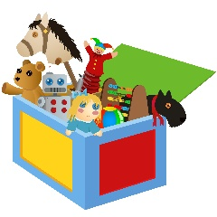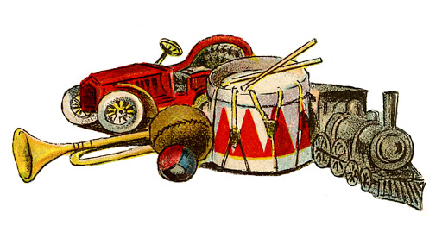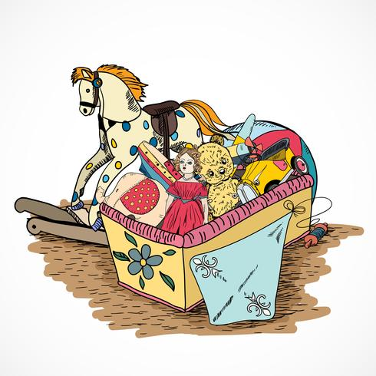

Science

Seasonal changes

Literacy

Recounts

Comic strips

Maths

Fractions

Year 1 - Spring 2

Old and new toys within living memory.

PE

Rounder’s

Games

Music

Round and Round.

Playing/singing in different styles and learning about those styles.

Latin and mixed styles.

PSHE

Keeping and staying safe and healthy.

ICT

Can you create a poster showing how different technology is used?

Art/DT

Design and make a toy

RE

The Eucharist- Meals

Caritas

Change