Welcome to our EYFS Home Learning Zone.

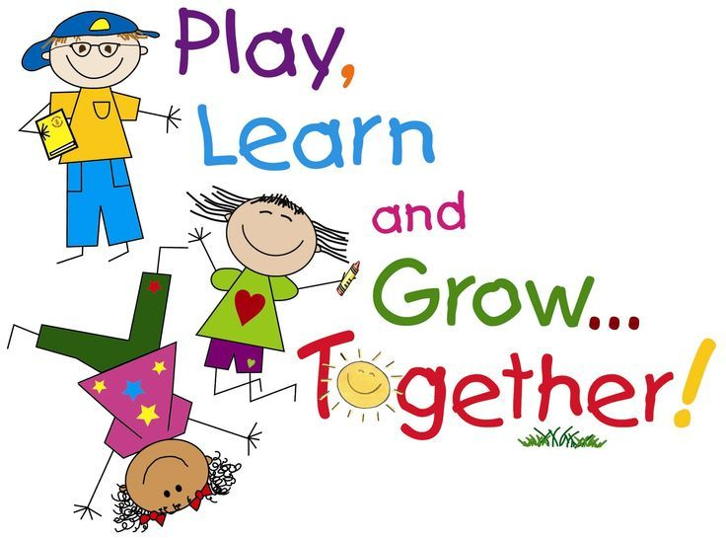

A very warm welcome to our wonderful nursery and reception pupils and their families to our EYFS Home Learning Zone. We hope you are keeping well. As school is now closed, together with the learning packs we have provided (those pupils who have not yet received their learning packs, these can be collected from school on Tuesday 24th March 2020) we would like to provide you with our very own home learning zone. This is where we will set daily activities for you to complete at home, together with providing the necessary support and guidance you may require.

The following activities/ideas are suggestions to maintain your child’s learning while school is closed.

- Share books with your child, talk about what’s happened, how the characters are feeling. Encourage your child to draw their favourite character, re tell the story, describe the setting, act out the story or create their own version.
- Sing songs or read rhymes
- Make an experience book that encourages your child to retell something they recently did.
- Play simple games like snap, pairs or dice-board games

Number Work
- Count sets of objects
- Count out set numbers of objects from a larger group
- Go on a number hunt. Where can you spot numbers around your home?
- Painting. Use either water or paint to practise number formation.
- Chalks. Draw a hop scotch grid on your patio and count the numbers as you play.
- Sing a counting song. Our current class favourites are ‘Five little speckled frogs’ and ‘Five cheeky monkeys jumping on a bed’ to practise counting backwards from 5.
- Counting objects. Give your child different numbers and let them count out the correct amount using pieces of pasta, beads or blocks.

Shape Work
- Go on a shape Hunt. Which shapes can you find in your home?
- Arts & crafts. Can you use collage materials, paints or crayons to make different shapes?
- Junk modelling. Can you make something using your clean recycling? Perhaps a rocket, house or car. Can you name the 3D shapes you are using?
- Could you draw a picture using 2d shapes? Perhaps a robot, building or animal. Can you name the 2d shapes you’re using?
- Can you count the corners & sides of 2d shapes and the corners, edges and faces of 3d shapes?

Please follow the links below to access some excellent online resources to help with your child’s learning while at home.

Oxford Owl
This site has a number of activities you can do with your child including online books.
https://www.oxfordowl.co.uk/for-home/advice-for-parents/fun-ideas-learning-at-home/fun-ideas-ages-3-4/

Small Talk: the literacy trust
These links have ideas for activities you can do with your child that support communication and literacy. While the 2 to 3 years may seem a little young, the activities and ideas are still relevant for 3 to 4 year olds.

2 to 3 years
https://small-talk.org.uk/2-3-years/
3 to 5 years
https://small-talk.org.uk/3-5-years/

Book start from the book trust:
This link has a few books you can share online. The first is a class favourite ‘Oh no George’. If you click on another book more are revealed.
https://www.booktrust.org.uk/books-and-reading/have-some-fun/storybooks-and-games/oh-no-george/

This link has rhymes at the bottom of the page you can download
https://www.booktrust.org.uk/what-we-do/programmes-and-campaigns/bookstart/practitioners/delivering-bookstart/information-for-librarians/rhymetimes/

Barefoot Books
This link has many books that are animated often with songs which the children love.
https://www.barefootbooks.com/kids/animated-videos/

Phonics Play
Use the Phonics Play website for a variety of free phonics games to play on a computer or tablet.
https://www.phonicsplay.co.uk/freeIndex.htm

Alphablocks
Watch as the letters of the alphabet tell stories and make words using phonics.
https://www.bbc.co.uk/cbeebies/shows/alphablocks

Learn English British Council
A lovely, clear website for all children, not just those learning English! Lots of stories, songs and activities.
https://learnenglishkids.britishcouncil.org/?utm_source=lekids&utm_medium=header-tab&utm_campaign=learnenglish-kids

Top marks
This link has a number of counting games you can do with your child
https://www.topmarks.co.uk/maths-games/3-5-years/counting

Number Blocks
Click the link to watch an episode of Number Blocks (https://www.bbc.co.uk/cbeebies/shows/numberblocks).
Occasionally, we use these short clips in our lessons. The children are familiar with the Number Blocks characters as what each character block represents.

Home Activities Bingo!
Keep boredom at bay with this fun bingo of activities to do around your home! Can you work as a team to complete the tasks?

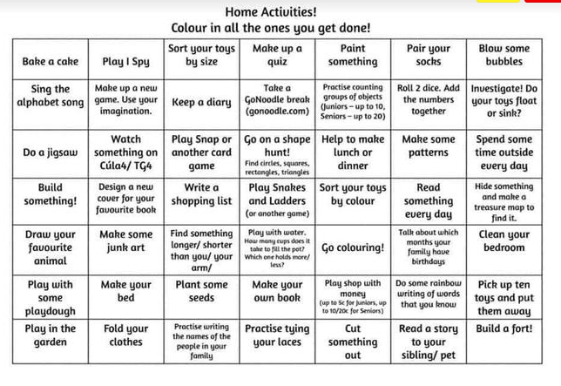

Ideas for you to stay active at home;

Joe Wicks Body Coach

Starting Monday 23rd March I'm going to be hosting a free workout aimed at kids LIVE on my YouTube channel. With the schools closed and with us all spending more time at home, it's more important than ever that we keep moving and stay healthy and positive. Exercise is an amazing tool to help us feel happier, more energised, and more optimistic. The workouts will be fun and suitable for all ages and even adults can get involved. You don't need any equipment, just tune in to my YouTube channel at 9am each morning for a 30-minute, fun workout.

https://www.thebodycoach.com/blog/pe-with-joe-1254.html

Cosmic Kids Yoga
We use Cosmic Kids Yoga at school so the children are familiar with Jamie who takes us in yoga story adventures. Click the link to check it out!
https://m.youtube.com/user/CosmicKidsYoga/featured

Jumpstart Johnny
https://www.jumpstartjonny.co.uk/home

Twinkl
Twinkl are offering free home learning resources and they have many brilliant resources for maths, writing activities and phonics work.
https://www.twinkl.co.uk/search?term=school+closure

Classroom secrets
This website has created free age specific home learning packs for you to access from home. Each pack contains all you’ll need to ensure your children continue to learn during the school closure.
https://classroomsecrets.co.uk/free-home-learning-packs/

General Useful Websites

Activity Village
Lots of free printables and craft ideas.
https://www.activityvillage.co.uk/

Family Learning
Information and links to support home learning.
http://www.familylearning.org.uk/

Cbeebies
Games and activities that include your child’s favourite TV characters.
https://www.bbc.co.uk/cbeebies

Tapestry
Please also remember that you can continue to add anything your child is doing at home to Tapestry with pictures and/or videos. Though the school is closed, staff will continue to work remotely during school hours and we will be checking Tapestry daily for updates on the learning your children have been accessing at home.
https://tapestryjournal.com

Many Thanks for your continued support.

Keep safe and well,

Best wishes,

The EYFS Team.

