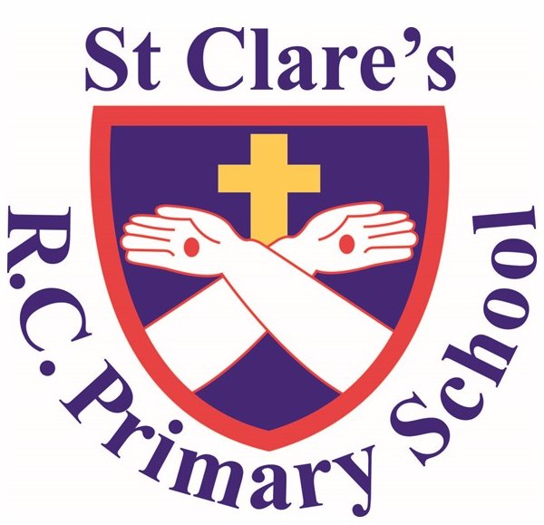

Early Years Foundation Stage Information Booklet

Welcome to St Clare's R.C. Primary School

Our Mission

'Guided by Jesus Christ, our teacher, we journey together, learning to dream, believe and achieve'

We are pleased to welcome you and your child to St Clare’s School. We hope this will be the beginning of an enjoyable and successful time at St Clare's R.C. Primary School and the start of an important partnership between home and school. It is our aim for your child to play and learn in an environment where they feel safe, happy and secure.

The Aims of the Early Years Foundation Stage (EYFS) Team
- To offer a broad and balanced curriculum - this enables children to progress to the best of their ability.
- For children to know that they are valued and important, and will be listened to at all times.
- To develop children's self- esteem and confidence so that they will take pride in their achievements and successes.
- To encourage independence so that all children will take an increasing responsibility for their learning and behaviour, and not be afraid to attempt unfamiliar tasks.
- To prepare children for the move to the Reception and Year 1 classes, ensuring that this is as smooth and stress free as possible.
- To promote equal opportunities and British values throughout EYFS, ensuring that the children are taught to value others in relation to race, culture, religion, class, gender and individual needs.
- To accept that each child is an individual, with individual needs which will be met accordingly.

Starting School
Your child will be starting school soon. There will be lots of new things for them to get used to. They will make new friends and there are lots of things you can do to make starting school easier for them.
- You can encourage your child to play with other children so they get used to being with other children, sharing things, being kind and helpful.
- You could also get another adult to look after your child so they get used to being away from you and being looked after by others.
- Encourage your Child to go to the toilet on their own and to flush the toilet and wash their hands: this is something that you could practise with your child at home. If your child needs support in going to the toilet please make staff aware.
- Help your child to be independent by encouraging them to dress themselves, put their coat on etc.
- Encourage your Child to follow instructions and always be consistent with your expectations of good behaviour.
- Please ensure that your child has had breakfast and is ready for a busy day.

Settling in at St. Clare’s
In order to help your child settle into the routine and for the day to run smoothly, we would like to share the following information with you:

- Please ensure your child arrives at school in good time.
- Children are all different and the settling in period will differ for each child. Please be patient and understand that this transition is a big upheaval for your child. However difficult the first few days may appear, you may be reassured that your child will settle and that our staff will care for your child.
- If you feel you need to talk to the staff about any issues, we are available at the beginning and the end of each session. We will also approach you if we have any news to share about your child.
- At the beginning of each session parents are invited to bring their child into the classroom and you are welcome to stay to help them settle.
- At the end of the session we have a story or discussion time with the children. The classroom doors will be opened at the end of the session in order for you to collect your child. The children will be called one at a time as an adult comes to collect them.

General Information
Current Nursery Hours
Our current hours (2018-19) for Nursery are listed below. Once the hours have been confirmed for next year, you will be informed of these.
Mrs Drury Mrs Barrie
Monday - 8:45am - 3:15pm Wed (PM) 12:15pm -3:15pm
Tuesday - 8:45am - 3:15pm Thursday 8:45am - 3:15pm
Wednesday(AM) — 8:45 - 11:45am Friday - 8:45am - 3:15pm

Reception Hours
8.50am – 3.15pm
The door to each classroom opens at 8.50am. All children must be in school for the register at 9am. If you arrive after the doors have been closed at 9am, then please bring your child through the main entrance.
Pick up: Children can only be picked up by the adults listed on the collection sheet in your pack. If anyone different is picking up then please inform staff, otherwise we will not be able to allow your child to leave until a parent/ guardian can confirm this is ok. Please add any adults to the list who may pick up your child, as it makes the process much easier for everyone.
Behaviour: As part of the learning process, the staff at St Clare's expect good behaviour from all children. We operate a system of positive rewards; children will receive praise, reward stickers and certificates to encourage this good behaviour. If your child misbehaves or is disruptive you will be informed by a member of staff and we will work together to resolve any issues.

Medical Information:
If your child suffers from any medical conditions e.g. Asthma or Epilepsy
or Food allergies it is important that the adults working with your child are made aware of these, and that all medical records are kept up to date. If your child needs to take any medicines during school time, these can be administered by a designated member of staff. An authorisation form must be completed, signed and returned to school. (These are available from the school office or can be downloaded from the school website.)
Parent Help
Parents are encouraged to help within school to support the children and the staff. Parents are sometimes required to help on school trips or with different activities. Your help is much appreciated. If you would like more details, please see a member of staff.

What will my child learn in Nursery and Reception?

- Language and Literacy- Reading, writing and speaking and listening activities.
- Problem solving, reasoning and numeracy- Number work, shape and measure.
- Creative development- Art and Craft activities, dance and music
- Physical development- Outdoor play, fine motor control and developing co-ordination.
- Personal, social and emotional development- understanding what is right and wrong. Respect for their own and others cultures. Developing personal hygiene etc.
- Knowledge and understanding of the world- Investigating objects, investigating how things work, building and construction and information technology etc.
More details about the Foundation Stage Curriculum will be provided at the induction meeting and throughout the year.

Activities your child will be involved in:

Your child will be encouraged to take part in all activities, these include the following:
- Reading books
- Painting pictures
- Arts and crafts
- Singing and making music
- Writing and colouring
- PE and Dance
- Creative play (Sand, water, modelling and role play)
- Attending assemblies
- Imaginative play
- Story time
- Circle time (where the children learn to share and make
friends and learn from one another)
- Outdoor Play
- Number, shape and space
- Baking
- Phonics

At certain times in the year, your child will also have the opportunity to be involved in the following:

- Nativity play
- Christmas party
- Themed days
- Sports day
- Farm trip
- Visits from librarian
- Day trips
- Fun activities e.g. building snowmen in winter.

Starting school is an enormous event in a child's life, for many they are leaving mum, dad or a carer for the first time. Please be reassured that the staff at St Clare's will care for your child and help them to develop. If at any time you have any problems or concerns, please do not hesitate to contact us and let us know, so we can all work together. Telephone school and ask for the Reception/ Nursery staff on 0161 740 4993.

We cannot wait for your child to start with us, so we can begin building a positive relationship with your family.

