Step 1: Use the following link to arrive at the EducationCity website;
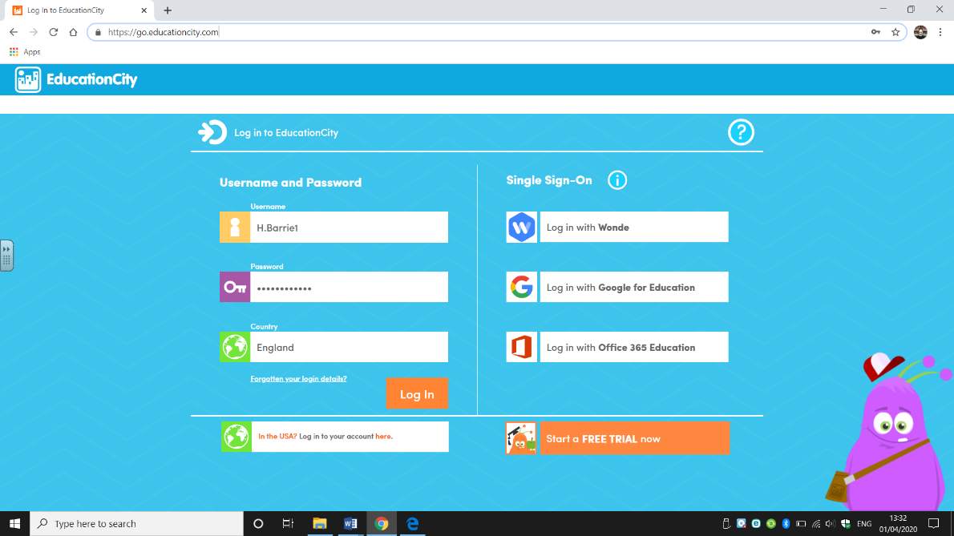
https://go.educationcity.com/

Step 2: When you log on, please select the ‘Classwork’ tab on the left hand side of the page.
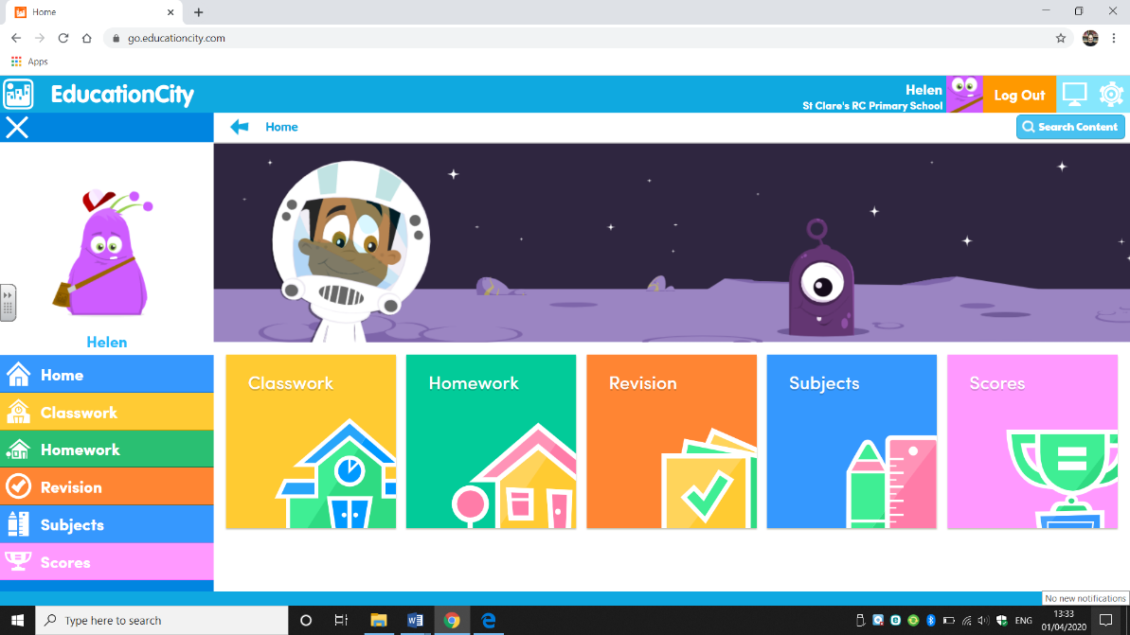

Step 3: This will then bring you to the ‘MyCity’ page where you can select the ‘Nursery Week 3’ folder
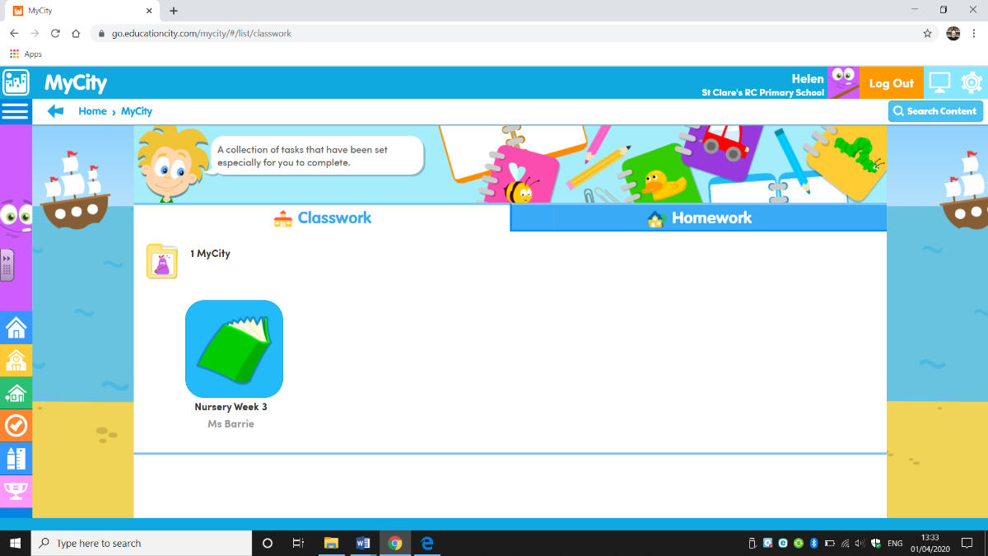

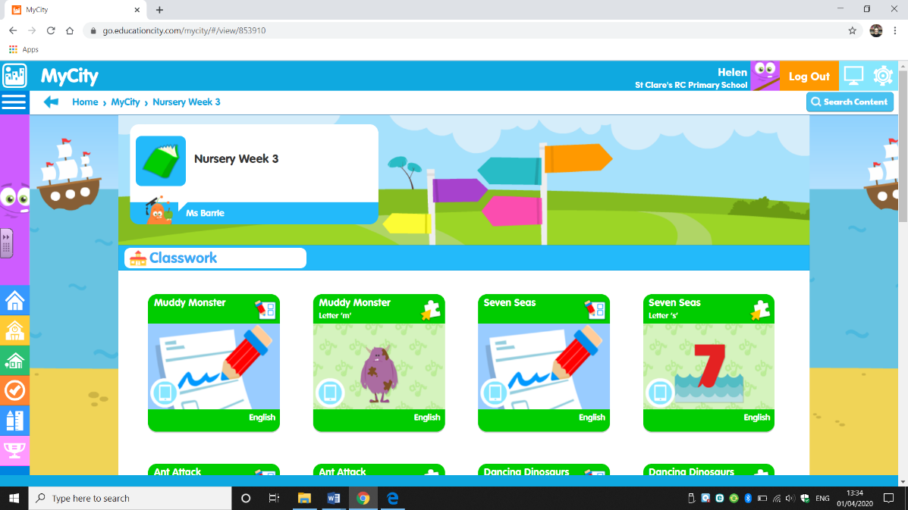
Step 4: Select your activities and enjoy learning!

