Personal, Social & Emotional  - Persevering to reach our goals  - Resolving conflict ourselves  - Learning to recognise the feelings of characters in stories  - Saying what we are good at and what we need to practise  - Taking turns in games and activities without an adult present and offering to share toys  - Communicating to others how they have made them feel  - Making healthy food choices  - Making healthy choices in relation to health and wellbeing | Physical Development  - Using scissors to cut straight and curved lines  - Using tweezers to pick up objects  - Using a knife and fork correctly  - Holding a pencil using a tripod grip  - Throwing a ball/ beanbag at a given target  - Catching smaller items from a longer distance  - Walking, running, climbing, crawling, hopping, jumping and skipping with increasing control | Communication and Language  - Listening to longer stories and explain what is read to them, answering questions  - Understanding ‘how’ and ‘why’ questions  - Retelling short stories  - Reciting rhymes, poems and songs independently  - Using a range of tenses  - Using new vocabulary within conversations and play  - Having longer conversations  - Retelling our own stories  - Speaking using the correct tense  - Articulating our ideas and thoughts in well-formed sentences, using connectives
Literacy  - Creating stories using Tales Toolkit  - Making predictions about what might happen next in a story  - Re-enacting stories during play  - Repeating words and phrases from familiar stories  - Recognising rhyming words  - Recognising the Red Words: I, the, to, no, of, go, my, he, me, for, she, we, was  - Beginning to read simple sentences  - Beginning to read CCVC and CVCC words  - Using finger spaces between words  - Using language such as “Once upon a time…’, ‘Suddenly…’, ‘First/ Next/ Then…’ to create and tell stories  - Beginning to write sentences | ST CLARE’S R.C PRIMARY SCHOOL  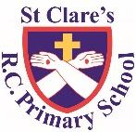  CURRICULUM OVERVIEW  Reception  Spring 2 2022-2023  ‘ Topic: Fee Fi Fo Fum’  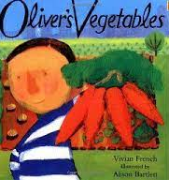  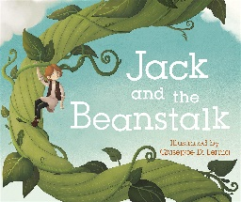  Main texts:  Jack and the Beanstalk, Oliver’s Vegetables  Linked texts: What Did the Tree See? Shhhhh! If I Had a Raptor, The Smartest Giant in Town, Dragon Stew | Maths  - Adding by counting on  - Taking one number away from another using objects  - Adding and subtracting using a number line  - Writing addition and subtraction number sentences  - Learning to say our bonds to 5/10 off by heart  - Representing numbers beyond 10 using a range of resources  - Counting forwards and backwards beyond 10, starting at different points e.g. counting on from 6, counting back from 12  - Looking for patterns with numbers 1-9 and beyond  - Using positional language such as: on top, behind, under, beside, inside
Understanding of the World  - Identifying some trees/ flowers  - Labelling parts of a flower  - Learning what a plant needs to survive  - Drawing animals and in the environment  - Visiting a farm and observing the animals  - Matching baby animals to their parent  - Looking after baby chicks  - Learning about life-cycles of plants & animals | Religious Education  - Recognising growth in nature and discovering the ways in which things grow  - Learning about Lent and how it is a time to grow more like Jesus  - Learning about what happened on Good Friday  - Learning about what happens during Lent and Easter | Expressive Arts and Design  - Drawing flowers and animals in the environment  - Learning Nursery Rhymes  - Deepening our knowledge of apps on the i-pad  - Using technology in different ways  - Creating our own stories using Tales Toolkit  - Creating stories to use in our play
Enrichment Opportunities: | - Visit a garden centre/ park to look at different plants and talk about how they grow | - Visit the free farm at Heaton Park to see the animals

