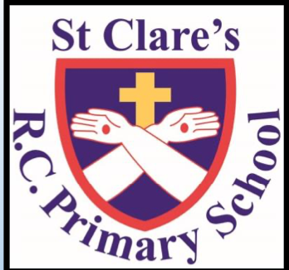



* Games: throwing and catching skills
* Attacking and defending skills

**Art**

* Research and design a Roman mosaic
* Use computer graphics to design tile patterns
* Add texture to the mosaics
* Appreciate ancient art
* Plan and evaluate our own work

**History**

* How the Romans invaded Britain
* The Roman Empire’s growth
* Comparing Britain now and then.
* Comparing how different queens reacted to the Roman invasion
* Investigate the legacy the Romans left in Britain



**I’m a Data Producer**

Can you publish an online poll and then present the results?



Created to Love Others: relationships with family and friends



* How belonging to a group involves rules and promises
* Analysing the promises made at a baptism
* Thinking of ways to help others keep their promises
* Investigating the importance of a baptism
* Researching a saint and thinking about the promises they made



* The energy of fire and wind
* The wonder and power of the Holy Spirit
* The Ascension and the coming of the Holy Spirit
* How to use the energy of and be inspired by the Holy Spirit



The class text will be ‘Iliona, Diary of a Young Slave’ by Richard Platt.



* Non-chronological reports

**Year 3: Summer 1**



Fractions

* Making a whole
* Tenths, counting in tenths, tenths as decimals
* Fractions of a set of objects
* Equivalent fractions
* Comparing fractions
* Ordering fractions
* Adding and subtracting fractions

Time

* O clock, half past, quarter past, quarter to
* Months and years
* Hours in a day
* Telling the time to 5 minutes and 1 minute
* Am and pm
* 24 hour clock
* Finding and comparing durations
* Start and end times
* Measuring time in seconds
* Problem solving with time

