Core Homework:
Hand in 1 task each Monday
15 minutes reading every night
Practise weekly spellings
Practise times tables @ ttrockstars

Spellings
Week 6 –18.5.26
Recap week 1 to 5 spellings for the end of term spelling test.
Week 5 –11.5.26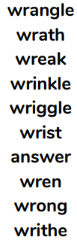

Week 4 – 5.5.26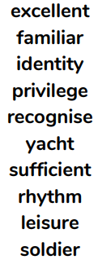

Week 3 – 27.4.26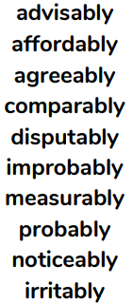

Week 2 -.20.4.26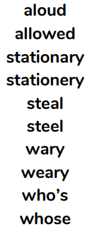

Week 1 – 13.4.26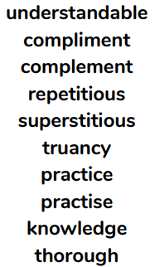

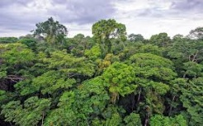
Year 5: Summer 1
Science - Animals including humans Geography - Rainforests
Animal Art
Create a piece of art about your favourite animal. You could sketch, paint, create a collage or make a design using computing. Be creative!
“Did You Know?” Box: Create a box of five or more interesting facts about the human body.

Body Systems Mini-Poster: Choose one body system (circulatory, digestive, or respiratory) and create a mini-poster explaining what it does and why it’s important.

Create a short PowerPoint presentation about one animal of your choice. Your PowerPoint should include:
A title slide with the animal’s name, 3–5 slides explaining: where it lives, what it eats, its life cycle.
Rainforest Poem: Write a short poem using sensory language (what you might see, hear, smell).
Mini Research Task: Why Are Rainforests Important? Write a short paragraph explaining why rainforests matter to the planet (oxygen, biodiversity, climate).
Life Cycle Fact File: Choose an animal (mammal, bird, amphibian, insect, or reptile) and create a short fact file showing its life cycle. Include a simple diagram.

Rainforest Map Task: Draw a world map and mark where the major rainforests are located (Amazon, Congo Basin, Daintree, Borneo).
Indigenous People Snapshot: Choose one rainforest tribe and write 4–5 sentences about their way of life. Creating a mini fact-file.
Make a Wordsearch:
Create your own rainforest wordsearch.
Instructions:
Choose some rainforest words.
Draw a grid.
Hide the words in the grid.
Fill the rest with random letters.
Write the word list underneath.
Keep it neat and fun to solve.
Oracy task: Prepare and deliver a short-spoken presentation persuading the class that one specific rainforest (e.g., the Amazon, Congo Basin, Daintree, Borneo, etc.) is the most important rainforest on Earth and deserves urgent protection
Flashback Challenge: Earth and Space
Create an information page about one idea from our Earth and Space topic. Choose something like the Solar System, the Moon, Day and Night, or the Seasons.
Your page must include:
A title, a short explanation of your chosen idea.
Three key facts or a simple labelled diagram
Keep it neat, clear, and easy for someone else to learn from.

