Core Homework:
Hand in 1 task each Monday
15 minutes reading every night
Practise weekly spellings
Practise times tables @ ttrockstars

Spellings
Week 6 –13.7.26
End of year statutory word list assessment
(List will be sent home separately)

Week 5 –6.7.26
End of year statutory word list assessment
(List will be sent home separately)

Week 4 – 29.6.26
Consolidation of spellings from the previous three weeks.
Week 3 – 22.6.26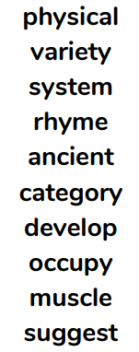

Week 2 -15.6.26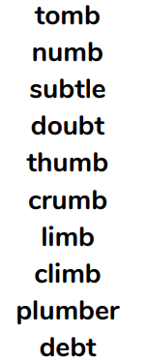

Week 1 – 8.6.26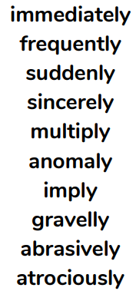

Year 5: Summer 2
Science – Habitats and life cycles History – Crime and Punishment
Wildlife spotters:
Get outside to your local park or woods, hunt for some wildlife and take some photos to share with the class. (Print or email to your teacher).
Persuasive writing: Think about the periods we have been learning about: Anglo-Saxon, Tudor, Stuarts, Victorians etc. Write a paragraph to explain which period of history you would least like to live in and why.
Oracy task: Imagine you are a criminal in Tudor times about to be executed. Prepare your execution speech for the crowd. What would your last words be?
"Good people of London! I stand here today because I broke the law. Do not follow my path, or you will end up just like me!"
Prison rules poster: Design a poster that could be displayed in a Victorian prison listing the very strict rules. You could make the poster look old and authentic by crumpling the edges and using teabags.
Example Rules: 1. Absolute silence at all times. 2. Keep your eyes on the floor. 3. Turn the treadmill for 6 hours. 4. No looking at other prisoners.

Design a map: In Anglo-Saxon times, if a crime was committed, citizens had to raise a "Hue and Cry"—shouting and chasing the criminal. Draw a bird's-eye view map of an imaginary village showing the path a thief took, and mark out where the villagers are standing, shouting, and banging pots to trap them.
The "Wanted" Poster: Design a poster for a historical crime, like stealing a sheep in Anglo-Saxon times or taking something from a Roman bathhouse. Focus on drawing the criminal and listing a punishment appropriate to that time (like paying a Wergild fine to the owner).
Create a creature:
Invent a creature that could survive in two completely different habitats (like the Arctic and the Sahara Desert). Draw it and use arrows to point out its special adaptations—for example, "thick fur that can unzip"
Quiz: Create a quiz for your classmates including 10 questions about animal life cycles.
Shoe box Microclimate: Find a small box or a plastic container. Using only things found in nature (leaves, twigs, stones, soil), construct a miniature model of a specific habitat, such as a damp rainforest floor or a desert hideout

Comic Strip: Choose an animal that undergoes metamorphosis (like a frog or a butterfly). Create a 4-panel comic strip showing its life cycle transformation, but give the creature a dramatic, funny voice in the speech bubbles as it changes (e.g., a caterpillar complaining about having to build its own chrysalis).

Flashback Challenge: Rainforests
Create a poster about protecting the rainforest. Remember a poster is bright and eye-catching and does not include large paragraph of text. Instead, try to include illustrations and key words to explain why rainforests are being destroyed and the importance of protecting them.

