•  •  • • | Personal, Social & Emotional  Making friends  Recognising and responding to feelings e.g. jealous, worried, frightened  Talking about what we are good at  Following rules | Physical Development  - PE: Dance  - Practising different balances  - Throwing and catching large balls  - Using scissors to make snips  - Using large tweezers to pick up objects  - Practising using a knife and fork  - Holding a pencil using a 3 fingered grip | •  •  •  •  • | Communication and Language  Listening and responding to stories  Answering a range of questions, including  ‘how’ and ‘why’ questions  Following instructions with more than two parts  Reciting nursery rhymes and poems  Using a range of tenses
 |  |  | • | Starting conversations with adults & friends
 |  |  | • | Using talk within our play
• •  •  •  •  •  •  •  •  • | Literacy Name writing  Hearing initial sounds  Beginning to use letters to represent what we are writing  Learning the difference between a letter and a word  Recognising letters in the order: masdt inpgo ckub felhr jvyw zx  Orally blend CVC words (words with three sounds)  Segmenting CVC words e.g. bus is made up of bu-s, chop is made up of ch-o-p  Recognising rhyming words  Reading ‘red words’: I, the, to, no, go  Learning letter formation rhymes for each letter | 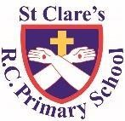  ST CLARE’S R.C PRIMARY SCHOOL  CURRICULUM OVERVIEW  Reception  Autumn 1 2021-22  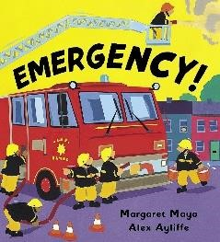  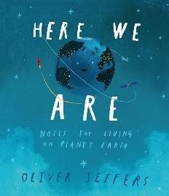  ‘Me and My World’  Main texts: Here We Are, Emergency!  Linked texts: Happy in Our Skin, Along Came a  Different, Amazing, The Family Book, You Choose, Home, Fantastically Great Women Who Changed the World | • •  •  •  •  •  • | Maths  Matching and sorting  Comparing length and height (tall, long, short, longer, shorter, taller, shorter, big, small, little, large, longest, shortest, tallest  Comparing amounts (more, fewer) Comparing capacity (full, empty, nearly full, nearly empty, half-full)  Exploring patterns (large, small, wide, narrow, pattern, what comes next?  repeating, shape names, colour names, small, large) Representing 1,2,3  Composition and comparing 1,2,3
•  •  •  •  •  • | Understanding of the World  Talking about past and present events  Talking about members of our family  Identifying emergency situations and who can help  Learning about Blackley/ Manchester  Naming and exploring senses  Autumnal changes and similarities/ differences between seasons | Religious Education  - Understanding that God loves each and everyone one and knows us all by name  - Understanding the importance of our names  - Exploring the story of Hanukkah  - Learning how we can make good friends  - Understanding that Jesus had good friends  - Understanding what Jesus tells us about friendship | •  •  •  •  •  • • | Expressive Arts and Design  Mixing primary colours to make secondary colours  Drawing bodies with more detail e.g. eyebrows  Using glue sticks and cellotape to join materials together  Charanga Music module: Our World  Naming instruments  Making short dance routines  Learning nursery rhymes, poems and simple songs
 | Enrichment Opportunities | - Class Visit to St Clare’s Church |  | - Visit from police/fire fighters/nurse

