Personal, Social & Emotional  - Making friends  - Recognising and responding to feelings e.g. jealous, worried, frightened  - Talking about what we are good at  - Following rules | Physical Development  - PE: Dance  - Practising different balances  - Throwing and catching large balls  - Using scissors to make snips  - Using large tweezers to pick up objects  - Practising using a knife and fork  - Holding a pencil using a 3 fingered grip | Communication and Language  - Listening and responding to stories  - Answering a range of questions, including ‘how’ and ‘why’ questions  - Following instructions with more than two parts  - Reciting nursery rhymes and poems  - Using a range of tenses  - Starting conversations with adults & friends  - Using talk within our play
Literacy  - Name writing  - Hearing initial sounds  - Beginning to use letters to represent what we are writing  - Learning the difference between a letter and a word  - Recognising letters in the order: masdt inpgo ckub felhr jvyw zx  - Orally blend CVC words (words with three sounds)  - Segmenting CVC words e.g. bus is made up of b-u-s, chop is made up of ch-o-p  - Recognising rhyming words  - Reading ‘red words’: I, the, to, no, go  - Learning letter formation rhymes for each letter | 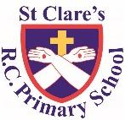  ST CLARE’S R.C PRIMARY SCHOOL  CURRICULUM OVERVIEW  Reception  Autumn 1 2023-24  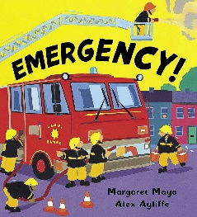  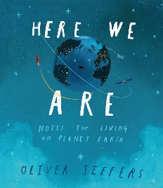  ‘Me and My World’  Main texts:  Here We Are,  Emergency!  Linked texts: Happy in Our Skin, Along Came a Different, Amazing, The Family Book, You Choose, Home, Fantastically Great Women Who Changed the World | Maths  - Matching and sorting  - Comparing length and height (tall, long, short, longer, shorter, taller, shorter, big, small, little, large, longest, shortest, tallest  - Comparing amounts (more, fewer)  - Comparing capacity (full, empty, nearly full, nearly empty, half-full)  - Exploring patterns (large, small, wide, narrow, pattern, what comes next? repeating, shape names, colour names, small, large)  - Representing 1,2,3  - Composition and comparing 1,2,3
Understanding of the World  - Talking about past and present events  - Talking about members of our family  - Identifying emergency situations and who can help  - Learning about Blackley/ Manchester  - Naming and exploring senses  - Autumnal changes and similarities/ differences between seasons  - Using a drawing app on the i-pad | Religious Education  - Understanding that God loves each and everyone one and knows us all by name  - Understanding the importance of our names  - Exploring the story of Hanukkah  - Learning how we can make good friends  - Understanding that Jesus had good friends  - Understanding what Jesus tells us about friendship | Expressive Arts and Design  - Mixing primary colours to make secondary colours  - Drawing bodies with more detail e.g. eyebrows  - Using glue sticks and cellotape to join materials together  - Charanga Music module: Our World  - Naming instruments  - Making short dance routines  - Learning nursery rhymes, poems and simple songs
Enrichment Opportunities:  Trip to the letter box  Visit from police/ fire engine/ nurse  Visit parish church | - Explore your senses by taking it in turns to be blindfolded and see if you can guess the different foods based on how they smell, taste and feel. | - Explore your local area and make a map of where you live.  - Clapping back simple rhythms

