Personal, Social & Emotional  - Beginning to take turns and share toys with others.  - Begin to ask others for help when needed  - Begin to share their likes and dislikes  - Become more independent with personal care e.g. toilet, feeding, dressing | Physical Development  - Kick a large ball  - Begin to move in different ways e.g. skip, hop  - Start to eat independently, using a knife and fork with some support  - Use large tweezers to pick up objects e.g. pom poms | Communication and Language  - Listening and responding to stories  - Enjoy stories and sing a large repertoire of songs/ nursery rhymes  - Following simple instructions  - Communicating our wants and needs to familiar adults  - Beginning to use talk within our play
Literacy  - Continue phase 1 phonics – aspects 3-5  - Listen to stories, anticipating events and joining in with repeated refrains  - Develop fine and gross motor skills for writing through dough disco and squiggle whilst you wiggle.  - Mark making in a variety of ways such as chalk, crayons, sticks in mud/sand etc | St. CLARE’S R.C PRIMARY SCHOOL  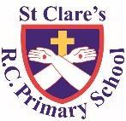  CURRICULUM OVERVIEW  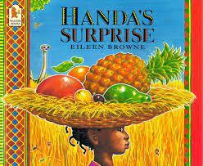  Nursery  Autumn 2 2023  ‘My 5 Senses.’  Main texts: Wow said The Owl and Handa’s Surprise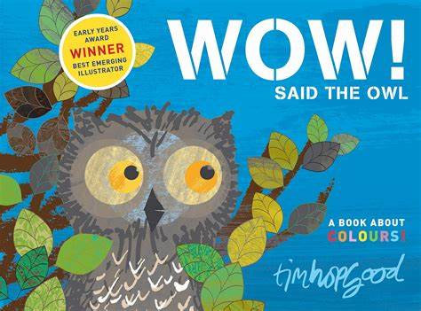  Linked Texts: Nativity Story  Funnybones  We’re Going on a Leaf Hunt | Maths  - Sort objects based on given criteria  - Know there is an order to counting  - Use the language of ‘more’ and ‘lots’  - Use number language in plays  - Join in with number rhymes  - Show an interest in shapes in the environment  - Notice patterns in the environment  - Compare objects according to size
Understanding of the World  - Learning about the 5 Senses – sight, smell, taste, touch, sound. We will explore our senses through a variety of ways by exploring the world around us e.g. touching the inside of a pumpkin, smelling and tasting vegetable soup/fruits of the world etc.  - Exploring various materials and their uses  - Focusing on different Celebrations & places of worship including Diwali, Bonfire night, Remembrance Sunday, Hanukah and Christmas  - Autumn -exploring the seasonal changes through our senses. | Religious Education  Come and see topic – Baptism  Know and understand:  - What is is to welcome and be welcomed  - To know that God loves them  Come and see topic – Advent  Know and understand:  • what a birthday is; waiting for a birthday – Explore  • Advent: looking forward to Christmas, the birthday of Jesus  Other religions - Islam | Expressive Arts and Design  - Autumn Leaf Collage  - Vegetable and fruit printing  - Autumn/Christmas songs  - Remembrance Day poppies  - Firework chalk pictures ( Bonfire night)  - Christmas crafts

