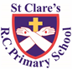

ST CLARE’S R.C.P NEWSLETTER

Our School Mission Statement: Guided by Jesus Christ, our teacher, we journey together learning to dream, believe and achieve. Friday 15th November 2024

Friday 24th November 2023

This week some time has been spent by each class remembering those people who have given their lives for our freedom. They also focused on the role that women played during the wars.

It has also been anti-bullying week, so our school council led assemblies this week on the need for respect which is the focus of the national campaign. The children also had a travelling theatre company who performed a play based on the anti-bullying theme.

In Nursery, our children made a poppy bauble in honour of Remembrance Day. Reception have been looking at celebrations and have on Remembrance Day and Divali. They made Divali lamps. Year 1 have been working hard on their fact families in maths. In art, Year 2 have been learning about William Morris as their work this term will be based on his printing style. After having read ‘Escape from Mount Vesuvius’ Year 3 have written letters to the captain in character for saving them. In science, Year 4 have been investigating sound vibrations using various objects. In English, following their reading of Kensuke’s Kingdom, the children in Year 5 have been writing a set of instructions for how to survive on a desert island. As part of their science topic, Year 6 have been learning about the features and functions of the heart.

**Chapel / prayer garden**

Our chapel / KS2 prayer garden is open each Tuesday morning before school for staff, pupils and parents to come and pray privately. Starting the day with God is beautiful. You are very welcome to pop in from 8.15am each Tuesday.

Luna in Nursery for always being so helpful to her friends and teachers.

David in RS for a great improvement in his pencil control.

Olivia W in 1S for showing great resilience in maths.

Elijah in 2D for working hard in everything.

Nayane in 4O for working hard, being a good team player and always following the school rules.

Lily I in 5K for settling into life at St Clare’s so well.

George in 6S for putting so much effort into all his work.

**Pupil certificates**

**Headteacher awards**

**Caritas Award**

The Caritas is awarded each week in recognition of someone in school who has shown kindness to others by putting love into action. This week the award goes to Isabella H in 2C for noticing someone sat on their own at lunchtime and moving tables, so that they were not alone. How thoughtful and kind!

**Attendance**

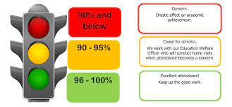

Whole school attendance this week is 94.8%. Best attendance this week is class 1S with 100% which is brilliant. They will have an own clothes day next Friday and each receive a dough-nut.

Most of our pupils arrive in school on time every day. It is vital that your child arrives at school on time every day to maximise your child’s success. We are seeing the same children late several times a week which is not acceptable. We are here to help you with good attendance. If for any reason you are in need of support, please contact Mrs Burgess Hamlett.

**Photographer**

The photographer will be in school on Monday for individual photographs of your children.

**Support**

As a school we are here for both your children and your family. If you are experiencing any difficulties or have any anxieties, please get in touch with Mrs Sylvester for a private conversation. Her email address is [c.sylvester@st-clares.manchester.sch.uk](mailto:c.sylvester@st-clares.manchester.sch.uk) or you can ring the school number or message via the school app. If we are unable to help you, we may be able to refer you to somebody who can.

**Safeguarding**

Safeguarding children is everyone’s responsibility. If you have any concerns regarding the safety of a child, please report it. You are able to refer concerns directly or you can contact one of the Designated Safeguarding Leads in school. Contact details can be found below.

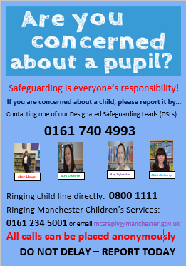

I hope that you have a relaxing, peaceful weekend,

Mrs Howe

**Upcoming dates:**

**Upcoming dates:**

18th November – school individual photographs

**Christmas dates:**

Year 2 carols – Thursday 5th December 2.15pm

Reception carols – Tuesday 10th December 2.15pm

Nursery carols – Wednesday 11th December 2.15pm

Year 1 Christmas play – Thursday 12th December 2.15pm

Year 3 Christmas play – Friday 13th December 9.30am

Music Showcase – Monday 16th December

Whole school Mass – Tuesday 17th December 9.15am

Year 4, 5 and 6 Christmas service – Wednesday 18th December 9.15am

Christmas dinner / jumper day – Wednesday 18th December

Pantomimes in school and party afternoon – Thursday 19th December