ST CLARE’S R.C.P NEWSLETTER
Guided by Jesus Christ, our teacher, we journey together learning to dream, believe and achieve.
Friday 17th November 2023

Our Nursery and Reception children have been excited this week as they have had a nursery rhyme focus. On Wednesday, many of the children (and staff) dressed up as a character from a nursery rhyme – they all looked amazing. Year 1 have been busy writing postcards to the toys from their class text ‘Toys in Space.’ In English, Year 2 wrote a narrative based on ‘Major Glad and Major Dizzy.’ Year 3 have been publishing letters using Microsoft Word on our computers. In science, Year 4 have been investigating which material insulates sound the best. In religion, Year 5 have been looking at the significance of wedding rings in the Sacrament of Marriage. In maths, Year 6 have been adding and subtracting mixed number fractions.
Assembly
This week 6S led our key stage assembly. They focused on World Kindness day which links very nicely with this week’s anti-bullying focus. We have so many kind children at St Clare’s, but they gave us reminders on how we can be kind to each other, to people in our community and in the world. Thank you to everyone who was able to join us for the assembly.
This week was Anti-Bullying week. We did have anti-bullying workshops booked for this week, but unfortunately the provider cancelled due to sickness. All children did attend an anti-bullying assembly where they were reminded of the need to speak out and make some noise if they were ever subject to any incidents of bullying either face to face or online – neither is acceptable and will not be tolerated.
Morning Prayers
Our school chapel is open every Tuesday morning from 8.30 -9.00am for parents (and children) to come into school for some private prayer, some time alone with God or quiet reflection.

Pupil certificates
 | Pupil of the week | Achievement
N | Nancy for being a ray of sunshine and always having a big smile on her face. She is a pleasure to have in the classroom. | Oscar for doing really good listening all week and choosing to do the right thing.
RDM | Olivia W for always being a brilliant role model | Isaac for a brilliant costume for World Nursery Rhyme Week
RS | Hosea for trying his best in everything he does | Oscar for improving so much in his letter writing
Y1D | AJ for making a conscious effort to stay focussed on the carpet. | Hugo for writing lovely sentences using your finger spaces!
Y1G | Ollie for being helpful around the classroom and being a positive role model. | Tomasz for using adjectives in his writing.
Y2C | Harlen for always being a kind member of his table | Therence for trying his hardest on TTRockstars
Y2O | Joy for being an amazing wellbeing buddy! | Jaxon for using his maths knowledge to complete his work independently. Super impressed.
Y3F | Esra for making a great start to her life at St Clare’s, what a wonderful well polite girl. | Alex K for being a superstar in our Spanish lessons, and trying really hard.
Y3H | Olivia W, for fantastic use of the weekly spellings in her writing. | Madeline, for fantastic pace and expression in her reading.
Y4H | Uvie for always behaving perfectly and being the first to stop when I do ‘show me 5.’ | Malik for working really hard in Science.
Y4S | Jeff for always doing the right thing, being respectful to everyone and coming into class ready to learn. | Phaedra for sharing fantastic ideas in English this week.
Y5G | Ella for demonstrating a fantastic attitude to learning this year, confidently sharing ideas and challenging herself in every lesson. | Marcel for excellent work in science this week whilst learning about irreversible changes.
Y5W | Sharon for always trying her best in every subject even when she might find something difficult. | Ryan Mc for his fantastic work converting between improper fractions and mixed numbers.
Y6K | Scarlett for some wonderful ideas in preparation for writing a formal letter based on “The Highwayman” poem. | Jack M for always being an absolute delight to teach and to have as a member of our class.
Y6S | Dylan for showing compassion and care towards a police officer at Crucial Crew, he thanked him and shook his hand for his 39 years of service as he was completing his last few days of his job. | All of 6S for their fantastic class assembly.

Headteachers awards:
Rosie in RDM for working hard on her letter formation.
Olivia in 1D for great responses relating to prayer and liturgy.
Carter S and David in 2C for quick reading of their speedy words.
Daniel in 3F for supporting others with their comprehension.
Nicholas in 5G for sharing his books with the class.
Poppy C in 5W for being mature in her approach to maths.
Holly in 6S for being a good role model to others.
Caritas Award
This week our award goes to Bradley in Year 4 for showing kindness to another child when he was upset. It was so lovely to see this natural act of love and support.
Attendance
Whole school attendance this week is 94%. We aim for 96%, so we are falling short of this target at the moment. If you need any support with attendance matters, please contact school.
The best class for attendance this week is 6K with 98.1% - what great result! They will get a longer playtime as a reward.

Athletics
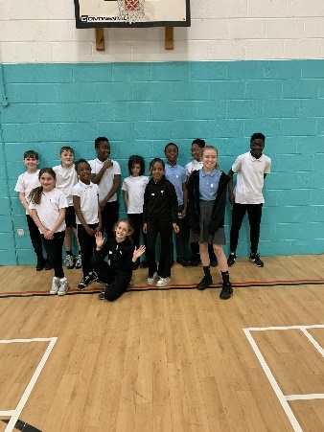
On Thursday evening a group of children from Years 5 and 6 took part in an athletics competition. The children were amazing and we were so proud of them. We have some great athletes who represented the school so well. We had lots of determined pupils who won many races.
RE questionnaire
Your views are very important to us and as a Catholic school your views on the religious nature of our school are even more so. You should have received a simple questionnaire to fill in regarding our religious provision in school which we would be very grateful if you could fill in for us.
Support
We know that families may experience difficult times and difficult situations throughout a year, especially with the cost of living increase. We are here to support you in any way we can - should you need it. If you are experiencing any financial or other worries, please get in touch. If we are unable to help you, we may know of a group who can help. Please contact Mrs Sylvester at school for a discrete conversation if you require some support.
The dark evenings and cold winter months are challenging for everyone, especially those struggling with the cost of living. Support and advice is available from Manchester City Council:
- Manchester’s FREE Cost of Living Advice Line: Support with benefits, help and advice about rent, debt, bills, food support and help to get online (support to access the internet, laptops, phones and data). The advice line is open Monday to Friday 9am to 4.30pm on 0800 023 2692. You can also text on 07860 022 876 or visit manchester.gov.uk/coladvice.
- Manchester’s web page for help with the cost-of-living crisis: A comprehensive guide to the financial help and practical support available to Manchester residents.
- Manchester’s web page for those in financial difficulty: Providing information on housing/council tax, FSM, fuel, travel and cash grants, furniture and white goods.
- Warm Welcome: You can find out more about Warm Welcome spaces near you by accessing the web pages and map at https://www.warmwelcome.uk/.
- Food Banks and Community Grocers : There are both referral and non-referral foodbanks across Manchester. You can find your nearest online at www.trusselltrust.org or www.greatertogethermanchester.org.
- Local help and support: Information about support and advice in your local area.
- Free SIMS/internet data for those eligible.
- Help with internet use, digital inclusion and use of computers in our libraries.
- Governments Help for Households campaign and web pages https://www.gov.uk/cost-of-living for information and support with benefits, income, rent and bills, pension, subsidised travel, childcare and maternity costs.
- Social Tariffs: Low-cost broadband and phone service packages, for those on low incomes. Check the Ofcom website to see if you can switch to a social tariff.
Upcoming dates:
Thursday 30th November – Y2 and Y6 height and weight
Sunday 3rd December – Family Mass at 10.30am
Christmas Dates
Wednesday 6th December – Reception Christmas carols
Friday 8th December – Year 3 Christmas performance
Monday 11th December – Year 2 Christmas carols
Wednesday 13th December – Nursery Christmas carols / Christmas dinner day – wear Christmas jumpers.
Thursday 14th December - Year 1 Christmas performance
15th December – Y4/5/6 Christmas service in church and pantomime afternoon
Monday 18th December – Christmas music showcase
Tuesday 19th December – Whole school Mass 9.15am
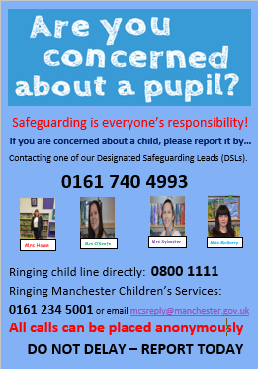

Have a lovely weekend,
Mrs Howe

