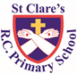
ST CLARE’S R.C.P NEWSLETTER
Our School Mission Statement: Guided by Jesus Christ, our teacher, we journey together learning to dream, believe and achieve. Friday 28th November 2025
Friday 24th November 2023

It was lovely to welcome our Nursery and Reception parents into school on Thursday for an information session on speech and language, followed by a stay and play session. Thank you for attending – I know that your children loved you being in school.
Much of the morning sessions this week have been spent doing assessments in both English and maths.
In Nursery this week the children have read ‘Handa’s Surprise’ and drawing their favourite animal from the story. In Reception, the children enjoyed listening to the story of ‘One Snowy Night’ and identifying places where the animals could hide. In the Willow Room, the children have loved creating hedgehogs using leaves. There is a definite animal theme in school this week as Year 1 have been writing acrostic poems about animals. In English, Year 2 have been identifying the subject and verbs within sentences. Meanwhile, Year 3 have been writing reports about earthquakes. In art, Year 4 have created beautiful landscapes using oil pastels in the style of Peter Hill. Year 5 have been busy writing a setting description for a desert island which they can use in their adventure narrative story. As part of their RE topic, Year 6 have been learning about the story of David and Goliath to help them understand that any challenge can be overcome with God at your side.

Assembly

“Jesus, remember me when you come into your Kingdom.” And He said to him, “Truly, I say to you, today you will be with me in paradise.” Luke 23:43

Our assembly this week focused on Christ the King. The feast that marks the end of the Church’s liturgical year. We heard the Scripture reading from St Luke’s Gospel where we recognised Jesus as the King of Kings and Lord of Lords. The good thief, on the cross besides Jesus, knew this and his faith saved him. Through the gift of faith, one day we too can be with Jesus in paradise.

Come and pray

Our chapel / KS2 prayer garden is open each Tuesday morning before school for staff, pupils and parents to come and pray privately. Starting the day with God is a

beautiful way to begin the morning. You are very welcome to pop in from 8.15am each Tuesday.

Advent
This Sunday marks the beginning of the season of Advent. – the time when we wait and prepare for Jesus’s birth. During Advent we will again be selling raffle tickets to raise money for charities. Usually the money is split between CAFOD and Caritas. The Mini Clares will decide which charity the money raised will support.
Advent packs will also be sent home with your children for you to come together to pray during this special season. Please return the pack to school the next day to ensure all families get the chance to use them.
We are also asking you to create Teeny Tiny Nativity scenes again with your child at home for us to display in classes.

Pupil certificates
 | Pupil of the week | Achievement
N | Vincent for being a wonderful role model within Nursery | Zanna for recalling ‘Handa’s Surprise’ so well and drawing a wonderful picture of the giraffe in the story!
RDM | D'Jamela for always working hard and setting a great example. | Raya for super role play about the story “One Snowy Night.
RS | Ayoyimika for always answering questions on the carpet with enthusiasm | Jayce for writing his name with lovely letter formation
Y1G | Luke for being a confident independent learner. | Molly Mae for doing everything with a smile.
Y1S | Zion for fantastic singing and acting in our nativity practice. | Joelvy for brilliant poetry skills in English this week.
Y2C | Tobi for always being ready to learn | Paige for her beautiful letter formation in English
Y2D | Blake for always being ready to learn and setting a good example to others. | Patrick for amazing reading during assessment week!
Y3F | Olivia K for doing an amazing castle in DT, making sure she included all the features. | Fabian for really trying with his handwriting
Y3H | Ollie for making a fantastic castle in DT. He used excellent cutting and fixing skills. | Patrick for excellent vaulting from apparatus in PE.
Y4H | Curtis for always leading our class prayers clearly and confidently! | Fabian for making great progress in reading!
Y4O | Vanna for having a wonderful first week at St Clares | Grace for creating fantastic landscape this week based on Peter Hill in art.
Y5K | Nylah for always being ready to learn and for being a great role model to her classmates. | Esra, for some great design ideas for her pop up book in DT.
Y5L | Leah for making a fantastic effort in her subjects assessments this week. | Luca for trying really hard to stay focused and engaged this week.
Y6S | Alexis for trying very hard in her assessments this week and not giving up. | Yoel for his superb work and vocabulary use during his independent writing this week.
Y6W | Henry for having a great attitude towards his learning and his assessments showing a desire to learn and improve. | Dolcie for her fantastic results this assessment week, showing great progress

Headteacher Awards
Myla Mae in RDM for being such a kind friend.
Gabriel in 1S for always working hard.
Ellion in 4O for overcoming his fear when swimming.
Skylar in 6S for a great attitude to work, always doing her best and good improvement.

Caritas appeal
During the season of Advent, our Mini Clares have decided that they would like to support the Caritas Advent toiletries appeal. They have therefore arranged an own clothes day on Friday 5th December in which the children will be asked to bring toiletries which will be donated to Caritas.
Obviously, any item is gratefully received, but in order to be able to send a selection of items we request that children in each class send in the following items:
Nursery - toothbrush
Reception - toothpaste
Year 1 - shower gel
Year 2 - deodorant
Year 3 - shaving gel / foam
Year 4 - toothbrush
Year 5 - toothpaste
Year 6 - shower gel

Attendance
Overall whole school attendance this week is 93.4%. The best class this week for attendance for the second week running is 1S with 98%. They will have a longer break. Well done to them!

School doors open at 8.40am to give the children time to take off their coats and be ready at their desks for an 8.45am start. The doors close promptly at 8.45am.
Under the UN Convention on the Rights of the Child (UNCRC), Article 29, children have the right to an education. If you are experiencing any difficulties or require any additional support with attendance or punctuality, please contact our Attendance Officer, Mrs Burgess Hamlett.

Athletics
This week a selection of boys and girls from Upper Key Stage 2 took part in an indoor athletics competition. The children really enjoyed representing the school and competing against others. Thanks to Miss McGarry and Mrs Heaps for taking the children.
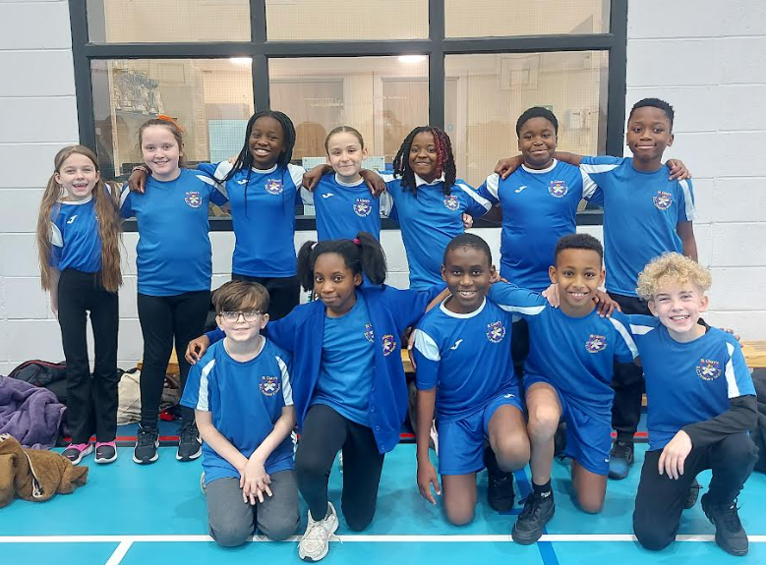

School nurse coffee morning
The school nurse will be in school on Tuesday 2nd December from 8.45am. She will be sharing information and guidance on head lice, continence, sleep patterns, oral health and hygiene. Please come along, enjoy a hot drink and ask any questions that you may have.

Uniform
If you are in need of some items of uniform, please contact the office. We have a supply of items kindly donated by families whose children have outgrown them.

Support
As a school we are here for both your children and your family. If you are experiencing any difficulties or have any anxieties, please get in touch with Mrs Sylvester for a private conversation. Her email address is c.sylvester@st-clares.manchester.sch.uk or you can ring the school number or message via the school app. If we are unable to help you, we may be able to refer you to somebody who can.

Safeguarding
Safeguarding children is everyone’s responsibility. If you have any concerns regarding the safety of a child, please report it. You are able to refer concerns directly to children’s services. The contact details for them is particularly important during the summer holidays when some children may be susceptible to more harm and neglect.

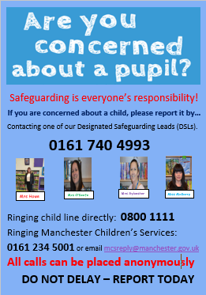

Wishing you all a peaceful weekend,
Mrs Howe

Upcoming dates
2nd December – school nurse coffee morning 8.45am
9th December – SEND coffee morning 8.45am
14th December – Family Mass 10.30am
Christmas Dates
Reception Carols – Tuesday 9th December 2.15pm
Y1 Nativity – Thursday 11th December 2.15pm
Nursery carols – Wednesday 10th December 2.15pm

Y3 Nativity – Friday 12th December 9.15am

Y4, 5, 6 Carole service in church – Wednesday 17th December 9.15am

Music Showcase – Monday 15th December 9.15am

Y2 carols – Monday 15th December 2.40pm

Music showcase – Monday 15th December 9.15am

Christmas Mass (whole school) – Tuesday 16th December
9.00am

Christmas dinner day – Wednesday 17th December

Panto / party day – Thursday 18th December

School closes for Christmas – Friday 19th December 1.15pm

The weekly newsletter is also available on our school website Newsletters
A Prayer of Hope


