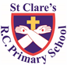

ST CLARE’S R.C.P NEWSLETTER

Our School Mission Statement: Guided by Jesus Christ, our teacher, we journey together learning to dream, believe and achieve. Friday 13th December 2024

Friday 24th November 2023

It has been a busy week of Christmas performances this week. Our Reception children and Nursery children sang for their parents which was beautiful. Both our Year 1 and our Year 3 classes performed their Christmas plays. Their preparations paid off as they were all amazing. I hope you enjoyed sharing the experiences with your children. They were so confident, spoke clearly, sang beautifully and oozed enthusiasm. They sparkled the joy of Christmas in the room. Today was own clothes day in aid of CARITAS. Once again, thank you for your very generous donations. We will be delivering all the items to the CARITAS Lalley Centre in Collyhurst.

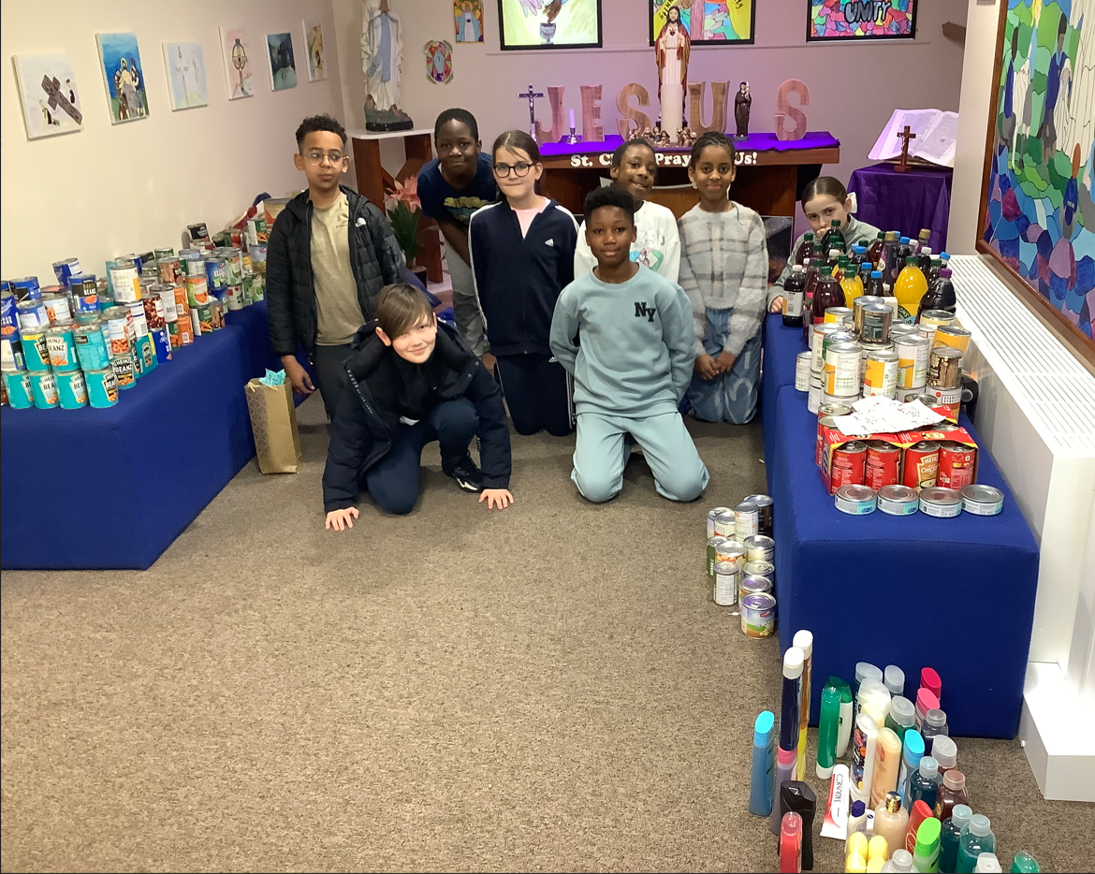

Mission Christmas arrived at school on Wednesday with all the gifts delivered by the GM Fire Service. Our KS2 children were very excited to see the engines arrive. Year 3 and Year 5 had the chance to come and meet the firemen and sing some Christmas songs. It was great fun!

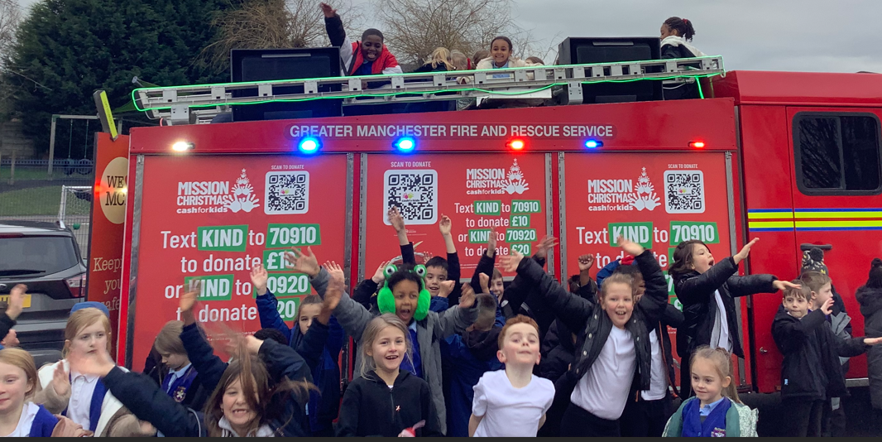

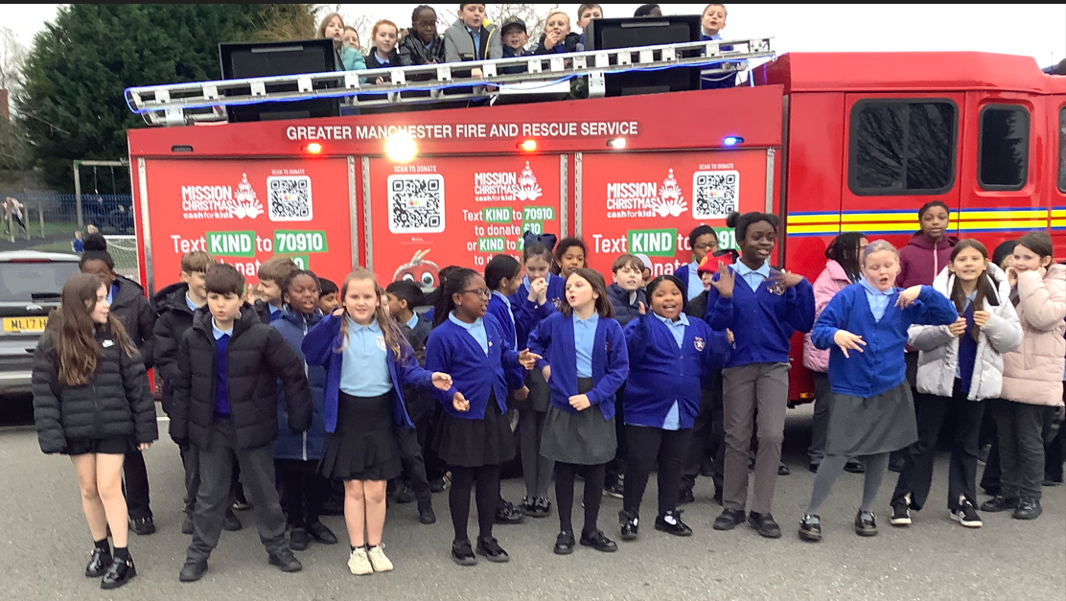

We have another busy week scheduled next week starting off on **Monday with some surprise visitors on the playground. Do not be late for school!** We will also be hosting the music showcase where our talented musicians get to show off their skills. We have our whole school Mass on Tuesday at 9.00am. You are very welcome to join us. On Wednesday morning our children in Years 4,5 and 6 will perform their Christmas service in church. As we have not sold tickets for this event, we ask that you kindly donate a food item for the parish foodbank. It is also Christmas dinner day. On Thursday, we have two pantomime performances of Snow White followed by a party afternoon. The children may wear their own (sensible) clothes on Thursday.

Despite all of this, learning has taken place this week. In Nursery, the children have been learning about the Nativity Story. In maths, Reception have been matching numerals to quantities. Year 1 have been bust making Christingles. In English, Year 3 have written a newspaper report about the eruption of Mount Vesuvius. Meanwhile, Year 4 have been writing free verse poetry. In maths, Year 5 have been doing some tricky calculations involving adding and subtracting mixed number fractions. In science, Year 6 (along with their parents) have dissected pigs’ hearts.

**Assembly**



This week our Mini Clares led our assembly focusing on how Christmas is celebrated around the world. It was good to hear what we have in common with other countries around the world and how we differ in our celebrations.

**Christmas Mass St Clare’s**

I am sure that many of you will want to mark the Holy Season by attending Mass in church.

There will be a Christmas Eve Vigil Mass on 24th December at 8 pm. On Christmas day, Masses will be at 8 am and 10:30 am.

**Reconciliation**

This week our children on the Sacramental Programme took another step in their faith journey as they received the Sacrament of Reconciliation. Thank you to our parish team for preparing the children so well for this important event.

**Ordination**

On Saturday, Brother Peter is being ordained in church at 11am. Obviously, this is a very special occasion and we are honoured that some of our choir and Mini-Clares have been invited along to sing at the service which will be led by Bishop John.

**Advent Prayer Packs**

The Mini-Clares have prepared prayer packs for you to share as a family at home. During Advent, we need to remind each other of the true meaning of Christmas – the celebration of the birth of our Saviour, Jesus Christ. We aim for each family to receive the pack, but it does need to be returned to school the next day for this to happen. Our Mini-Clares hope that you take the opportunity to pray together as a family.

**Teeny Tiny Nativity**

We are loving seeing the Teeny Tiny Nativities coming into school which you have made with your children. We do not expect you to buy anything in order to do so, just use the empty boxes etc that you have lying around at home. The children love making things at home and bringing them into school to share. Any nativities sent into school, will be displayed around the class / school. Have fun creating!

**CAFOD**

We are selling raffle tickets for Christmas hampers in the run up to Christmas in aid of CAFOD. Tickets will cost £1 each. We will draw the winning tickets next week and let you know the winners via the school app. Thank you for supporting the raffle.

**Chapel / prayer garden**

Our chapel / KS2 prayer garden is open each Tuesday morning before school for staff, pupils and parents to come and pray privately. Starting the day with God is beautiful. You are very welcome to pop in from 8.15am each Tuesday.

**Pupil certificates**

|  |  |  |
| --- | --- | --- |
|  | Pupil of the week | Achievement |
| N | Daniel for trying really hard during our Christmas show! | Rosie for using a loud and clear voice during our Christmas show! |
| RDM | Luke for wonderful and confident speaking in our nativity! | Oscar for wonderful and confident speaking in our nativity! |
| RS | Heidi-May for being an absolute superstar in our Christmas show! | Anastazja for getting better at blending in phonics! |
| Y1G | All of 1G for their brilliant performance of Boogie Woogie Nativity! | All of 1G for their brilliant performance of Boogie Woogie Nativity! |
| Y1S | All of 1S for their amazing performance of Boogie Woogie Nativity! | Alba D for brilliant work looking at patterns in maths. |
| Y2C | Phoenix for always being a smiley member of our class | Ollie for amazing shape knowledge |
| Y2D | Macey for always trying your best in every lesson. | Maggie for writing a lovely letter, using capital letters, full stops and question marks correctly. |
| Y3F | Grace for being amazing during her solo singing part in the nativity. | Mia for writing a wonderful diary entry in RE as if she was Mary. |
| Y3H | Kael for a lovely piece of work in RE about scripture | Rehoboth for beginning to understand the process for the written method of multiplication. |
| Y4H | Denver for behaving beautifully and having lovely manners. | Amelia S for some lovely RE work, she is very thoughtful with her answers! |
| Y4O | Hillary for being extremely helpful and organised in class! | Maria for an interesting non-chronological report about guitars! |
| Y5G | Hepzibah for being a positive influence and giving it her all no matter what. | Jack for showing his extensive knowledge during science thai week! |
| Y5K | Lilly for always working her hardest, never causing a fuss and for being a pleasure to have in 5K! | Isla for planning and writing an absolutely wonderful narrative! |
| Y6S | Kayleb for great behaviour this week, he has been focussed and on task in every lesson. | Sam for fantastic engagement during our pig heart dissection in science. |
| Y6W | Miley for always having a fantastic attitude towards her learning, always wanting to improve. | Josh for his fantastic effort with his accelerated reading this week, quizzing on books with over 40,000 words. |

**Headteacher awards**

Zuzanna in Nursery for growing in confidence.

Daisy in RDM for great progress in phonics.

Rory in 1G for great enthusiasm in the play rehearsals.

Indiya for amazing singing and dancing in the play.

Olivia K in 4H for leading by example.

Alexis in 5G for working so hard on fractions.

Matiyar in 6W for good engagement in the dissecting of the pig heart.

**Caritas Award**

The Caritas is awarded each week in recognition of someone in school who has shown kindness to others by putting love into action. This week the award goes to Olivia C in Year 3 for sending Christmas presents to hospital patients. How very kind!

**Attendance**

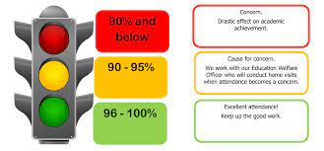

Whole school attendance this week is 94.99%. This week 77 children were late 116 times. Some are just literally a minute or two late, but it is still late. Please ensure that you leave the house early enough to arrive at school for 8.40am. Your children do miss valuable learning time. Should you need any advice or support, please contact Mrs Burgess Hamlett, our Attendance Officer.

The best class for attendance this week is 3F with 97.4% - well done to them! They will receive a longer break time next week.

**Support**

As a school we are here for both your children and your family. If you are experiencing any difficulties or have any anxieties, please get in touch with Mrs Sylvester for a private conversation. Her email address is [c.sylvester@st-clares.manchester.sch.uk](mailto:c.sylvester@st-clares.manchester.sch.uk) or you can ring the school number or message via the school app. If we are unable to help you, we may be able to refer you to somebody who can.

If you are struggling to buy food at the moment, please contact school. We do not want any families to go without food. We do have contact with some food banks who may be able to offer support.

**Safeguarding**

Safeguarding children is everyone’s responsibility. If you have any concerns regarding the safety of a child, please report it. You are able to refer concerns directly or you can contact one of the Designated Safeguarding Leads in school. Contact details can be found below.

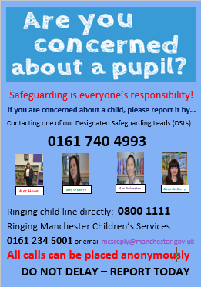

Thank you for all your support this week. Thank you for your attendance at our concerts. Thank you for buying raffle tickets. Thank you for your food donations. St Clare’s is a wonderful place to be!

Have a lovely weekend,

Mrs Howe

**Christmas dates:**

***You do not require tickets for the Years 4, 5 and 6 Christmas Service in church, but we do ask, if you are able, to donate a tin for the parish foodbank.***

Music Showcase – Monday 16th December

Whole school Mass – Tuesday 17th December 9.15am

Year 4, 5 and 6 Christmas service – Wednesday 18th December 9.15am

Christmas dinner / jumper day – Wednesday 18th December

Pantomimes in school and party afternoon – Thursday 19th December (Own clothes day)