ST CLARE’S R.C.P NEWSLETTER
Our School Mission Statement: Guided by Jesus Christ, our teacher, we journey together learning to dream, believe and achieve. Friday 19th December 2025
Friday 24th November 2023




We have had a very busy few weeks in school celebrating Advent and the upcoming Christmas time. The children have been amazing and have enjoyed the many events and I thank you all for your support and attendance at our celebrations.
We have tried to focus the children on the reason for the Christmas season and to ensure that Christ is not forgotten as we’ eat, drink and be merry!’
This week, the toiletries that you very kindly donated were taken to the Lalley Centre for CARITAS. They were truly overwhelmed with your generosity and had very little toiletries left, so were extremely grateful. Extending love and care to others is part of our mission as Catholics.

On Monday, our talented musicians and singers performed for the school and parents in our traditional music showcase. We do have some very talented children. We had several groups of drummers, a small recorder group, the choir and each year group sang a Christmas carol for us. It was a wonderful show!

On Tuesday, Father Giles led our Christmas Mass in church. It was lovely to share this special occasion with the parish community, our governors and yourselves – thank you for joining us.
On Wednesday, Years 4, 5 and 6 led the Christmas service in church where they sang, read from Scripture and shared poems linked to the Christmas story. It was wonderful!
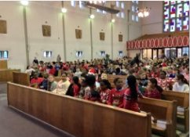
They children also enjoyed their Christmas dinner where the Grinch made a fleeting appearance.


Thursday was panto and party day which were a great success.
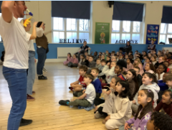
Father Christmas and the Naughty Elf also visited each class bearing a gift for each child.
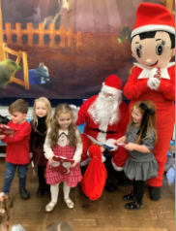
There have been so many wonderful experiences for the children which we know they have enjoyed. They really are such special children that all the staff work hard to ensure they experience the best of everything. You are raising some truly remarkable human beings.

The raffle was as popular as ever with £756.64 being raised for charity. Thank you all so much for your generosity in supporting this and special thanks to Tricia Pollard for her very kind donations.
The winners of the raffle were:
1. Diana in 2D
2. Thea in 1S
3. Ella in 2D
4. Reggie in 1S
5. Grace in 4O
We also raised £533 in ticket sales. This money is used each year to pay for costumes and we are going to buy microphones for our key stage 1 building, so that they are readily available for them to use instead of sharing between the two buildings. Again, thank you for your support in enabling us to do this.

Come and pray
Our chapel / KS2 prayer garden is open each Tuesday morning before school for staff, pupils and

parents to come and pray privately. Starting the day with God is a
beautiful way to begin the morning. You are very welcome to pop in from 8.15am each Tuesday.

Attendance
Overall whole school attendance this week is 92.9%. We have been hit with colds, temperatures and sickness over the last couple of weeks. Let’s hope that everyone is on the road to recovery now. The best class this week for attendance is 3H with 97%. They will have a longer break. Well done to them!

School doors open at 8.40am to give the children time to take off their coats and be ready at their desks for an 8.45am start. The doors close promptly at 8.45am.
Under the UN Convention on the Rights of the Child (UNCRC), Article 29, children have the right to an education. If you are experiencing any difficulties or require any additional support with attendance or punctuality, please contact our Attendance Officer, Mrs Burgess Hamlett.

Illness advice
There are many bugs and illnesses around at the moment. If you would like some guidance please see https://ukhsa.blog.gov.uk/2024/09/04/a-parents-guide-to-keeping-kids-healthy-this-school-year/

Uniform
If you are in need of some items of uniform, please contact the office. We have a supply of items kindly donated by families whose children have outgrown them.

Support
As a school we are here for both your children and your family. If you are experiencing any difficulties or have any anxieties, please get in touch with Mrs Sylvester for a private conversation. Her email address is c.sylvester@st-clares.manchester.sch.uk or you can ring the school number or message via the school app. If we are unable to help you, we may be able to refer you to somebody who can.

Safeguarding
Safeguarding children is everyone’s responsibility. Some children are more susceptible to harm during holiday periods, so please be vigilant. If you have any concerns regarding the safety of a child, please report it. You are able to refer concerns directly to children’s services. The contact details for them is particularly important during the Christmas holidays when some children may be susceptible to more harm and neglect.

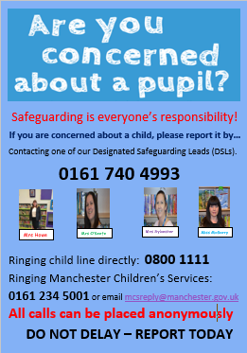

Whilst many families are busy celebrating during the festive season, there are people who are struggling in one way or another. We pray that God will be with them and give them the strength they need and the knowledge that they are loved. Below are some contact numbers for anyone who may need some support over the next two weeks:
- Samaritans: Offers confidential emotional support for anyone in distress, open 24/7, 365 days a year. Call for free on 116 123 or email jo@samaritans.org.
- Shout: A free, confidential 24/7 text messaging service if you're in a crisis and need immediate help. Text "SHOUT" to 85258.
- NHS 111: For non-emergency medical or urgent mental health needs (select option 2 in England), this service operates 24/7. Call 111 or visit 111.nhs.uk for England or 111.wales.nhs.uk for Wales.
- Campaign Against Living Miserably (CALM): Provides a helpline and webchat for anyone affected by suicide or suicidal thoughts, open 5pm to midnight every day. Call 0800 58 58 58.
- Papyrus HOPELINEUK: Confidential support and advice for young people (under 35) struggling with thoughts of suicide, or people worried about a young person. Call 0800 068 41 41 (open 9am-midnight, every day of the year).
- National Domestic Abuse Helpline: A free, 24-hour helpline for women experiencing domestic abuse and violence, run by Refuge. Call 0808 2000 247.
- Childline: Offers free, confidential advice and support for children and young people under 19, open 24/7. Call 0800 1111 (the number won't show up on a phone bill).

Over the Christmas holiday period myself, the staff, the governors and our pupils wish you the hope, peace, joy and love of Christ.
We re-open on Tuesday 6th January 2026.
Mrs Howe

Upcoming dates
Monday 5th January – closed
Tuesday 6th January – whole school Mass – Epiphany
Sunday 11th January – Family Mass 10.30am
14th and 15th January – Y3 reconciliation retreat in school.
Saturday 17th January – Reconciliation rehearsal in church 10am
21st and 22nd January – Reconciliation in church 6pm
5th February – Young Voices (choir)

The weekly newsletter is also available on our school website Newsletters

Advent prayers



A prayer for hope
"God of hope, be with us on our Advent journey. We remember Mary and Joseph and give thanks for their faithfulness and courage in stepping out into the unknown in the strength of your Spirit".

A prayer for peace
"Lord, we pray that you would light up our lives with your coming. As we await Jesus, we pray for peace in our world, as we know that Jesus, the Prince of Peace, is the answer".
A prayer for joy.
Loving Father, You sent Your Son to bring joy to the world. As we await His coming, fill our hearts with gladness. Help us to rejoice in Your presence, to share joy with others, and to spread the good news of salvation. Amen
A prayer for love
God of endless love, You chose to enter our world as a child: vulnerable and small. Help us to be vulnerable, ready to open our hearts and become vessels of Your light and love, so that we, in turn, may bring our sisters and brothers who do not know You, into Your embrace. Through Christ, Our Lord.



