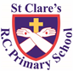

ST CLARE’S R.C.P NEWSLETTER

Our School Mission Statement: Guided by Jesus Christ, our teacher, we journey together learning to dream, believe and achieve. Friday 20th December 2024

Friday 24th November 2023

It is hard to believe that we are fast approaching the end of 2024 and this will be the final newsletter of the year.

It has been another jam packed week at St Clare’s.

The children were surprised to see 2 reindeers on the playground on Monday morning. Each class had the opportunity to go and meet Donner and Dasher.

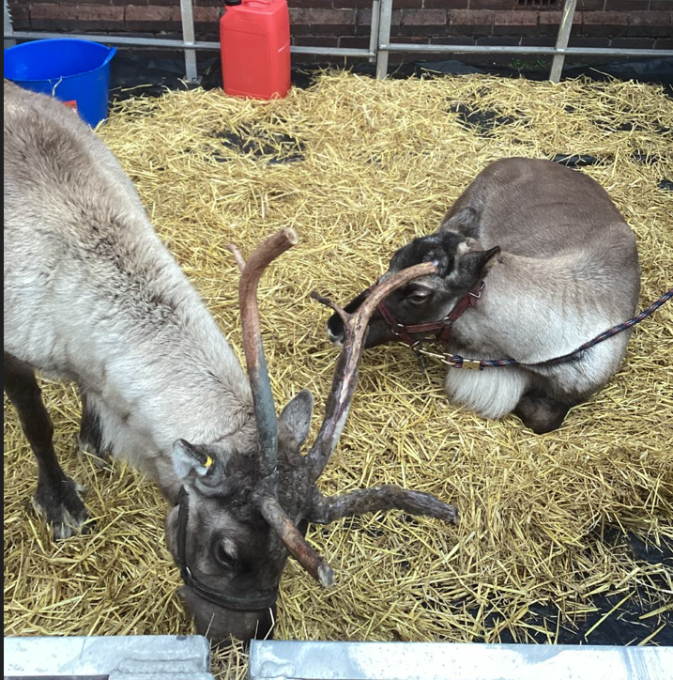

On Tuesday morning, we celebrated our whole school Christmas Mass together in church with Father Giles. This was another beautiful occasion. In the afternoon, our choir performed some songs for our younger children which was uplifting.

On Wednesday morning, Years 4, 5 and 6 led a beautiful Christmas service in church which parents were invited to. The children read passages from Scripture, read poems and sang a host of Christmas carols. It was a very special service. This was followed by a very tasty Christmas dinner prepared by our wonderful kitchen staff. It was also treat afternoon for the winning Saint in our token reward.

A selection of our Year 5 and Year 6 pupils got to spend the day at City in the Community’s Winter Wonderland. They had great fun (at the home of the premier league champions) on lots of inflatables. They even got some presents.

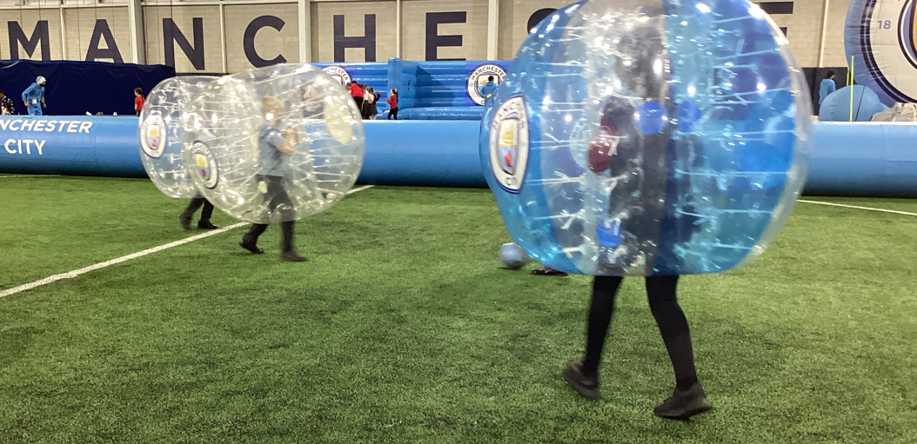

Thursday was another busy day with two pantomime shows for each key stage. All the children watched Snow White. After the excitement of the morning, the children had a party afternoon.

Friday finished with an assembly focused on the story of Papa Panov who was waiting for Jesus to enter his life. He eventually realised that when we welcomed and helped others, Jesus was most definitely alive in his life.

That is what we all hope for this year – that we see the gift of Jesus in each other.

**Christmas Mass St Clare’s**

I am sure that many of you will want to mark the Holy Season by attending Mass in church.

There will be a Christmas Eve Vigil Mass on 24th December at 8 pm. On Christmas day, Masses will be at 8 am and 10:30 am.

**Ordination**

Brother Peter and the parish community were delighted that children from St Clare’s attended his ordination on Saturday to sing as a choir. Friar Peter has offered up Mass for the year in recognition of the part the children played in this momentous occasion in his life.

**Advent Prayer Packs**

The Mini Clares’ hope that you have enjoyed praying together as a family during the season of Advent. If you have not already done so, please return the packs back to school.

**CAFOD**

Thank you to everyone who bought raffle tickets in the hope of winning one of the four hampers. We have raised an amazing £635 for CAFOD – thank you all so much.

The winners were:

1st prize - Jack K in 5G yellow ticket number 160

2nd prize - Dianna in 1G blue ticket number 85

3rd prize - Mia S in 3F pink ticket number 62

4th prize - Phoebe W in 5G yellow ticket number 2

**Chapel / prayer garden**

Our chapel / KS2 prayer garden is open each Tuesday morning before school for staff, pupils and parents to come and pray privately. Starting the day with God is beautiful. You are very welcome to pop in from 8.15am each Tuesday.

**Caritas Award**

The Caritas is awarded each week in recognition of someone in school who has shown kindness to others by putting love into action. This week the award goes to Ollie D in 6S for including a child with a disability in his game at City in the Community Winter Wonderland. The other school were touched by Ollie’s kindness. How beautiful!

**Attendance**

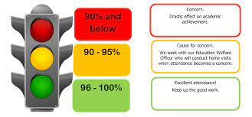

Whole school attendance this week is 94.8%. This week 68 children were late 94 times which is a reduction on last week Should you need any advice or support, please contact Mrs Burgess Hamlett, our Attendance Officer.

The best class for attendance this week is 2D with 98% - well done to them! They will receive a longer break time next week.

**Support**

As a school we are here for both your children and your family. If you are experiencing any difficulties or have any anxieties, please get in touch with Mrs Sylvester for a private conversation. Her email address is [c.sylvester@st-clares.manchester.sch.uk](mailto:c.sylvester@st-clares.manchester.sch.uk) or you can ring the school number or message via the school app. If we are unable to help you, we may be able to refer you to somebody who can.

If you are struggling to buy food at the moment, please contact school. We do not want any families to go without food. We do have contact with some food banks who may be able to offer support.

**Safeguarding**

Christmas time is a very difficult time for many families and when police see a significant increase in alcohol misuse and domestic violence.

Please remember that safeguarding children is everyone’s responsibility. If you have any concerns regarding the safety of a child, please report it. You are able to refer concerns directly or you can contact one of the Designated Safeguarding Leads in school. Contact details can be found below.

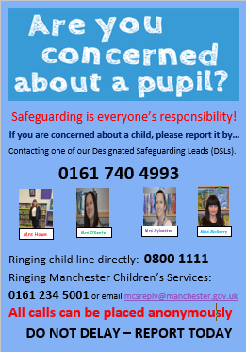

Below are some useful sites / links that you may find useful:

**Online safety**  
[Thinkuknow](https://kdsafeguarding.us13.list-manage.com/track/click?u=6615dc6ff0c643c66e2bd99c7&id=bf22e9abde&e=86aeebb9a4) , [NSPCC](https://kdsafeguarding.us13.list-manage.com/track/click?u=6615dc6ff0c643c66e2bd99c7&id=9750bdfad0&e=86aeebb9a4) and [UK Safer Internet Centre](https://kdsafeguarding.us13.list-manage.com/track/click?u=6615dc6ff0c643c66e2bd99c7&id=da54ab237c&e=86aeebb9a4) all have helpful advice and information for parents and carers about how to keep their children safe online

**Domestic Abuse**  
For further information and support you can visit [HM Government](https://kdsafeguarding.us13.list-manage.com/track/click?u=6615dc6ff0c643c66e2bd99c7&id=d62252f634&e=86aeebb9a4), [National Domestic Abuse Helpline](https://kdsafeguarding.us13.list-manage.com/track/click?u=6615dc6ff0c643c66e2bd99c7&id=b7588876a5&e=86aeebb9a4) and [Women's Aid](https://kdsafeguarding.us13.list-manage.com/track/click?u=6615dc6ff0c643c66e2bd99c7&id=db0e76c554&e=86aeebb9a4)    
  
**Mental Health**  
You can find advice, support and calming activities at [NHS](https://kdsafeguarding.us13.list-manage.com/track/click?u=6615dc6ff0c643c66e2bd99c7&id=7aad1a16f1&e=86aeebb9a4), [Samaritans](https://kdsafeguarding.us13.list-manage.com/track/click?u=6615dc6ff0c643c66e2bd99c7&id=131c90cd82&e=86aeebb9a4), [Mind](https://kdsafeguarding.us13.list-manage.com/track/click?u=6615dc6ff0c643c66e2bd99c7&id=05ef290e9e&e=86aeebb9a4), [Young minds](https://kdsafeguarding.us13.list-manage.com/track/click?u=6615dc6ff0c643c66e2bd99c7&id=46a8544a81&e=86aeebb9a4) and [Childline's calm zone](https://kdsafeguarding.us13.list-manage.com/track/click?u=6615dc6ff0c643c66e2bd99c7&id=392f40b36a&e=86aeebb9a4).    
  
**Loss and bereavement**  
[Child bereavement UK](https://kdsafeguarding.us13.list-manage.com/track/click?u=6615dc6ff0c643c66e2bd99c7&id=1840cbcc6a&e=86aeebb9a4) have developed some resources to help children explore and talk about their emotions.

**Children and young people who have a family member in prison**  
Children who have a parent or family member in prison may also experience feelings of loss and isolation. The [National Information Centre on Children of Offenders (NICCO)](https://kdsafeguarding.us13.list-manage.com/track/click?u=6615dc6ff0c643c66e2bd99c7&id=9cbdb3151c&e=86aeebb9a4) provides a service for all professionals who come into contact with the children and families of offenders. If you are working with a child or young person who has a family member in prison there are some really useful resources on their website.

**We return to school on Tuesday 7th January 2025.** Doors open at 8.40am. Please ensure that you are on time.

Thank you for all your support over this festive period. Your support and generosity knows no bounds and we are eternally grateful for it. St Clare’s is a very special place to be.

Lord God,

This Christmas, please give me

the gentleness of Mary,

the kindness of Joseph,

the joy of the angels,

the wonder of the shepherds

and the generosity of Papa Panov,

who saw Jesus in everyone he met.

Amen

I wish you all a very happy, peaceful and holy Christmas and all the very best for the New Year.

Mrs Howe

Upcoming dates:

Sunday 12th January – family Mass 10.30am

Tuesday 14th January – whole school Mass 9.00am