ST CLARE’S R.C.P NEWSLETTER
Our School Mission Statement: Guided by Jesus Christ, our teacher, we journey together learning to dream, believe and achieve. Friday 12th January 2024
Friday 24th November 2023

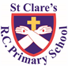
Happy New Year!
I hope that you all enjoyed the Christmas holidays and that 2024 will be a happy and healthy year for you and your family.
We are delighted to welcome the children back. In Nursery, as part of their RE topic on celebrations, the children have had a party – what a great start to the year! Reception children have been reading about Captain Yellow Belly, the terrible pirate, and creating wanted posters for him. Year 1 have lost a penguin and have found out that he has returned to the South Pole. They are writing setting displays about where the penguin returned to. Year 2 have enjoyed making predictions on their new class book ‘Lila and the secret of the rain.’ As part of their science topic, Year 3 have been learning about the five key food groups. In their new history topic, Year 4 have role played Vikings travelling over from Scandinavia on a long boat. In geography, Year 5 have been exploring the Grand Canyon and made posters detailing the main features of it. Year 6 have started their World War 2 topic and are getting an insight into what life was like for evacuees through their class book ‘Dear Mum, I miss you.’
Mass
And a voice came from heaven: "You are My beloved Son; in You I am well pleased." Luke 3:22
We celebrated our return to school on Monday with a whole school Mass linked to the Baptism of our Lord. Baptism cleanses us and links us closer to God and a New Year offers us the chance to do the same. As we make New Year Resolutions, let us think of ones that bring us closer to God and follow the example He set us whilst on earth.
Morning Prayers

Our school chapel is open every Tuesday morning from 8.30 -9.00am for parents (and children) to come into school for some private prayer, some time alone with God or quiet reflection.
Pupil certificates
12.1.24 | Pupil of the week | Achievement
N | Charlotte for an amazing first week at Nursery | Yasir for wonderful maths work exploring the number 3
RDM | Chidumebi - excellent writing when making a “Pirate wanted poster.” | Archie - Good independent writing in the classroom areas
RS | Alba Downie for painting a great pirate flag! | Jayson for independently writing 3 sentences about our story Captain Yellowbelly!
Y1D | Finley for a super start back to school. | Prince for working hard to make your work neat and tidy.
Y1G | Anuli for being so enthusiastic about learning. She always uses her growth mindset to challenge herself. | Myla Grace for amazing descriptive sentences about the South Pole.
Y2C | Pablo for having a great attitude to all of his learning. | Grace for fantastic shape knowledge.
Y2O | Anthony for trying so hard with his work this week | Hope for taking part in class discussions and sharing her wonderful ideas.
Y3F | Elijah for being a superstar. Elijah is always ready to learn and is a great respectful talk partner. | Hillary for sharing some amazing predictions about what she thinks will happen in our class book, ‘Stone Age Boy’.
Y3H | Heidi, for making sure her work is of a high quality with beautiful presentation | Evie, for working hard to solve related addition and subtraction problems.
Y4H | Phoebe, for always behaving beautifully and being kind to others. | Isla, for some brilliant writing about the Anglo Saxons, I loved her short, sharp sentences!
Y4S | Adam, for a brilliant attitude this week and trying very hard in all lessons. | David, for sharing fantastic ideas about Vikings in our English and History lessons.
Y5G | Tianna for some lovely responses in R.E about the rewards of being a follower of Jesus. | Liam for trying really hard to improve his presentation and for always sharing his wealth of general knowledge.
Y5W | Cora for her fantastic attitude towards her reading. | Jagger for producing a fantastic piece of work on growth mindset using his imagination and creativity.
Y6K | Ivy, for some brilliant work in Maths on Ratio. | James, for reading beautifully in Church this week in our School Mass.
Y6S | Amaya for always having a lovely positive and resilient attitude towards her learning. | Destiny for brilliant work in maths this week on Ratio.

Headteachers awards:
Romeo in RDM for always being kind to others.
Rowan in 1G for super work all week.
Peter in 2O for being such a good role model.
Denver in 3H for great maths work on related calculations.
Alexis in 4S for working hard and doing her best.
Ayla in 6K for perfect behaviour at all times.
Caritas Award
The Caritas is awarded each week in recognition of someone in school who has shown kindness to others by putting love into action. This week, our award goes to Rayarna from 3h for helping her friend in class every day.

Attendance
Whole school attendance this week
Inclu N & R 95.5
Exclu N & R 95.9
The best class this week is 5G again with 100% - they will again enjoy an own clothes day as a reward next Friday.
Website
Our website contains a wealth of information relating to our school. On the class pages, you can see what your child will be studying this half term. If you want to know what your child is learning in a particular subject, you will find the information you need in the curriculum section. There is a section showcasing what we do in relation to our religious life; support for SEND; a selection of key policies; online safety; newsletters; and holiday dates. Please take a look.
https://www.st-clares.manchester.sch.uk/

SEND coffee morning
We are holding our second SEND coffee morning to which all parents of children with any form of SEND are invited. Come and join us for a coffee and a chat in a welcoming, friendly environment.
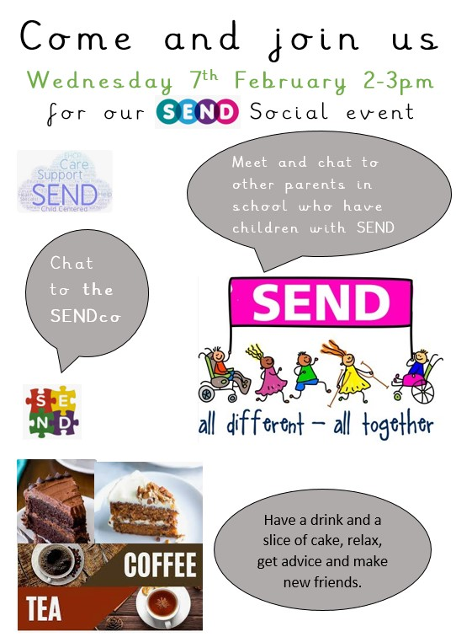

Support
As a school we are here for both your children and your family. If you are experiencing any difficulties or have any anxieties, please get in touch with Mrs Sylvester for a private conversation. Her email address is c.sylvester@st-clares.manchester.sch.uk or you can ring the school number or message via the school app. If we are unable to help you, we may be able to refer you to somebody who can.
Safeguarding
Safeguarding children is everyone’s responsibility. If you have any concerns regarding the safety of a child, please report it. You are able to refer concerns directly or you can contact one of the Designated Safeguarding Leads in school. Please see the poster below for more details
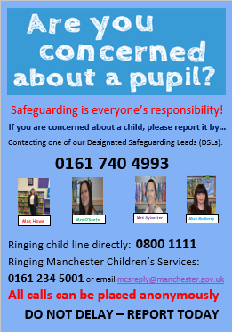
Mrs Howe

