ST CLARE’S R.C.P NEWSLETTER
Our School Mission Statement: Guided by Jesus Christ, our teacher, we journey together learning to dream, believe and achieve. Friday 19th January 2024
Friday 24th November 2023

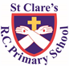
I bet you all had some very excited children this week when they woke up to the snow on Tuesday morning. The problems arise when it turns to ice!
In Nursery this week, the children have carried out observations into the quickest way to make ice melt. Reception have also been investigating objects to see if they sink or float in water. In religion, Year 1 have been looking at the qualities of people who help us. Year 2 have been recognising coins in maths and learning how to make different amounts. With the dance coach, Year 3 have been learning a routine to the Lion King’s ‘I just can’t wait to be king!’ In religion, Year 4 have been learning about Jesus calling his apostles to join him. Year 5 spent the morning at Our Lady’s on Thursday making a bolognese sauce as part of their DT work. They smelt delicious! As part of their science topic, Year 6 have been learning how to make simple circuits this week.
Assembly
Look, there is the Lamb of God. John 1: 35

In assembly this week, the children were reminded that Jesus is the Lamb of God who invites us to ‘Come and see’. When we see Him for who He is, we receive peace, joy and life to the full.
Morning Prayers
Our school chapel is open every Tuesday morning from 8.30 -9.00am for parents (and children) to come into school for some private prayer, some time alone with God or quiet reflection.
Pupil certificates
 | Pupil of the week | Achievement
N | Asa for amazing behaviour and choosing to do the right thing! | Makayla for wonderful phonics skills
RDM | Abbie - settling onto her new class brilliantly! | George - fantastic use of phonics in his group writing activity.
RS | Abongwi for always being a kind friend | Paige for super work in maths with one more and one less
Y1D | Ugochi for always being ready to learn and for being such a sensible and considerate member of our class. | Ellis for your super setting description using 2A sentences.
Y1G | Ryan for having a great week and coming to the carpet to listen. | Aria for using adjectives in her setting description about the South Pole.
Y2C | Kody for having a super first week at St. Clare’s. Keep it up! | Carter H for super answers in maths
Y2O | Joy for being ready to work and following our school rules throughout the week, a role model! | Jaxley for designing a lovely cover for a bible in RE!
Y3F | Layla-Mae for having an excellent first week at St Clare’s, she has shown already how helpful she is! | Poppy Leigh for trying her best, even when she finds it difficult!
Y3H | Tyler for a fantastic setting description in his short write. | Mikaela for learning the dance routine in PE flawlessly!
Y4H | Tyssiana has been absolutely fantastic this week. she has had a great attitude to learning and achieved so much! | Troy has worked really hard this week and produced some AMAZING Viking writing!
Y4S | Phoebe for always being a superstar and trying hard in everything she does. | Harry for being really engaged in our English work this week and producing fantastic writing.
Y5G | Matthew for a fantastic attitude to learning this term and demonstrating some great hockey skills. | Halle for excellent independence and for being a great role model to others whilst cooking her bolognese sauce.
Y5W | Josh for having a great attitude towards school and producing fantastic work all week. | Sharon for a fantastic piece of geography work on the Grand Canyon
Y6K | Jayden, for great enthusiasm during our WWII child evacuee letter writing task this week. | Sheldan, for producing his best piece of writing of Y6 so far, a great letter from a WWII child evacuee.
Y6S | Ivan for settling in to 6S really well and being extremely well mannered and polite. | Ade for a fantastic informal letter written as an evacuee in WW2.

Headteacher’s awards:
Caritas Award
Heidi in nursery for developing her independence skills.
Jason in RS for a great treasure map.
Olivia G in 1D for always following instructions.
Shay in 2C for being so focused on his RE work.
Marnie in 3F for a good diary entry written as Stone Age Boy.
Alvaro in 5W for his mature attitude to learning and keeping focused on his work.
Lennon in 6S for great work on ratio in maths.
The Caritas is awarded each week in recognition of someone in school who has shown kindness to others by putting love into action. This week, our award goes to Chukwudozie in Nursery for always making sure his friends are happy.

Attendance
It is really important that your child is in school and on time everyday. This week our whole school attendance falls well short of out 96% target at 93.6%. The best class for attendance this week is 1G with 97% - well done!
Thank you to everyone who has brings their children to school on time every day. Unfortunately, fifty-nine children have been late seventy-nine times this week which equates to lost learning time. This is not acceptable. If you are experiencing any difficulty in getting your child to school on time, please contact our Attendance Officer, Mrs Burgess Hamlett, who will be able to suggest some strategies to help. School doors open at 8.50am and close at 9.00am.
Family Mass
Parents of the children who are making their Holy Communion this year are invited to the parish Family Mass on Sunday 28th January at 10.30am.
Reception Stay and Play
Parents and carers of our Reception pupils are invited to a stay and play session on Wednesday 24th January at 9.00am
Basketball
Last night a group of our Year 5 and 6 pupils represented the school in an Inspire basketball competition and won. Points were awarded by the opposing teams for honesty, self-belief, team work and fair play. The fact that the other pupils taking part voted for St Clare’s makes it even more of a special award. We are so very proud of our team. Thank you also to Mr Willis and Miss Gill for accompanying the children.
Website
Our website contains a wealth of information relating to our school. On the class pages, you can see what your child will be studying this half term. If you want to know what your child is learning in a particular subject, you will find the information you need in the curriculum section. There is a section showcasing what we do in relation to our religious life; support for SEND; a selection of key policies; online safety; newsletters; and holiday dates. Please take a look.
https://www.st-clares.manchester.sch.uk/
SEND coffee morning
We are holding our second SEND coffee morning to which all parents of children with any form of SEND are invited. Come and join us for a coffee and a chat in a welcoming, friendly environment.
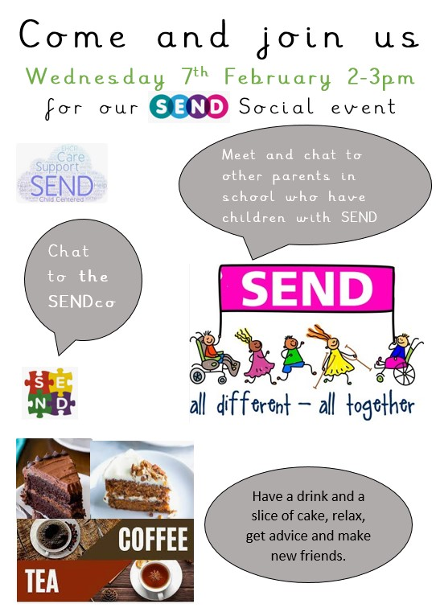

Support
As a school we are here for both your children and your family. If you are experiencing any difficulties or have any anxieties, please get in touch with Mrs Sylvester for a private conversation. Her email address is c.sylvester@st-clares.manchester.sch.uk or you can ring the school number or message via the school app. If we are unable to help you, we may be able to refer you to somebody who can.
Safeguarding
Safeguarding children is everyone’s responsibility. If you have any concerns regarding the safety of a child, please report it. You are able to refer concerns directly or you can contact one of the Designated Safeguarding Leads in school. Please see the poster below for more details
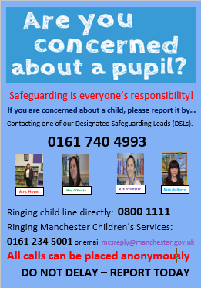
Thank you for all your support this week. Enjoy the weekend!
Mrs Howe

Upcoming dates:
Reception stay and play – Wednesday 24th January
Family Mass – Sunday 28th January
Nursery stay and play – Wednesday 31st January
Young Voices – Tuesday 6th February
SEND coffee morning – Wednesday 7th February
Year 3 Marist centre trips – Tuesday 13th and Wednesday 14th February

