ST CLARE’S R.C.P NEWSLETTER
Our School Mission Statement: Guided by Jesus Christ, our teacher, we journey together learning to dream, believe and achieve. Friday 26th January 2024
Friday 24th November 2023

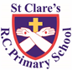
It has been another busy week of learning at St Clare’s. In Nursery, our children have been acting out the story of ‘We’re Going on a Bear Hunt.’ Parents and carers were invited into Reception this week for a stay and play and maths session. This was very well attended with 46 adults joining us – I hope you enjoyed it as much as the children did. Thank you for attending! In maths, Year 1 have been busy ordering numbers from smallest to largest. AS part of their geography topic, Year 2 have been on a walk around the local area looking at houses, so that they can make comparisons with homes in Zambia. Fortunately, the weather was dry. In Dt, our Year 3 pupils have been learning how to chop and peel vegetables and fruit. Father Jeremiah was a special visitor to Year 4 this week. As part of their RE topic, the children enjoyed asking Father lots of questions about his life as a priest and what inspired him to become one. Thank you for your time Father! Year 5 have been learning how to use the ‘bus stop’ method to complete division calculations. In history, Year 6 have been learning about important turning events in World War 2 and why they were key events.
Assembly
And His teaching made a deep impression on them because, unlike the scribes, He taught them with authority. Mark 1: 22

In assembly this week, the children were reminded that Jesus’ teaching was amazing as he spoke to people in ways they understood. People change when they hear Jesus’s words because what he says comes from God. Jesus coming to earth to live amongst us helped us all to get to know and love God more. Jesus didn’t only tell us how to love, he showed us too. In doing so, Jesus has made a lasting, deep impression on our hearts and guides our thoughts, actions and words.
Morning Prayers

Our school chapel is open every Tuesday morning from 8.30 -9.00am for parents (and children) to come into school for some private prayer, some time alone with God or quiet reflection.
Pupil certificates
 | Pupil of the week | Achievement
N | K’cey for always doing the right thing and following our golden rules! | Theo for becoming more confident and developing his communication skills!
RDM | Anaya - always setting a wonderful example to her peers | Matilda - fantastic phonic work
RS | Mia for coming into school so sensibly each morning and getting straight on with her morning work | Miles for using finger spaces independently in his writing
Y1D | Farhan for always taking care with your handwriting and trying hard in every lesson | Maggie for writing a beautiful setting description of the town from Lost and Found.
Y1G | Annie Rose for an all round brilliant week. She has been so helpful, caring and hard working! | Uririoghene for working hard learning his numbers to 20.
Y2C | Jacob K for being a kind and caring member of the class | Mia for an amazing field sketch in geography
Y2O | Racquel for being a caring member of our class, always looking out for everyone! | Louie for his beautiful handwriting, he has made wonderful progress!
Y3F | Evana for starting life at St Clares so well. She is an excellent addition to the class. | Purity for some amazing sentences in our short write this week.
Y3H | Felicity, for a fantastic score in her end of topic maths assessment. | Jake, for an excellent improvement in his handwriting.
Y4H | Liza, as she always behaves beautifully and has respect for everyone in school. | Lacey for writing an incredible story about a Viking this week- I have been so impressed!
Y4S | Skylar for always doing the right thing, being a wonderful role model to everyone in our class and giving 100% in everything she does. | Ryan for creating a brilliant comic at home, which was full of fantastic writing.
Y5G | Marcel for setting high standards for himself and always producing work to the best of his ability. | Ramani for some fantastic, accurate maths work on division
Y5W | Enzo for a fantastic improvement in his behaviour and attitude towards school this week. | Tope for fantastic work on his comprehension this week.
Y6K | Abigail for being a fantastic role model to the rest of her class with regards to how to conduct yourself in school. | Dennan for using some brilliant adjectives in his WW2 evacuee letter this week.
Y6S | Evie for putting 100% effort into her work and consistently setting high standards. | Orlaigh for brilliant research in history based on the key events and turning points of WW2.

Headteacher’s awards:
Eryn in RDM for making a great attempt at writing her full name independently.
Isabelle O in 1G for always being a kind, helpful friend to everyone.
Pippa in 2O for great geographical fieldwork on different houses.
Molly in 4S for always being amazing and doing her best.
Ollie D in 5G for an excellent attitude and great effort in all his work.
Millie in 6K for using what she has learnt to write a good World War 2 evacuee letter.
Caritas Award
The Caritas is awarded each week in recognition of someone in school who has shown kindness to others by putting love into action. This week, our award goes to Ivy in Reception for inviting a friend to play with her parents at the Stay and Play session as she was sad that her parents were unable to attend. How kind!

Millionaire Readers
We have 6 new millionaire readers this week which is amazing! We are very proud of them. Our new millionaires are:
Tolani 4H
Daniella 5W
Cassius 5W
Lydia 6K
Ivy 6K
Maddison 6S

Attendance
Attendance is very important. Children, unless they are ill, need to be in school every day. School opens at 8.50am every morning. This week our whole school attendance is 94.9%. The best classes this week are 4S and 6K with 97%. They will receive a longer break time.
Catholic schools
You should have received a document today detailing what makes Catholic schools in general distinctive and how St Clare’s is a special place to be.
Our school website has a section dedicated to the Catholic life and mission of our school. Please have a look to see what has been happening.
https://www.st-clares.manchester.sch.uk/religious-life-at-st-clare-s
Family Mass
Parents of the children who are making their Holy Communion this year are invited to the parish Family Mass on Sunday 28th January at 10.30am.
Website
Our website contains a wealth of information relating to our school. On the class pages, you can see what your child will be studying this half term. If you want to know what your child is learning in a particular subject, you will find the information you need in the curriculum section. There is a section showcasing what we do in relation to our religious life; support for SEND; a selection of key policies; online safety; newsletters; and holiday dates. Please take a look.
https://www.st-clares.manchester.sch.uk/
Safer Internet Day
On Tuesday 6th February we will be joining schools and youth organisations across the UK in celebrating Safer Internet Day 2024. Safer Internet Day is a global campaign to promote the safe and responsible use of technology, which calls on young people, parents, carers, teachers, social workers, law enforcement, companies, policymakers and more, to help to create a better internet. This year the campaign will be focusing on change online, this includes covering: • Young people’s perspective on new and emerging technology • Using the internet to make change for the better • The changes young people want to see online • The things that can influence and change the way young people think, feel and act online and offline. Using the internet safely and positively is a key message that we promote in school, and celebrating Safer Internet Day is a great opportunity for us to re-emphasise the online safety messages we deliver throughout the year. We would be delighted if you could join us in celebrating the day by continuing the conversation at home. To help you with this, the UK Safer Internet Centre has created some free activities and information for parents and carers which are available at: saferinternet.org.uk/SID-parents. Whether you have 5 minutes to start a conversation or hours to spare, there are top tips, quizzes and films which you can use at home with your child. If you have any concerns or questions about keeping your child safe online, please do get in touch with your child’s class teacher, Mr Flint or one of our Designated Safeguarding Leads.

SEND coffee morning
We are holding our second SEND coffee morning to which all parents of children with any form of SEND are invited. Come and join us for a coffee and a chat in a welcoming, friendly environment.
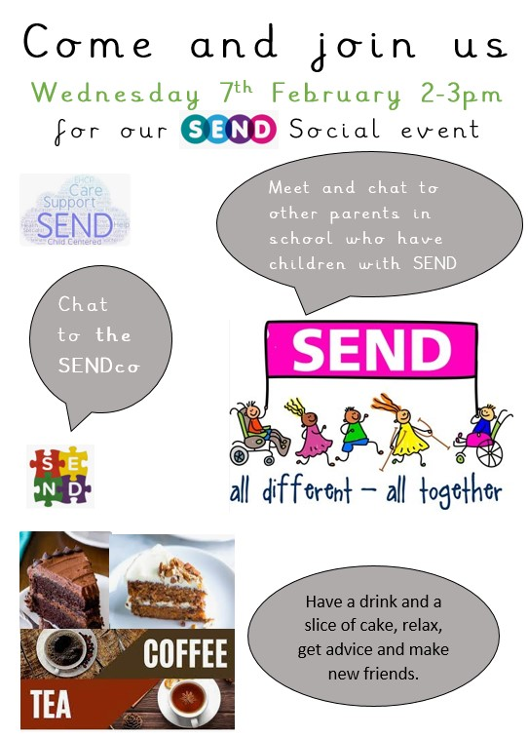

Support
As a school we are here for both your children and your family. If you are experiencing any difficulties or have any anxieties, please get in touch with Mrs Sylvester for a private conversation. Her email address is c.sylvester@st-clares.manchester.sch.uk or you can ring the school number or message via the school app. If we are unable to help you, we may be able to refer you to somebody who can.
Safeguarding
Safeguarding children is everyone’s responsibility. If you have any concerns regarding the safety of a child, please report it. You are able to refer concerns directly or you can contact one of the Designated Safeguarding Leads in school. Please see the poster below for more details
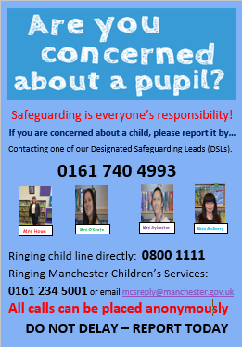

I hope that you all enjoy the weekend break,
God bless,
Mrs Howe

Upcoming dates:
Family Mass – Sunday 28th January
Nursery stay and play – Wednesday 31st January
Young Voices – Tuesday 6th February
SEND coffee morning – Wednesday 7th February
Year 3 Marist centre trips – Tuesday 13th and Wednesday 14th February

