ST CLARE’S R.C.P NEWSLETTER
Our School Mission Statement: Guided by Jesus Christ, our teacher, we journey together learning to dream, believe and achieve. Friday 2nd February 2024
Friday 24th November 2023

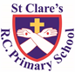
This week we got to share our wonderful school with the RE inspectors from the diocese. We know how special St Clare’s is and it was lovely to share what we experience everyday with the inspectors. Thank you to you all for sharing your experiences of St Clare’s with the inspectors. We will have to wait for their report and then we will share their findings with you. Whatever the outcome, we are extremely proud of the St Clare’s community.
In Nursery this week, we welcomed parents in to share a maths lesson with the children. Attendance was very good – thank you for joining us. The children love welcoming you into school to share their learning. Year 1 have been busy being maze explorers using computers. Year 2 have been experimenting with clay, so that they will be able to make clay huts. In forest school, Year 3 have been busy weeding and plating – answering Pope Francis’s call to care for our common home. They also made houses using natural resources. Year 4 have written recounts using their Viking topic knowledge. As part of their history topic, Year 5 have attended interactive Greek story sessions on Zoom. In RE, Year 6 have been comparing different versions of parables from the Gospels.
Assembly
‘The time has come and the kingdom of God is close at hand. Repent and believe the Good News.’
Mark 1:15
In assembly this week, the children were invited to drop what they’re doing and come now! Jesus gives us the best news and this is His invitation - to listen to Him, turn back to Him and believe what He tells us because the kingdom of God is close at hand.
Morning Prayers
Our school chapel is open every Tuesday morning from 8.30 -9.00am for parents (and children) to come into

school for some private prayer, some time alone with God or quiet reflection.

Pupil certificates
 | Pupil of the week | Achievement
N | Sophia for always being a fantastic role model to her friends | Kieran for sitting really well on the carpet during our learning time
RDM | Patris for being a smiley, happy member of our class | Archie for wonderful maths work
RS | Emmanuella for joining in so well with our Prayer and Liturgy this week | Olivia for writing a sentence completely independently!
Y1D | Talia for being an amazing role model to her peers and for trying hard to work more independently this week. | Teti for being so knowledgeable and enthusiastic to learn during our religion lessons.
Y1G | Cole for having an amazing week and working hard! | Leonardo for writing a great recount of Jesus being lost in the temple.
Y2C | Antoni or always being kind and helpful to everyone in class | Carter Stanton for an amazing leaflet in RE
Y2O | Maria for always being on green since the beginning the of year! | Louie for creating a fantastic end of topic piece of work in RE all about books.
Y3F | Josephine for always being an excellent pupil and being ready to learn | Esra for always doing fantastic handwriting in all of her books, keep it up!
Y3H | Olivia K for making a fantastic non-chronological report about the Stone Age for her homework. | Esosa for writing an excellent letter about the importance of prayer.
Y4H | Toby for having lots of enthusiasm for learning this week. | Liza for trying really hard in Violin lessons- she is so focused!
Y4S | Phaedra for really getting involved in our Prayer and Liturgy this week and giving a fantastic reading. | Jenson for trying very hard with his handwriting in English.
Y5G | Kayleb for a fantastic start at St Clare’s - he has given his all in everything he has done! | Poppy for designing a beautiful altar cloth to represent living Jesus’ mission.
Y5W | Karis for always looking after everyone in the class. | Ava for her fantastic work in maths this week.
Y6K | Ollie K for some wonderful work looking at similarities and differences between different versions of the same story in the Gospels. | Millie for trying really hard in our Maths work on algebra, and for successfully solving some two step equations!
Y6S | Ayesha for a fantastic lead in our child led prayer and liturgy this week. Well done. | Lennon for working hard on his handwriting and presentation this week, he has taken a lot of pride in his written work.

Headteacher’s awards:
Bereket in Nursery for growing in confidence and speaking more.
Mickey in RS for carefully looking after our books.
Yohannes in 1D for trying so hard to stay focused and on task.
Jakub W in 2C for being such a kind and caring friend to everyone.
Lilith in 3H for writing a great non-chronological report on the Stone Age at home.
Isla in 4S for always doing the right thing.
Harry in 5W for his amazing attitude towards school.
Emmanuella in 6K being such a fantastic role model to others.
Caritas Award
The Caritas is awarded each week in recognition of someone in school who has shown kindness to others by putting love into action. This week, our award goes to Nneoma in 5G for being a wonderful learning partner by putting the needs of others before herself to help them succeed – just like Christ!

Attendance
Attendance is very important. Children, unless they are ill, need to be in school every day. School opens at 8.50am every morning. This week our whole school attendance is 96%, so well done to everyone. Fifty-three pupils were late – please try to leave the house five minutes earlier. The best classes this week is 4S again with 99% which is amazing attendance. They will receive a longer break time. Well done 4S!
Own clothes day
Next Friday we are holding an own clothes day to support the parish foodbank as their resources are running low following the Christmas period. Any donation will be gratefully received, but if possible could you please send in the following items:
Nursery: noodles
Reception: soup
Year 1: tinned peas or carrots
Year 2: pasta
Year 3: baked beans
Year 4: tinned potatoes
Year 5: tinned meat – hotdogs / meatballs
Year 6: rice

Catholic schools
You should have received a document today detailing what makes Catholic schools in general distinctive and how St Clare’s is a special place to be.
Our school website has a section dedicated to the Catholic life and mission of our school. Please have a look to see what has been happening.
https://www.st-clares.manchester.sch.uk/religious-life-at-st-clare-s
Safer Internet Day
On Tuesday 6th February we will be joining schools and youth organisations across the UK in celebrating Safer Internet Day 2024. Safer Internet Day is a global campaign to promote the safe and responsible use of technology, which calls on young people, parents, carers, teachers, social workers, law enforcement, companies, policymakers and more, to help to create a better internet. This year the campaign will be focusing on change online, this includes covering: • Young people’s perspective on new and emerging technology • Using the internet to make change for the better • The changes young people want to see online • The things that can influence and change the way young people think, feel and act online and offline. Using the internet safely and positively is a key message that we promote in school, and celebrating Safer Internet Day is a great opportunity for us to re-emphasise the online safety messages we deliver throughout the year. We would be delighted if you could join us in celebrating the day by continuing the conversation at home. To help you with this, the UK Safer Internet Centre has created some free activities and information for parents and carers which are available at: saferinternet.org.uk/SID-parents. Whether you have 5 minutes to start a conversation or hours to spare, there are top tips, quizzes and films which you can use at home with your child. If you have any concerns or questions about keeping your child safe online, please do get in touch with your child’s class teacher, Mr Flint or one of our Designated Safeguarding Leads.

SEND coffee morning – Wednesday 7th February
We are holding our second SEND coffee morning to which all parents of children with any form of SEND are invited. Come and join us for a coffee and a chat in a welcoming, friendly environment.
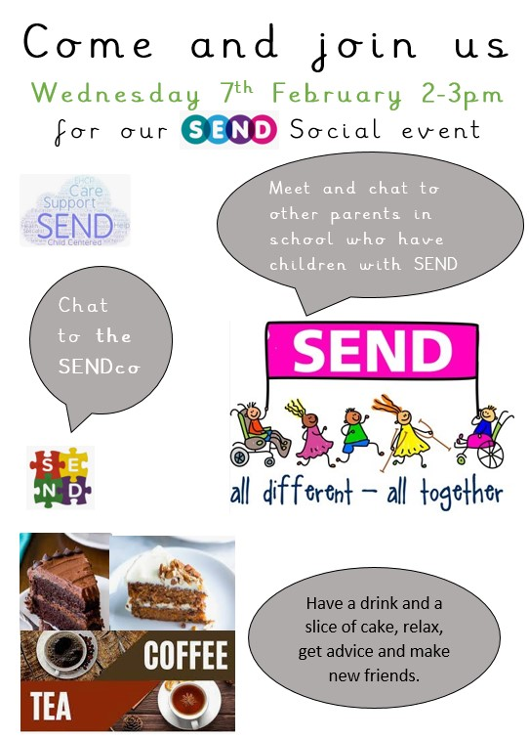

Support
As a school we are here for both your children and your family. If you are experiencing any difficulties or have any anxieties, please get in touch with Mrs Sylvester for a private conversation. Her email address is c.sylvester@st-clares.manchester.sch.uk or you can ring the school number or message via the school app. If we are unable to help you, we may be able to refer you to somebody who can.
Safeguarding
Safeguarding children is everyone’s responsibility. If you have any concerns regarding the safety of a child, please report it. You are able to refer concerns directly or you can contact one of the Designated Safeguarding Leads in school. Please see the poster below for more details.
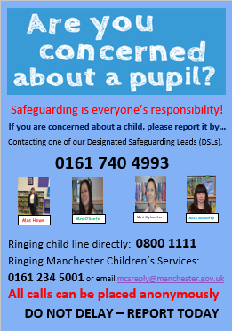

Wishing you all a peaceful weekend,
Mrs Howe

Upcoming dates:
Young Voices – Tuesday 6th February
SEND coffee morning – Wednesday 7th February
Year 3 Marist centre trips – Tuesday 13th and Wednesday 14th February

