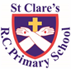

ST CLARE’S R.C.P NEWSLETTER

Our School Mission Statement: Guided by Jesus Christ, our teacher, we journey together learning to dream, believe and achieve. Friday 24th January 2025

Friday 24th November 2023

Our Nursery children have been reading ‘We’re going on a bear hunt’ this week and have had fun acting the story out. In maths, our Reception children have been learning about weight and capacity and the mathematical language associated with them. As part of their PE lessons, Year 1 have been learning to throw and catch a ball. On Monday, Year 2 had a great ‘African’ day where they learnt African dances and decorated African masks. In DT, Year 3 have been learning to peel, chop and cut vegetables. Year 4 have been learning about the Viking raid in Lindisfarne in their history lessons. This week, they raided the Year 3 classrooms as Vikings! They made their own swords and shields and 'sailed' down the stormy corridor to take anything of value. They stole valuables such as chairs, rulers and books! Luckily, the children in Y3 were not in class at the time, so no-one was hurt! As part of their community topic in RE, Year 5 have been learning about the roles and responsibilities of a bishop. In Year 6, the children have been researching the Dead Sea Scrolls.

**Chapel / prayer garden**

Our chapel / KS2 prayer garden is open each Tuesday morning before school for staff, pupils and parents to come and pray privately. Starting the day with God is beautiful. You are very welcome to pop in from 8.15am each Tuesday.

**Jubilee Year – Pilgrims of Hope**

Pope Francis has deemed this year a jubilee year where the focus is ‘pilgrims of hope.’ We are all invited to make a pledge to work together for God’s kingdom of justice, peace and love by putting our faith into action to build a better world for everyone.

The Jubilee Year was launched in assembly today with the children. Pope Francis calls us all to celebrate the year with ‘deep faith, lively hope and active charity.’ We will engage in various activities over the course of the year as pilgrims of hope including making a pledge to walk in solidarity with our poorer brothers and sisters. We will keep you updated in the newsletter and on our school website about activities we take part in relating to this special year of hope.

**3H class assembly**

You are very welcome to join 3H for their class assembly on Monday morning at 9.00am.

**Pupil Certificates**

|  |  |  |
| --- | --- | --- |
|  | Pupil of the week | Achievement |
| N | Piotr for following our routines and boundaries this week! | Timi for fantastic phonics |
| RDM | Dior for always being ready to learn! | Kieran for great enthusiasm to complete his challenges! |
| RS | Danica for always being ready to learn. | Amina for a fantastic effort writing CVC words this week! |
| Y1G | Eliza for her fantastic first couple of days at St Clare’s. She has been a smiley and helpful addition to our classroom. | Uyi for role playing being a hairdresser on a teddy bear. He even showed the bear their  new haircut in the mirror. |
| Y1S | Alba Do for brilliant work in all lessons this week and challenging herself in her work. | Norah for fantastic writing this week. |
| Y2C | Anuli for always completing amazing work. | Frank for an amazing diary entry with beautiful letter formation |
| Y2D | Fabian for being a brilliant role model this week! | Hugo for putting 100% effort into your diary entry this week. |
| Y3F | Kody for having an amazing week and completing his work! | Therence for trying really hard with his writing this week, and producing a wonderful diary entry. |
| Y3H | Peter  for brilliant work on human and animal skeletons. | Jaxon, for brilliant maths work, converting metres to centimetres |
| Y4H | Honor for behaving beautifully in class and setting a great example to others. | Elena for some brilliant work in maths- she is a whizz! |
| Y4O | Marta for working hard in maths and making good progress! | Marnie for writing a fantastic historical narrative! |
| Y5G | Julia for helping other members of the class and being an amazing member of 5G! | Jeff for his fantastic biography on Phil Taylor |
| Y5K | Liza for being an absolute pleasure to have in class and for being an all round star pupil! | Eseosa for amazing all round efforts all week, especially with her Maths! |
| Y6S | Ramani for putting 110% effort into everything that he has done this week. | Tianna for identifying problems in a series circuit and offering solutions to fix them (Science) |
| Y6W | Tope for his fantastic attitude and effort during maths this week. | Poppy C for working extremely hard on her narrative writing about an evacuee in WW2 |

**Attendance**

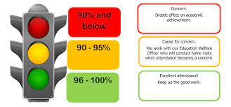

Overall whole school attendance this week is 95.6% Thank you for getting your child to school on time each day. The number of lates is reducing which is good news, although we had 50 pupils late 63 times this week and 25 instances of children being late after 9.15am. Lots of children are literally minutes late, so please make a concerted effort to leave the house five minutes earlier. Children arriving into class late disturbs the other children and their learning and is often embarrassing to the late child.

Under the **UN Convention on the Rights of the Child (UNCRC),**  **children have the right to an education**. As parents, it is your responsibility to ensure that your children are in school every day on time, unless they are ill. I can not stress how important this is, so if you are experiencing any difficulties or require any additional support, please contact our Attendance Officer, Mrs Burgess Hamlett.

The best class for attendance this week again is 4O with 99% - well done to them! They will receive a longer break time next week.

**Rights Respecting School Award**

You have received a letter this week explaining that we are working towards being a Rights Respecting School. Under the United Nations Convention on the Rights of Children, there are various responsibilities that fall upon governments and their staff to ensure that children’s rights are met. We will be helping children to understand what their rights are and how they are evident in their lives.

For further information, please see https://www.unicef.org.uk/wp-content/uploads/2017/09/Our-rights_UNCRC.pdfor our school website <https://st-clares.manchester.sch.uk/children/rights-respecting-school>

We have already achieved our bronze award!

**School Uniform**

I just want to say thank you for following our school uniform policy – the children look very smart and feel part of our very special school community. The vast majority of children have now removed their ear-rings as per our policy. Thank you for re-iterating the safety aspect of this to them and the need to follow rules. I am sure that they look forward to wearing them again in the evening or at weekend.

**Support**

As a school we are here for both your children and your family. If you are experiencing any difficulties or have any anxieties, please get in touch with Mrs Sylvester for a private conversation. Her email address is [c.sylvester@st-clares.manchester.sch.uk](mailto:c.sylvester@st-clares.manchester.sch.uk) or you can ring the school number or message via the school app. If we are unable to help you, we may be able to refer you to somebody who can.

If you are struggling to buy food at the moment, please contact school. We do not want any families to go without food. We do have contact with some food banks who may be able to offer support.

**Safeguarding**

**Under the United Nation Convention on the Rights of a Child, all children under the age of 18 have a right to be protected from violence, abuse and neglect (Article 19) and a right to be alive (Article 6).**

There are many forms of abuse – sexual, neglect, emotional, physical, online – and it is everyone’s responsibility to safeguard children from any harm.

If you have any concerns regarding the safety of a child, please report it. You are able to refer concerns directly or you can contact one of the Designated Safeguarding Leads in school. Contact details can be found below.

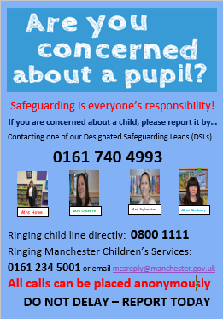

**Whitworth Gallery**

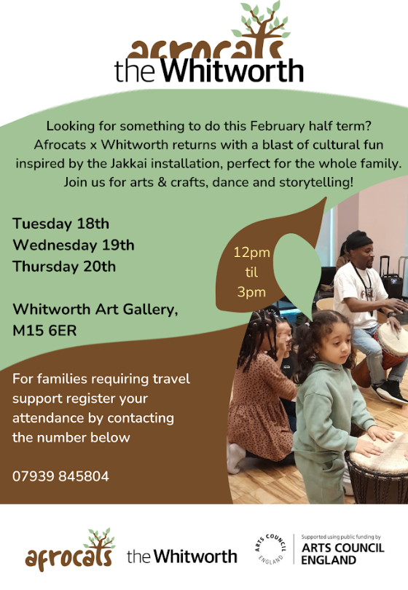

Thank you for your continued support this week.

Enjoy your weekend,

Mrs Howe

Upcoming dates:

3rd February – Online Safety performance and workshops in school.

4th February – SEND coffee morning 8.40-9.30am

4th and 6th February – Reconciliation retreat focus in school for Year 3

7th February – own clothes day ‘Express Yourself’ mental health theme.

9th February – Family Mass 10.30am

14th February – Finish for half term 3.15pm

**A Prayer of Hope**

