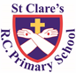

ST CLARE’S R.C.P NEWSLETTER

Our School Mission Statement: Guided by Jesus Christ, our teacher, we journey together learning to dream, believe and achieve. Friday 31st January 2025

Friday 24th November 2023

Our children in Nursery have been to the parish mass this week and have enjoyed learning about celebrations in their own lives. Reception have had fun celebrating Chinese New Year: they made lanterns and took part in a dragon dance. In science, Year 1 have been matching objects to their materials. As part of their art topic, Year 2 have been making Zambian patterns using clay in preparation for making their clay huts. In RE, Year 3 have been learning about different prayers we say and why we pray. Linked to their history topic, Year 4 have been interviewing each other as Viking warriors preparing for battle. Year 5 have started a new genre in English and are investigating the features of newspaper reports. In maths, Year 6 have been solving two step function machine questions as part of their algebra topic.

**Assembly**

***The Spirit of the Lord is upon me, because He has anointed me to proclaim good news to the poor. He has sent me to proclaim liberty to the captives and recovering of sight to the blind, to set at liberty those who are oppressed, to proclaim the year of the Lord’s favour. Luke 1:18-19***

This week,our assembly explored what this special Jubilee year can mean for children and their friendship with God. It’s a time to restart, a time for resting with God and a time for worshipping Him!

**Chapel / prayer garden**

Our chapel / KS2 prayer garden is open each Tuesday morning before school for staff, pupils and parents to come and pray privately. Starting the day with God is beautiful. You are very welcome to pop in from 8.15am each Tuesday.

**Jubilee Year – Pilgrims of Hope**

Pope Francis has deemed this year a jubilee year where the focus is ‘pilgrims of hope.’ We are all invited to make a pledge to work together for God’s kingdom of justice, peace and love by putting our faith into action to build a better world for everyone.

During this Jubilee Year, Pope Francis calls us all to celebrate with ‘deep faith, lively hope and active charity.’ We will engage in various activities over the course of the year as pilgrims of hope including making a pledge to walk in solidarity with our poorer brothers and sisters. We will keep you updated in the newsletter and on our school website about activities we take part in relating to this special year of hope.

**3H class assembly**

Thank you to everyone who joined us for 3Hs class assembly. The children were amazing and confident. We learnt lots about Chinese New Year.

**Pupil Certificates**

|  |  |  |
| --- | --- | --- |
|  | Pupil of the week | Achievement |
| N | Luna for amazing maths work and attempting to write number sentences to make 4. | Lucia for amazing maths work and attempting to write number sentences to make 4. |
| RDM | Ethan for trying hard in all areas this week. | Gerald for super effort with his letter formation. |
| RS | Joelvy for creating his very own storybook! | Joel for doing super maths work this week, finding new ways to make the number 8. |
| Y1G | Gilly for his hard work and consistently beautiful handwriting. | Jorgi for beautiful handwriting in her RE book. She has worked hard to make sure this has improved this week. |
| Y1S | Szymon for a fantastic attitude all week. | Rory for working very hard with his writing. |
| Y2C | Hajra for trying her hardest in all of her work- keep it up! | Annie Rose for showing off amazing number knowledge in our money topic. |
| Y2D | Hanna for always doing the right thing, good presentation and completing all work set to a high standard. | Teti for finding lots of ways to make £1 using different coins in maths |
| Y3F | Julia never fails to put a smile on everyone's face, always smiling, welcoming, polite and gives her all in singing. | Fabian has been really trying hard with his maths this week. He is able to convert between m, cm and mm! |
| Y3H | Emiley, for a beautiful explanation of why we pray | Luca for being incredibly helpful |
| Y4H | Felicity for always behaving beautifully, and being very helpful around the classroom this week. | Logan for wowing me with his correspondence work in maths - he answered a really tricky question that even I couldn’t work out!!! |
| Y4O | Kian for always being a mature and responsible member of the class! | Joleen for trying hard with her times table and really improving her instant recall. |
| Y5G | Phaedra for always being involved and giving excellent suggestions during class discussions. | Jenson for his excellent work in Maths this week with multiplying fractions by integers. |
| Y5K | Cole for being so enthusiastic about his learning and eager to answer questions. | Eseosa for amazing work on multiplying unit fractions by integers. |
| Y6S | Same for his great attitude towards his learning, it is a pleasure to see. | Ella for a great double page spread in History filled with information on rationing in WW2. |
| Y6W | Jessica for her perfect attitude towards school and her work, a role model for other children. | Miley for a fantastic improvement in her arithmetic score, achieving her best score all year. |

**Headteacher awards**

**Ruby** in nursery for being so resilient.

**Isabella** in RDM for being a great role model to others.

**Abongwi** in 1S for reading so much at home and improving in his phonic knowledge.

**Ugochi** in 2D for always working hard.

**Delina** in 3H for super listening.

**Lilith** in 4H for great expression and intonation in oracy.

**Hepzibah** in 5G for helping others with their work.

**Lilly** in 6S for great work in algebra.

**Caritas Award**

The Caritas Award is presented each week to a child in recognition of their outstanding achievement in putting love into action. This week the award goes to Ella in 1G for being incredibly welcoming and helpful to a new class member. How lovely!

**Attendance**

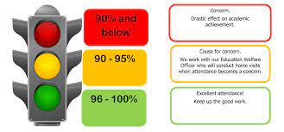

Overall whole school attendance this week is 95% Thank you for getting your child to school on time each day. The number of lates has increased this week, we had 70 pupils late 97 times. Th number of lates after 9.15am has fallen to 12. Lots of children are literally minutes late, so please make a concerted effort to leave the house five minutes earlier. Children arriving into class late disturbs the other children and their learning and is often embarrassing to the late child.

Under the **UN Convention on the Rights of the Child (UNCRC),**  **children have the right to an education**. As parents, it is your responsibility to ensure that your children are in school every day on time, unless they are ill. I can not stress how important this is, so if you are experiencing any difficulties or require any additional support, please contact our Attendance Officer, Mrs Burgess Hamlett.

The best class for attendance this week again is 6S with 99% - well done to them! They will receive a longer break time next week.

**Rights Respecting School Award Competition**

We are holding a competition which calls on our children’s creative skills. We would like to have our own animal logo for displays relating to the articles of children’s rights. All children are invited to design a logo which could be used. We did suggest that the animal or its name could begin with ‘R’ to link to the RRSA for example Ronnie the rhino.

All entries need to be in school by 7th February.

If you need a piece of paper to take part in the competition, please just ask your child’s class teacher.

**Own clothes day**

As part of children’s mental health week, pupils are allowed to come into school wearing their own clothes next Friday.

The theme for the week is “Express Yourself”. Children can come to school dressed in clothes that make them happy: this may be their favourite colour or outfit. Please remember that children will be wearing these clothes all day, so they will need to be comfortable and sensible.

**Support**

As a school we are here for both your children and your family. If you are experiencing any difficulties or have any anxieties, please get in touch with Mrs Sylvester for a private conversation. Her email address is [c.sylvester@st-clares.manchester.sch.uk](mailto:c.sylvester@st-clares.manchester.sch.uk) or you can ring the school number or message via the school app. If we are unable to help you, we may be able to refer you to somebody who can.

If you are struggling to buy food at the moment, please contact school. We do not want any families to go without food. We do have contact with some food banks who may be able to offer support.

**Safeguarding**

**Under the United Nation Convention on the Rights of a Child, all children under the age of 18 have a right to be protected from violence, abuse and neglect (Article 19) and a right to be alive (Article 6).**

There are many forms of abuse – sexual, neglect, emotional, physical, online – and it is everyone’s responsibility to safeguard children from any harm.

If you have any concerns regarding the safety of a child, please report it. You are able to refer concerns directly or you can contact one of the Designated Safeguarding Leads in school. Contact details can be found below.

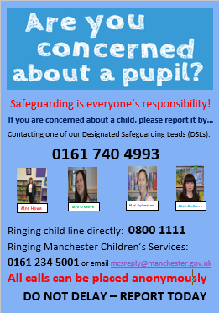

**Whitworth Gallery**

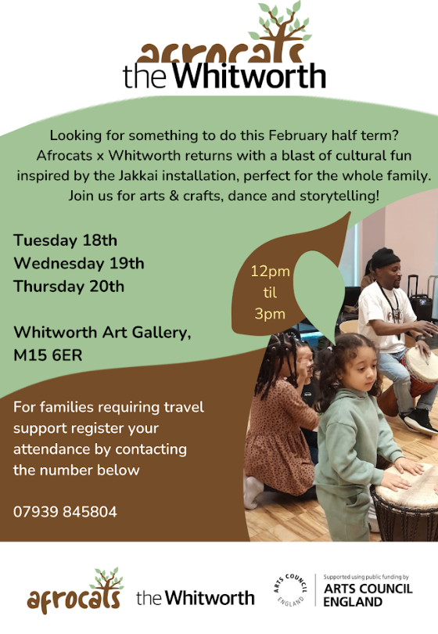

I hope that you all have a lovely weekend,

Mrs Howe

Upcoming dates:

3rd February – Online Safety performance and workshops in school.

4th February – SEND coffee morning 8.40-9.30am

4th and 6th February – Reconciliation retreat focus in school for Year 3

7th February – own clothes day ‘Express Yourself’ mental health theme.

9th February – Family Mass 10.30am

14th February – Finish for half term 3.15pm

**A Prayer of Hope**

