ST CLARE’S R.C.P NEWSLETTER
Our School Mission Statement: Guided by Jesus Christ, our teacher, we journey together learning to dream, believe and achieve. Friday 9th February 2024
Friday 24th November 2023

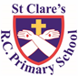
It has been another busy week this week at St Clare’s. On Tuesday evening, we took our choir to the Young Voices event in Manchester. The children loved singing along with 9000 other children. They were amazing, enthusiastic and loved every moment of it. They are such a credit to yourselves and the school. We also held our second SEND coffee morning – thank you to everyone who joined us. It was a great opportunity to come along, meet the SENDCo and chat with other families in similar positions. Thank you to everyone who attended.
Meanwhile, in Nursery the children have been celebrating Chinese New Year by tasting various Chinese foods. After having read ‘Who Swallowed Stanley’, Reception children have been looking at recycling in order to help protect the earth. In science, Year 1 have been looking at objects that float and sink. Year 2 have been learning about the features of a non-chronological report, so that they can write one about elephants. In DT, Year 3 have been designing a seasonal tart which they will make at Our Lady’s. In history, Year 4 have been debating whether or not Alfred the Great was a great king or not. As part of their geography topic, Year 5 have been researching Native American tribes living in the Grand Canyon. They also had a trip to Our Lady’s to watch their production of Matilda. In RE, Year 6 have been making links between Scripture and the Eucharist.
Assembly
This week is Safer Internet Week so the children have been reminded about how to stay safe online. If you are not sure how to change settings on your equipment to help keep your children safe online, please contact school and we will do our best to assist you. There are also many informative videos on our website. Click on the link to access them: https://www.st-clares.manchester.sch.uk/parents/e-safety

Ash Wednesday
Next Wednesday is Ash Wednesday and marks the start of the holy season of Lent. Our key stage 2 children will be attending Mass in church at 9.30am – you are very welcome to join us. Father Jeremiah will distribute the ashes to our younger children in school.
Morning Prayers
Our school chapel is open every Tuesday morning from 8.30 -9.00am for parents (and children) to come into school for some private prayer, some time alone with God or quiet reflection.
Pupil certificates
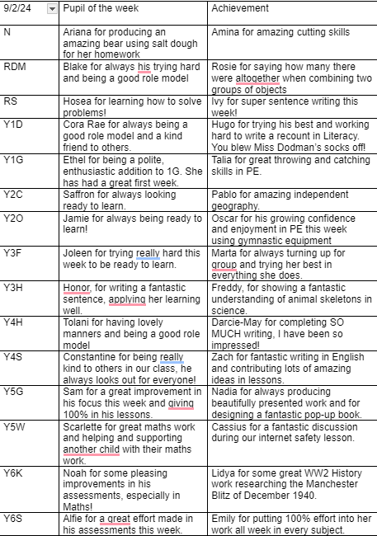

Headteacher’s awards:
Hassan in RDM for looking after his friends in class so well.
Milena in 1G for always being a kind, caring friend.
Louie in 2O for great work in RE on books that are special to us as Christians.
Kian in 3F for setting up our morning prayers when I forget!
Excel in 4H for being so helpful to others in the class.
Alexa in 5G for great geography work.
Alex in 6S for fantastic maths results in recent assessments.
Caritas Award
The Caritas is awarded each week in recognition of someone in school who has shown kindness to others by putting love into action. This week, our award goes to Kian and Dawid (2C) for showing great friendship in hymn practice when singing I’m Sorry.

Creation Walks
During Lent we are invited to pray more. As parents, you will be invited into school to share a Creation Walk with and led by your children. During this walk, we will pray and reflect on three areas: our wonderful world; those people in the world who experience problems – hunger, sickness, homelessness; and caring for our world. We will notify you of the dates.

Acts of kindness
Lent is a very important season in our liturgical year. The children will all be bringing home a calendar for Lent which suggests different acts that they can complete. They reflect the three main foci for us – to pray more, to fast / go without something / do something extra and support those in need.
Each child will be given a sheet and if they complete 20 acts of kindness or of the activities on the calendar, they will receive a small cross badge at the end of the season. There should be a separate action for each day. The cross will reflect the fact that they have been following in Jesus’s footsteps. The sheet will be signed by you to detail what your child has done and returned to school prior to the Easter holidays.

St. Joseph’s Penny
Children will be given the St J parent boxes next week for them to use during Lent and return when we finish for Easter.

Attendance
Attendance is very important. Children, unless they are ill, need to be in school every day. School opens at 8.50am every morning. This week our whole school attendance was 96.1%. 5W and 6S both had 100% attendance this week so will enjoy a non-uniform day, a donut and an extra break next Friday. Well Done to those two classes.

Own clothes day
Thank you for your very kind donations which have been given to the parish foodbank to help families in need.
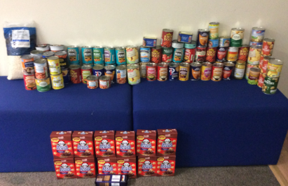
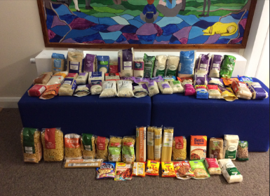
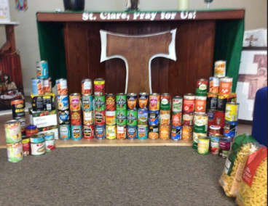

World War 2
Next Thursday, our Year 6 children are holding a World War 2 fun day when they will experience many different aspects of life during the war. It will bring their history topic to an end. Children are invited to dress up as refugees. Parents will be invited into school at the end of the day on Friday to share their experiences.

Holiday List 2024/25
Governors have approved the holiday list for 2024/25 and I have shared it on the school website. Here is the link:
https://www.stclares.manchester.sch.uk/parents/holidays

Support
As a school we are here for both your children and your family. If you are experiencing any difficulties or have any anxieties, please get in touch with Mrs Sylvester for a private conversation. Her email address is c.sylvester@st-clares.manchester.sch.uk or you can ring the school number or message via the school app. If we are unable to help you, we may be able to refer you to somebody who can.

Safeguarding
Safeguarding children is everyone’s responsibility. If you have any concerns regarding the safety of a child, please report it. You are able to refer concerns directly or you can contact one of the Designated Safeguarding Leads in school. Please see the poster below for more details.

Thank you for your continued support,
Mrs Howe

Upcoming dates:
2C parents invited into school to see their drumming skills – Tuesday 13th February 2.40pm – main building
Year 3 Marist centre trips – Tuesday 13th and Wednesday 14th February
Finish for half term 3.15pm – Friday 16th February

