ST CLARE’S R.C.P NEWSLETTER
Our School Mission Statement: Guided by Jesus Christ, our teacher, we journey together learning to dream, believe and achieve. Friday 11th September 2026
Friday 24th November 2023



Welcome back to a new school year. It Is so lovely to see you all again after the summer break. We are all refreshed and raring to go. The children have settled back into school life so well with beautiful smiles on their faces and are working hard. We are blessed with such wonderful children.
This week, Reception have been learning about different types of homes and who lives in them. They have also looked at who lives in our house with us. Year 1 have been learning about senses and have used their eyes to draw different flowers that they saw on their walk around the school grounds. In English, Year 2 have been writing instructions to make a shield for Traction Man. As part of their geography topic, Year 3 have started learning about how volcanoes are formed, labelling the inside of the earth. Year 4 have started their intensive swimming lessons! The children have absolutely loved their first week at lessons and have shown great perseverance. Thank you for your patience with the coach timings – they should be sorted now. Year 5 have been writing a mythical narrative based on Theseus and the Minotaur in literacy. Year 6 have been writing diary entries to express thoughts and feelings in the role of the main character in their class novel “The Light Jar.

Assembly
“For where two or three are gathered in my name, there am I among them.” Matthew 18:20

Jesus said that where two or three are gathered in His name, He is with them. In our Celebration of the Word Assembly children considered how working together makes us stronger and more effective. They discovered how prayer can strengthen and unite us together in faith.

Come and pray
Spending some quiet time with God is a great way to start each day. You are invited into our chapel each

Tuesday morning from 8.15am to start your day with individual prayer.
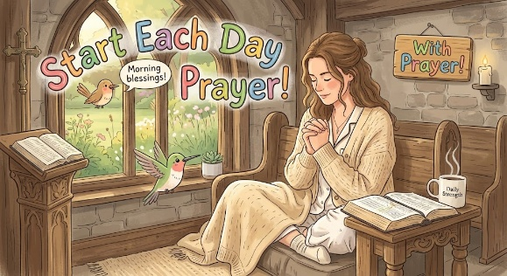

Pupil certificates
 | Pupil of the week | Achievement
N | Jack for a wonderful first week in Nursery!! | Chinenye for a super first week in Nursery!!
RDM | Erick for a making an excellent start to reception - well done! | Mia for a fantastic drawing of her family!
RS | Torvi for having a great start to reception and being a fantastic role model! | Giacomo for drawing a fantastically detailed portrait of his family and labelling it within his name and initial sounds!
Y1G | Ruben for being a brilliant role model in Year 1. | Aoife for her beautiful handwriting whilst writing an independent sentence.
Y1M | Iremide for being a wonderful role model. | Denylson for a brilliant drawing of a giraffe.
Y2C | Harlow for a always being ready to learn | Anastazja for beautiful letter formation in her writing
Y2D | Daisy for having an amazing start to Year 2! She is always ready to learn and loves contributing to lessons. | Elizabeth for your lovely RE work this week!
Y3F | Miles for having an excellent start to year 3 and always being ready to learn | Lily for producing some fantastic writing in our English work based on our book ‘Lubna and Pebble.’
Y3H | Archie for settling beautifully into Year 3 | Matilda for an excellent explanation of how igneous rock is formed.
Y4H | Hanna for behaving beautifully and always listening to instructions. | Ugochi for producing some incredible art work in RE.
Y4O’H | Pharrell for setting a wonderful example in our classroom. Always ready, focused and working hard. Very impressed. | Joseph for the most beautiful handwriting across every subject. He takes such time and dedication to show beautiful presentation.
Y5W | Jadon for demonstrating a fantastic attitude towards his learning in every lesson. | Pixie for a fantastic piece of artwork representing scripture.
Y5L | Lenny for starting his first term at St Clares full of enthusiasm for his learning. | Joy for producing and presenting a fantastic piece of homework on Ancient Greek meals.
Y6S | Elton for settling into year 6 so well, he follows the school rules beautifully. | Grace for using higher level vocabulary throughout all of her lessons.
Y6GK | Joleen for starting year 6 with such a mature attitude towards her learning, giving 100% focus in every lesson. | Lamaik for outstanding improvements to his handwriting and presentation

Headteacher’s Awards
Sultan in Nursery for singing Old MacDonald had a farm so beautifully.
Kory in RS for showing amazing kindness to his friends and helping them settle into school.
Mila in 2C for an amazing attitude to her work and letter formation.
Cole in 4OH for having a fantastic first week in year 4. He has settled in well and has produced amazing work throughout!
Henry in 6S for fantastic science work. He investigated reflection well and was able to record and analyse his findings using scientific vocabulary.

Caritas Award 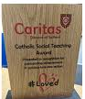
The Caritas Award is presented each week to a child in recognition of their outstanding achievement in putting love into action. This week the award goes to Hassan in Year 3 for kindly helping another child with their maths work.

Attendance
Overall whole school attendance this week 95.64% The best classes for attendance this week is Nursery with 99%. Well done – they will get a longer break.
School doors open at 8.40am to give the children time to take off their coats and be ready at their desks for an 8.45am start. The doors close promptly at 8.45am.
Under the UN Convention on the Rights of the Child (UNCRC), Article 29, children have the right to an education. If you are experiencing any difficulties or require any additional support with attendance or punctuality, please contact our Attendance Officer, Mrs Burgess Hamlett.
There are strict procedures in place issued by the government for schools to follow in the event of poor absence which may not be due to genuine illness. Parents can be fined or face legal action. We do not want this to happen, so please work with us if you are struggling getting your child to school or you personally need any support. Contact Mrs Burgess Hamlett.

Sacramental Programme
The registration meeting for this year’s Sacramental Programme is on Thursday 24th September at 6pm in the church hall for parents and children to attend . Children in Year 3 and those children in older years wishing to take part in the next stage of their faith journey should attend.
St Francis Mass
This year marks 800 years since the death of St Francis and has been declared a special jubilee year by Pope Leo. Bishop John is coming to our parish to celebrate this special occasion on Sunday 4th October at 10.30am. You are all welcome to attend. We will be asking the choir and Mini Clares to come along and join the parish acting as a choir.
Baby news
Over the summer holidays, Miss Sabor was blessed with the birth of a beautiful baby boy, Alfie. Mum and baby are doing well and we can not wait to meet him. We wish the family good health and happiness.
Our Lady’s High School Open Evening
Our Lady's Open Evening is being held in school on Thursday 24th September from 4.30 until 7pm giving all parents of primary children in years 4, 5 and 6 the chance to look around school, meet the teachers and hear from the headteacher. There is also the opportunity to come for a tour around our school during the school day to give you a better understanding of what life is like for a pupil at Our Lady's. You can make bookings by following this link or via the school website: https://forms.gle/j46K38vEUofdhQLq5
Let’s Talk
Good oracy skills are really important. Oracy doesn't stop at the school gates! Having conversations with your children really supports their learning journey in so many ways. Why not try our suggested "Let’s Talk" discussion below?

Statutory assessments
As you are aware, children are not authorised to take term-time holidays. During the summer term, there are statutory assessments which we have to administer at set dates / weeks. It is imperative that your child is in for these tests.
Year 1 phonics check – 14th -18th June.
Year 2 phonics check for those who did not pass it in Year 1 – 14th-18th June
Year 4 multiplication tables check -7th – 18th June
Year 6 SATs – 10th-13th May
Thank you for your understanding and support with these very important dates.
Support
As a school we are here for both your children and your family. If you are experiencing any difficulties or have any anxieties, please get in touch with Mrs Sylvester for a private conversation. Her email address is c.sylvester@st-clares.manchester.sch.uk or you can ring the school number or message via the school app. If we are unable to help you, we may be able to refer you to somebody who can.

Safeguarding
Safeguarding children is everyone’s responsibility. If you have any concerns regarding the safety of a child, please report it. You are able to refer concerns directly to children’s services or via school.

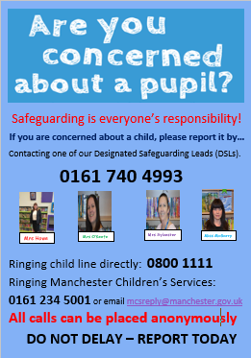

Mrs Howe

Upcoming dates
Tuesday 15th September – Welcome back Mass 9.00am in church
Friday 25th September – Macmillan coffee morning
Friday 2nd October – own clothes day in return for food items for the parish food bank.
Sunday 4th October – St Francis Mass 10.30am
Tuesday 6th October – whole school St Francis Mass 9.00am
Sunday 11th October – Family Mass (Sacramental Programme) 10.30am
Tuesday 20th October – Harvest Service in church 9.00am
Wednesday 21st October – parents evening

The weekly newsletter is also available on our school website Newsletters

