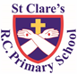
ST CLARE’S R.C.P NEWSLETTER
Guided by Jesus Christ, our teacher, we journey together learning to dream, believe and achieve.
Friday 8th September 2023

Welcome back to the new school year, welcome to children joining our school and to our new families too. We are so happy to have all the children back in school – we have missed them! We are all looking forward to the year ahead: to the new learning that will take place; to the exciting opportunities a new year brings; and to the wonderful friendships and memories that will be created. The children have settled back into the school year really well. They are a credit to you.
The year started off with a chance to experience a ‘triathlon’ for our pupils from Year 1 upwards. Trikidz kindly spent two days in school sharing this wonderful experience with our children. They had a great time!
Assembly
Some seed fell on rich soil and produced fruit. It came up and grew and yielded thirty, sixty, and a hundredfold. Mark 4:8
Our assembly this week focused on the Parable of the Sower and how we need to take God into our hearts and follow Jesus’s example of how to live our lives for our lives to purposeful. By doing so, we will make the world a far better place and we will spread the joy, love and hope that Christ brings to others. We also discussed that fact that, like seeds, we are all unique, but loved by God.
Mass
On Tuesday12th September we will be celebrating our first Mass of the school year in church. You are welcome to join us!
Morning Prayers
Our school chapel will be open every Tuesday morning from 8.30 -9.00am for parents (and children) to come into school for some private prayer, some time alone with God or quiet reflection.

Pupil certificates
Class | Pupil of the week | Achievement award
N |  | All of the pupils
RDM | Romeo | Patrick
RS | Oskar | Mia
1D | Lexi | Grace
1G | Mihan | Cole
2C | Carter S | Julia
2O | Jamie | Bryn
3F | Elizabeth | Oliver
3H | Blessing | Rayarna
4H | Lennon | James
4S | Eunice | Jack
5G | Laura | Tianna
5W | Poppy H | Miley
6K | Ivy | Ollie K
6S | Holly | Lennon

Caritas Award
This week, Ikemba in Year 6 received the kindness award for helping a class mate during the Trikidz session at the expense of his own performance.
Attendance
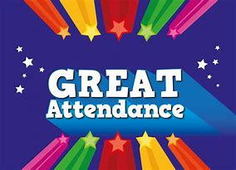
This week has started off well with 97% whole school attendance. Thank you for ensuring that your child is in school and on time every day. By doing so, you ensure that your child does not miss any valuable learning time. Doors open at 8.50am every day.
Uniform
The children look so very smart in their school uniforms. Please ensure that your child continues to wear the correct school uniform or PE kit everyday. The PE uniform stipulates a plain white t-shirt – multicoloured, football or sports tops are not permitted. Further guidance is available on our school website https://www.st-clares.manchester.sch.uk/parents/uniform-information
Meet the Teacher Meeting
Thank you to everyone who attended our ‘Meet the Teacher’ information session on Wednesday night after school. We love welcoming you into school! If you were unable to attend, the powerpoints containing the useful information will be available on your child’s class page on the school website.
https://www.st-clares.manchester.sch.uk/
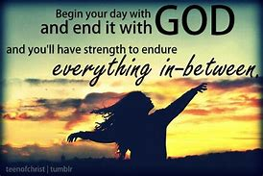

Support
We know that families may experience difficult times and difficult situations throughout a year, especially with the cost of living increase. We are here to support you in any way we can - should you need it. If you are experiencing any financial or other worries, please get in touch. If we are unable to help you, we may know of a group who can help. Please contact Mrs Sylvester at school for a discrete conversation if you require some support.
Upcoming dates:
Mass – 9.15am Tuesday 12th September
Holy Communion Registration – 6pm Thursday 28th September for any pupil in Years 3,4,5 or 6 who have not yet celebrated this Sacrament.

