ST CLARE’S R.C.P NEWSLETTER
Our School Mission Statement: Guided by Jesus Christ, our teacher, we journey together learning to dream, believe and achieve. Friday 6th February 2026
Friday 24th November 2023

This week we held a Times Table Rockstar Day in which knowing times tables off by heart and counting in equal steps was promoted. The children (and staff) looked fantastic and enjoyed the inter-class competitions. Our winning classes from the ‘battles’ will have a longer play as a reward.
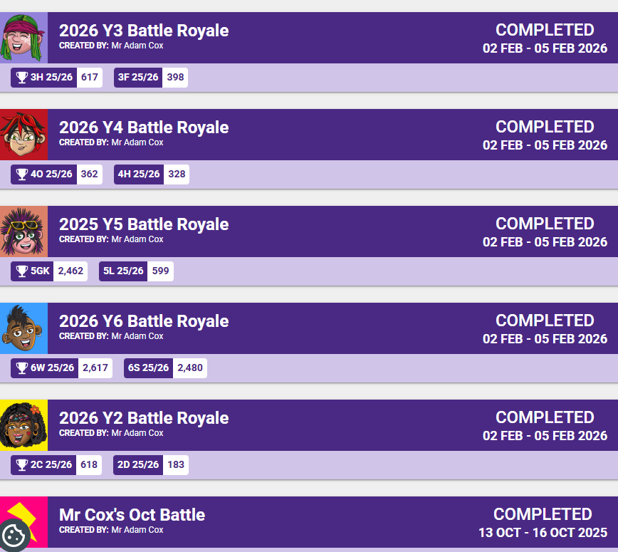In Reception this week, the children read Somebody Swallowed Stanley and looked at the importance of recycling and reusing to look after our planet and animals – something St Francis would definitely advocate. Pupils in the Willow Room have been having fun exploring new balancing equipment and playing peek-a-boo. In Year 1 pupils have been working on subtracting from numbers up to twenty. Year 2 have completed an exploratory task showcasing our oracy skills researching which animals live in the Arctic and Antarctic. Year 3 have written a diary entry as if they were living in the Stone Age. Year 4 were treated to a free showing of Cinderella at the Palace Theatre this week which they thoroughly enjoyed. In their basketball lessons, Year 5 have been learning different styles of defence: player-on player and zone defending. Year 6 have been planning and writing an informal letter based on the experiences of people in WW2.

Assembly
Next week RS and 4H will be leading our assemblies. You are very welcome to come and join us on Monday at

at 2.30pm for RS and Wednesday at 9am for 4H.

Come and pray

Our chapel / KS2 prayer garden is open each Tuesday morning before school for staff, pupils and parents to come and pray privately. Starting the day with God is a
beautiful way to begin the morning. You are very welcome to pop in from 8.15am each Tuesday.

Deanery Mass
A special Deanery Mass will be held in St Clare’s church on Wednesday 25th February at 7.30pm. It is a Station Mass linked to the season of Lent. During Lent we are invited to pray more. You are all invited to attend as members of our community, but Father Jeremiah has requested as many children as possible attend to act as a choir.

Pupil certificates

 | Pupil of the week | Achievement
N | Darla for settling into Nursery so well and following all routines beautifully. | Victoria for making a great start in learning our Set 1 sounds during phonics sessions
RDM | Nadia K for always being ready to learn and share her wonderful ideas! | Mayah for fantastic work about recycling using the discussion guidelines
RS | Nazarii for having a fantastic week settling into our routines at St Clare’s. | Jesse for amazing independent writing!
Y1G | Tare for always challenging himself and asking questions about all topics. | Daisy for her amazing leadership skills to help her group create a dance in PE.
Y1S | David for trying his hardest in everything he does. | Layla for working very hard with her writing.
Y2C | Oscar B for always trying his hardest and being ready to learn | Aminathi for showing great knowledge of bonds to 6
Y2D | Chidumebi for always being so enthusiastic during singing and celebration of the word. | Frankie for making an excellent Zambian hut using clay.
Y3F | Teti for being an exceptional example to her peers | Hugo for producing some wonderful work in RE about Jesus, miracles
Y3H | Ryan for being a good sport when playing board games. | Isabelle L for an incredible improvement in her spelling tests.
Y4H | Harlen for being kind and considerate member of the class | Julia for scoring full marks on her times tables test. 95/95!
Y4O | Jaxley for pushing himself this week and having great behaviour throughout. | Rehoboth for trying so hard with his maths work this week.
Y5KG | Esey for always being ready to learn and wanting to do his best in every lesson. | Esra for being such a resilient learner and always challenging herself with difficult problems in maths.
Y5L | Denver for his positive attitude towards learning | Rory for his wonderful Alan Peat sentences in his Literacy
Y6S | Phaedra for being an outstanding example of how to conduct yourself in school. | Ludiana for a very pleasing improvement in her arithmetic assessment score.
Y6W | Lennon for his fantastic attitude towards our TTrockstars battle this week. | Tyssianna for a massive improvement in her arithmetic assessment scores.

Headteacher Awards
Lucas in Nursery for independently creating a wonderful cave for his homework!
Rosie in 2D for always being ready to learn and setting a good example to others.
Keriane in 4O for being a great role model.
Jake in 5L for inspiring other children with his fantastic home writing

Attendance
Overall whole school attendance this week is 94.7% which is an improvement on previous weeks. The best class for attendance this week is 1S with 99%. Well done to them, they will have a longer break as a treat.

School doors open at 8.40am to give the children time to take off their coats and be ready at their desks for an 8.45am start. The doors close promptly at 8.45am.
Under the UN Convention on the Rights of the Child (UNCRC), Article 29, children have the right to an education. If you are experiencing any difficulties or require any additional support with attendance or punctuality, please contact our Attendance Officer, Mrs Burgess Hamlett.

National Year of Reading
The government have announced that this year will be a national year of reading. The aim is to improve reading for pleasure amongst children. We do try and promote a love of reading amongst our children as reading is such an important skill that they will need for the rest of their lives and is a great way to relax and switch off from the busyness of the day. Thank you to the parents who came into classes to read to the children. Our older children also spent time with our younger ones this week sharing books and reading stories together. We will keep you informed of what else we are doing this year to promote a love of reading. We have spent a substantial amount of money on new library books which the children chose and are excited to read.

Young voices
Last night, our school choir took part in the Young voices concert at Co-op Live. They were part of an 8552 children’s choir. They absolutely loved the experience and the joy on their faces as they sang and danced the night away was a pleasure to see. They really are a credit to you and to our school.

Tombola
We are holding a chocolate tombola in school with a number of prizes available, suitable for Valentine’s Day gifts. Tickets are available from the office – 50p each or 3 for £1. If your ticket ends in a 5 or a 0, you win a prize.
Money raised will go into our school fund.

Valentine’s Day biscuits
On Friday 13th February, Valentine’s biscuits will be on sale before school on the front playground. They will be £1 each. All proceeds will go to our school fund.

Online safety advice
There is support and guidance for parents available about managing your child’s digital life. The following link will give you some advice if needed.
https://www.childrenscommissioner.gov.uk/resource/what-i-wish-my-parents-or-carers-knew-a-guide-for-parents-and-carers-on-managing-childrens-digital-lives/

Support
As a school we are here for both your children and your family. If you are experiencing any difficulties or have any anxieties, please get in touch with Mrs Sylvester for a private conversation. Her email address is c.sylvester@st-clares.manchester.sch.uk or you can ring the school number or message via the school app. If we are unable to help you, we may be able to refer you to somebody who can.

Safeguarding
Safeguarding children is everyone’s responsibility. If you have any concerns regarding the safety of a child, please report it. You are able to refer concerns directly to children’s services or via school.

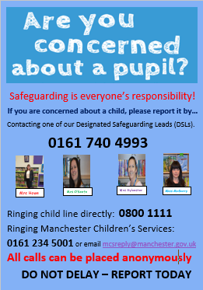

Just a reminder that we close on Friday at 3.15pm for our half-term break.
Have a wonderful weekend!
Mrs Howe

Upcoming dates

8th February – family mass 10.30am
13th February – finish for half-term

The weekly newsletter is also available on our school website Newsletters

