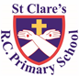

ST CLARE’S R.C.P NEWSLETTER

Our School Mission Statement: Guided by Jesus Christ, our teacher, we journey together learning to dream, believe and achieve. Friday 14th February 2025

Friday 24th November 2023

Happy Valentines Day! I hope that you have had the chance to spend time with the people who you love.

This week the parish community said goodbye and thank you to Father David who was a big part of St Clare’s parish and a welcome, regular visitor to our school. A group of our children were honoured to represent the school at Father David’s funeral. They sang beautifully and really added to this special requiem Mass. The family of Father David and parishioners were extremely complimentary about the children. Thank you for allowing your children to attend.

Our Nursery children have been making a good friend potion this week as part of their RE topic. In Reception, the children have been learning about St Valentine and writing cards for the people they care about. In science, Year 1 have been testing absorbent and non-absorbent materials. Year 2 have been learning about animals that live in Zambia. Year 3 have been practising their cutting skills by making wraps in their DT lesson. Year 4 have designed a piece of Viking jewellery and then made it out of clay. In DT, Year 5 have been making pop-up books. Year 6 had a great day on Wednesday dressed as World War 2 evacuees – they looked amazing! They took part in many activities including baking with rations, role play, cracking morse code messages, making an oscillator and creating Blitz artwork. Thank you to you if you were able to attend the showcase at the end of the day.

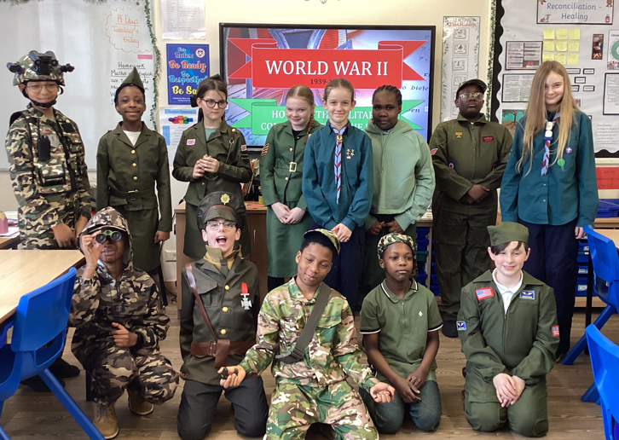

**Assembly**

5K led our assembly this week by relaying the story of Martin Luther King and his quest to strive for equality for all people in America. They relayed his actions to the call from Jesus to ‘ love one another as I have loved you.’ In a world where inequality, hatred and racial discrimination still lives, the children led us in prayers for justice, equality and love.

Thank you for joining us in this Celebration of the Word.

**Chapel / prayer garden**

Our chapel / KS2 prayer garden is open each Tuesday morning before school for staff, pupils and parents to come and pray privately. Starting the day with God is a beautiful way to begin the day. You are very welcome to pop in from 8.15am each Tuesday.

**Pupil Certificates**

|  |  |  |
| --- | --- | --- |
|  | Pupil of the week | Achievement |
| N | Daniel G for settling into Nursery so beautifully! | Nadia S for making a beautiful love heart for Valentine’s day! |
| RDM | Daisy for always being ready to learn and setting a great example! | Molly-Mae for brilliant maths work about long and short |
| RS | Asa for an amazing final week at St Clare’s. We are going to miss you! | Thea for remembering to use finger spaces in her independent writing! |
| Y1G | Briony for her increasing independence. Her work this week has been brilliant! | Matilda for writing an amazing recount with lots of features. |
| Y1S | Iris for always doing the right thing and making the right choices. | Olivia for trying very hard with her handwriting and presentation in books. |
| Y2C | Milena for always being ready, respectful and safe | Talia for an amazing Zambian hut. |
| Y2D | Olivia G for being a fantastic role model to others and always being ready to learn. | Lexi for your amazing ideas during our English lessons and for turning them into a wonderful non-chronological report. |
| Y3F | Pablo for really trying hard with his learning this week. | Saffron for always having an answer ready when asked a question. Always listening to adults and children. |
| Y3H | Ophelia, for beautiful work on reconciliation in RE. | Joy, for excellent work on fractions. |
| Y4H | Rory for always behaving well in class and following school rules. | Freddy, for some fantastic Viking Recount writing. |
| Y4O | Daniel for always being a kind, considerate and supportive member of the class! | Alex K for having a fantastic understanding of States of Matter in our Science lessons! |
| Y5G | Bradley for his excellent effort this week. | Isla for her excellent work in her newspaper report |
| Y5K | Isla for being an all-round superstar! | Sofia for her fantastic fact-file on the Havasupai |
| Y6S | Siam for always following our school rules and being a great role model for year 6! | Tianna for including higher level vocabulary at every opportunity in her writing, it is great to see. |
| Y6W | Sharon for her fantastic contributions to the class artwork during WW2. | Tope for his fantastic work during the algebra topic. |

**Headteacher awards**

Dior in RDM for always setting a good example to others.

Norah in 1S for caring for the class environment.

Lennox in 2D for being a great role model and having wonderful times table knowledge.

Jamie in 3H for always being kind, helpful and hardworking.

Esra in 4O for beautiful handwriting.

Laura in 6S for great Blitz artwork.

**Caritas Award**

The Caritas Award is presented each week to a child in recognition of their outstanding achievement in putting love into action. This week the award goes to Skylar in 5G for being so loving and welcoming to a new member of the class.

**Pilgrims of Hope**

One of the three diocesan anchors, that are travelling around all schools in the diocese, arrived at school on Monday. Some pupils from St Anne’s in Crumpsall had the honour of delivering it to us. They were welcomed by our Mini Clares and shared some refreshments with them. All the pupils then shared a Celebration of the Word which was led very confidently by our Mini Clares.

The children spent some time thinking of what they hope for the future for all people. This special year offers us an opportunity to reignite the flame of faith in our own hearts and to share the light of that faith with those in darkness.

We have now safely delivered the anchor to Our Lady’s High School.

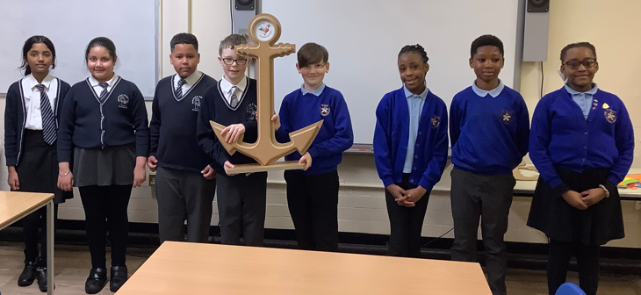

**Attendance**

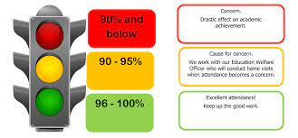

Overall whole school attendance this week is 93.4% which is lower than last week. Thank you for getting your child to school on time each day. The number of lates this week was 55 pupils late 66 times. The number of lates after the register has closed was 17 pupils late 18 times.

Under the **UN Convention on the Rights of the Child (UNCRC),** **children have the right to an education**. If you are experiencing any difficulties or require any additional support with attendance or punctuality, please contact our Attendance Officer, Mrs Burgess Hamlett.

The best classes for attendance this week were 1G and RS with 97% - well done to them! They will receive a longer break time next week.

**Support**

As a school we are here for both your children and your family. If you are experiencing any difficulties or have any anxieties, please get in touch with Mrs Sylvester for a private conversation. Her email address is [c.sylvester@st-clares.manchester.sch.uk](mailto:c.sylvester@st-clares.manchester.sch.uk) or you can ring the school number or message via the school app. If we are unable to help you, we may be able to refer you to somebody who can.

If you are struggling to buy food at the moment, please contact school. We do not want any families to go without food. We do have contact with some food banks who may be able to offer support.

**Safeguarding**

**Under the United Nation Convention on the Rights of a Child, all children under the age of 18 have a right to be protected from violence, abuse and neglect (Article 19) and a right to be alive (Article 6).**

There are many forms of abuse – sexual, neglect, emotional, physical, online – and it is everyone’s responsibility to safeguard children from any harm.

If you have any concerns regarding the safety of a child, please report it. You are able to refer concerns directly or you can contact one of the Designated Safeguarding Leads in school. Contact details can be found below.

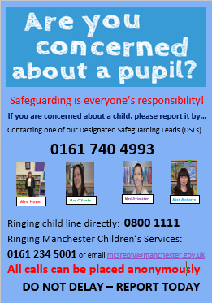

**Whitworth Gallery**



**Parent Workshop**

Our SENDCo has organised for Ceri Hewitt, a Health Improvement Practitioner who specialises in unintentional injury prevention, to come in to school to deliver a parent workshop. The workshop will offer advice, top tips and suggestions for parents/carers to help reduce unintentional injuries in the home. The session is for **one hour** and will be held in school on **Thursday 6th March 2pm-3pm**.In order to organise a suitable area within school to hold the workshop, please complete the form below if you wish to come along to this event.

<https://forms.gle/UipqxkgaEBc7KPrB6>

There is also a section on our school website which offers advice on unintentional injuries <https://st-clares.manchester.sch.uk/parents/unintentioonal-injury-prevention>

**Community Grocer**

There is free registration with the community grocers throughout February at the community grocers opposite Conran Street Market.

We finish today for half term. I hope that you have a great holiday and that you come back to school feeling refreshed. School re-opens on Monday 24th February.

Mrs Howe

**Upcoming dates:**

Monday 24th February – Young Voices at the Co-op Arena

Monday 3rd March – school class photographs

Thursday 6th March – World Book Day (children dress as a word)

Thursday 6th March – Parents’ workshop on unintentional injuries

Sunday 9th March – Family Mass 9.30am in church

***The weekly newsletter is also available on our school website***[*https://st-clares.manchester.sch.uk/parents/newsletters/newsletters-2024-2025*](https://st-clares.manchester.sch.uk/parents/newsletters/newsletters-2024-2025)

**A Prayer of Hope**

