ST CLARE’S R.C.P NEWSLETTER
Our School Mission Statement: Guided by Jesus Christ, our teacher, we journey together learning to dream, believe and achieve. Friday 1st March 2024
Friday 24th November 2023

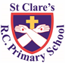
Welcome back to a new half-term. It is so lovely to have the pupils back in school albeit for a short half term.
I would like to thank you all for coming into school and sharing learning experiences with your children. Many parents have attended workshops, stay and plays and end of topic celebrations in class. The children love sharing their learning with you. Thank you so much for coming!
If you feel that there are any areas that we can support you with further by putting on a workshop, please contact me at school via the office.
Similarly, if anyone would like to come into class to share any of your cultural practices / traditions with the children e.g how you celebrate Easter, again please contact me at school via the office.
This week, In Nursery the children have been reading about Elma the elephant and have made colourful collage pictures of him. Reception have been reading Jack and the Beanstalk and were excited to find giant footprints and golden eggs in class. In history, Year 1 have been looking at photographs of Manchester to distinguish between the past and present. Year 2 have also started their history topic on the Great Fire of London and have been looking at photographs to compare the past and present. In science, Year 3 have been comparing the effect of different factors on the growth of plants. Year 4 carried out a nature walk to get inspiration for their haiku poems. In maths, Year 5 have been finding equivalent fractions and decimals. As part of their evolution and inheritance science topic, Year 6 have been looking at inherited characteristics.

Assembly
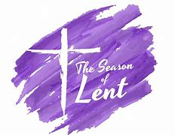

Our Mini-Clares led the assemblies this week and focused on Jesus’s time in the desert alone and whether we want to be like bread or stone during this season of Lent. Bread is nourishing, soft to touch, gives life and can be broken and shared with others; whilst stone is hard, cold and can be destructive. Children reflected on whether they wanted to be there for others when needed; whether they wanted to be kind-hearted and peace-makers; and whether they wanted God’s love and gentleness to shine through them. Alternatively, they could be selfish and cold hearted and shatter the lives, dreams and hopes of others. The children were able to recognise whether they would want to be like bread or stone.
4H and 2O assembly
On Monday 4th March, 4H will lead our KS2 assembly at 9.05am and 2O will lead their class assembly at 2.40pm. Parents and carers are invited in to join us.
Creation Walks
During Lent we are invited to pray more. As parents, you will be invited into school to share a Creation Walk
with and led by your children. During this walk, we will pray and reflect on three areas: our wonderful world; those people in the world who experience problems – hunger, sickness, homelessness; and caring for our world. We will notify you of the dates.

Acts of kindness
Lent is a very important season in our liturgical year. The children brought home a calendar for Lent which suggests different acts that they can complete. They reflect the three main foci for us – to pray more, to fast / go without something / do something extra and support those in need.
Each child has been given a sheet and if they complete 20 acts of kindness or 20 of the activities on the calendar, they will receive a small cross badge at the end of the season. There should be a separate action for each day. The cross will reflect the fact that they have been following in Jesus’s footsteps. The sheet will
be signed by you to detail what your child has done and returned to school prior to the Easter holidays.

St. Joseph’s Penny
Children have been given St Joseph Penny boxes for them to fill during Lent and return when we finish for Easter. The money goes to CARITAS.

Francis House
Each year, we sell crème egg chicks on behalf of the children’s charity, Francis House. They will again be sending us a batch of them to sell in school. They arrive on Monday 4th March. Francis House have requested that they be sold at £2 per crème egg chick.

Morning Prayers
Our school chapel is open every Tuesday morning from 8.30 -9.00am for parents (and children) to come into school for some private prayer, some time alone with God or quiet reflection.
Pupil certificates
 | Pupil of the week | Achievement
N | Uhmiana for always using her manners so beautifully | Lula for amazing name writing! She has formed all of her letters correctly.
RDM | Anaya for an excellent start to the half term! | Olivia S for excellent work about time in maths this week
RS | Mickey for being so imaginative in the creative area | Zion for using great language related to time in our maths lessons
Y1D | Jacob for always being such a kind and helpful member of our class. | Tommy for working hard to form letters correctly.
Y1G | Tomasz for always having a fantastic attitude to his learning. | Uririoghene for great number work counting to and back from 50!
Y2C | Julia for always trying her best | Shay for trying his hardest with his letter formation
Y2O | Ellion for participation in lessons and group discussions. | Lewis for his amazing knowledge on plants!
Y3F | Phoebe for having a great start to this half term, keep it up! | Oliver for doing some amazing work in Re on Reconciliation looking at the parable of the Prodigal Son
Y3H | Leah for an excellent start to the half term. She has shown excellent concentration and contributed well to all lessons. | Olivia K for excellent knowledge of fractions.
Y4H | Princess for always behaving beautifully and being respectful to others. | Darcie for some incredible work in maths! She has been flying through her questions!
Y4S | Hepzibah for being a brilliant role model to everyone in our class and always putting 100% effort into everything she does. | Max for fantastic poetry this week! He has written a brilliant Haiku and Tanka.
Y5G | Lewis for excellent focus this week, helping around the classroom and making great progress with his writing! | Ella for producing an excellent piece of work about the planets in our Solar System.
Y5W | Poppy H for being a role model for the class with her behaviour and work. | Adam for producing fantastic work all week, especially in science, history and art.
Y6K | Jack M for a brilliant attitude to his learning and for always working with enthusiasm and purpose. | Yamar for some excellent descriptive writing in English this week.
Y6S | Kaja for always being ready for every lesson and putting 100% effort into all of her work. | Ade for fantastic maths work this week on fractions, decimals and percentages.

Headteacher’s awards:
Abbie in RDM for fantastic improvement in her letter formation.
Hugo in 1D for working really hard on his concentration.
Jaxon in 2O for always being ready to learn.
Toby in 4H for sharing his faith so publicly with others.
Desmond in 5G for being a great role model.
David in 6S for working so well and improving his output this week.
Caritas Award
The Caritas is awarded each week in recognition of someone in school who has shown kindness to others by putting love into action. The award this week goes to Prince in 1D for showing love and kindness by encouraging other children and always celebrating everybody’s achievements. How beautiful!

Attendance
This week our whole school attendance is 95.9% which is an improvement on last week. The best classes this week are 1G and 5G who both achieved an amazing 100%. They will be rewarded with an own clothes day next Friday. Well done to both classes!
Millionaire Reader
This week, we have a new millionaire reader. Huge congratulations to Cora in 5W for this great achievement. She will receive a voucher.
School photographer
This school photographer is in school on Monday to take individual photos of the children.
World Book Day
Next Thursday is World Book Day and we are asking the children to dress up as a word. You do not need to spend any money on costumes – the costumes can be as simple or elaborate as you want. Here are a couple of simple ideas, but there are lots online if you search:
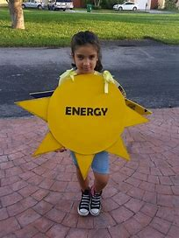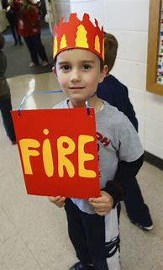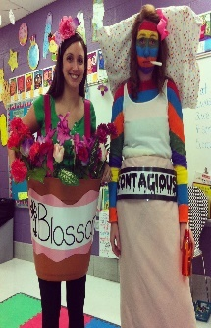
Please remember to redeem your £1 book token by 31st March 2024.
Year 6 SATs
The government have produced a document to inform parents about the Key stage 2 SATs taken by Year 6 pupils in May. It is vital that your child attends school during SATs week. Please click on the link for the information:
https://assets.publishing.service.gov.uk/media/65d8800b87005a001a80f8b5/2024_Information_for_parents_assessment_results_at_the_end_of_key_stage_2.pdf

Support
As a school we are here for both your children and your family. If you are experiencing any difficulties or have any anxieties, please get in touch with Mrs Sylvester for a private conversation. Her email address is c.sylvester@st-clares.manchester.sch.uk or you can ring the school number or message via the school app. If we are unable to help you, we may be able to refer you to somebody who can.

Safeguarding
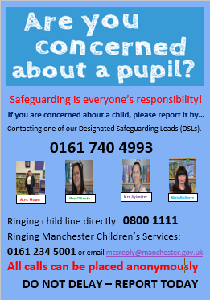
Safeguarding children is everyone’s responsibility. If you have any concerns regarding the safety of a child, please report it. You are able to refer concerns directly or you can contact one of the Designated Safeguarding Leads in school. Please see the poster below for more details.

Wishing you all a lovely weekend,
Mrs Howe

Upcoming dates:
Monday 4th March – school individual photographs
Thursday 7th March – World Book Day (dress as a word)
Sunday 10th March – Family Mass 10.30am
Saturday 16th March – Sacramental Programme Day
Wednesday 20th March – parents evening
Wednesday 20th and Thursday 21st –Reconciliation
Wednesday 27th March – finish for Easter

