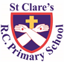
ST CLARE’S R.C.P NEWSLETTER
Guided by Jesus Christ, our teacher, we journey together learning to dream, believe and achieve.
Friday 3rd March 2023

Dear Parents / Carers,
Welcome back to the fourth half-term of the year. I hope you enjoyed the week’s break. Many of our classes were closed on Tuesday due to strike action. Further strike days are planned for 15th and 16th March unless a resolution is reached prior to the dates. I will advise you further nearer the time.
This week in school our Nursery children have been reading ‘Brown bear, brown bear what do you see?’ They have been for a walk outside, made up their own story and drew a story map relating to the story. In Reception, the children have been learning how to represent the numbers 9 and 10. They have also been reading ‘Jack and the Beanstalk.’ In religion, Year 1 have been learning about the Last Supper. In science, Year 2 have begun to look at how seeds and bulbs turn into plants. Year 3 have been learning how to represent fractions on a number line and what happens during the different parts of the Eucharist. Year 4 have also been working on how to subtract fractions. In maths, Year 5 have been exploring the link between fractions and decimals. Year 6 have been exploring holiday brochures in preparation for writing a persuasive piece next week.

Assembly
This week, 2C and 6H led our assemblies about Lent. They reminded us of Jesus’s forty days in the desert where he was tempted by the devil to prove his power. The importance of prayer, giving alms and fasting were discussed and Lenten promises shared.
Pupil Certificates
 | Pupil of the week | Achievement
N | Gilly for always doing the right thing and setting a wonderful example to his peers. | Florence for being very helpful around the classroom and tidying up our areas amazingly.
RBD | Yohannes for always being friendly and kind to others. | Rosie for great independent writing
RS | Annie Rose for offering good ideas during carpet sessions. | Ryan for doing some super decoding!
1D | Jacob K for always making me smile with your polite manners and positive attitude to learning. | Deborah for your beautiful handwriting and always presenting your work neatly.
1G | Jaxon for having a caring attitude to his friends in class. | Bryn for confidently counting forwards and backwards between 20 and 50.
2C | Honor for working incredibly hard all week | Rayarna for the amazing work she has completed around our new book The Last Wolf
2O | Elizabeth for being so engaged and creative in all of our WBD activities | Marnie for being so helpful this week in class and working so well with her shoulder partner.
3A | Toby for always encouraging his classmates and setting a lovely example to everyone | Roman for brilliant participation and teamwork skills during forest school
3K | Eunice for being a star in class and a great example and role model to her classmates! | Isla for coping extremely well in Maths this week when completing some very tricky fractions work!
4H | Ava for making a fantastic 3D model of the Amazon River for her half-term homework. | Karis for always working hard in everything that she does. Her information booklet on the Nile was fantastic.
4S | Kyle for a fantastic attitude this week and reading and quizzing lots. | Laura for making a brilliant 3D model of a river for her half-term homework.
5G | Vonn for being the best version of himself this week and setting a good example. | Kaja for growing in confidence and independence in maths lessons! You are doing so well!
5W | Abigail for putting in 100% effort into her work, especially in science. | Archie for fantastic maths work this week on thousandths.
6F | Evie for always trying her best and being amazing in everything she does! | Grace for doing some excellent investigative work in maths on area and perimeter
6H | Zac is a fantastic helper around the classroom, he loves to colour code our exercise books and help me make the maths working wall look beautiful! | Jake has done some amazing maths work this week, he is making great progress!

Headteacher Awards
Miles in N for using his phonic knowledge independently in the writing area.
Anuli in RS for writing a great story independently and without prompting.
Pixie in 1D for working hard to recognize nouns, verbs and time adverbials.
Arwaa in 3A for making a brilliant Stone Age hut at home.
Nadia in 4S for writing two pieces of work at home linked to the class topics.
Oliver T in 5G for working so hard to be an amazing writer and inspiring others with his ideas,
Ella in 6H for always being respectful to adults and helpful.
Caritas Award
The Caritas award this week goes to Jacob W in 5G for showing kindness, care and inclusivity to fellow classmates during their forest school session. Well done Jacob!

Attendance
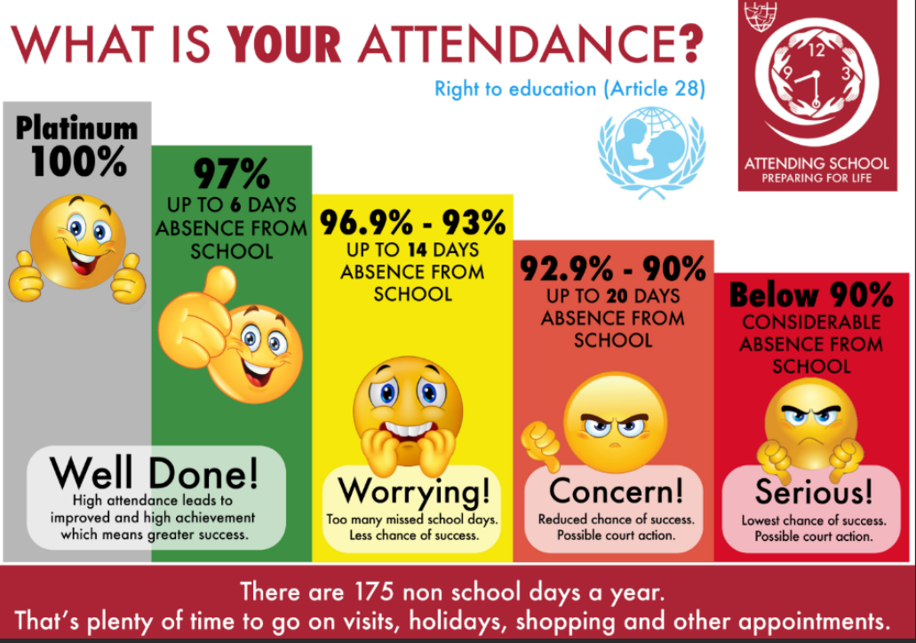
Attendance this week for the whole school is 95.9%. We are moving closer to our target of 97%.
Absences this week equate to 81 days which is 405 lost learning time.
The best class this week were 1D with 99.2%, so they will have a longer breaktime as a reward. Well done!

Nursery admissions September 2023
If you have a child, or know of a child, who was born between 1st September 2019 and 31st August 2020 they are eligible to apply for a Nursery place for September 2023. Please come into the main office in school and fill in an application form if you want a Nursery place for this September.
Year 6 SATs week
Year 6 SATs are due to take place from Tuesday 9th May to Friday 12th May. It is vital that holidays during this period are not booked. All Year 6 pupils will be expected to be in school every day during SATs week and on time due to the timings of the assessments. I know May seems a long way off, but it will soon be here.

St Joseph Penny boxes
The season of Lent begins during our half term holidays. Lent is a season to pray, fast and give. The children have all been given St Joseph penny boxes in order to collect any loose, spare change yourself or other family members may have. The money raised will go to Caritas to support families within the local area. The boxes do not need to be returned to school until when we finish for Easter.
The Big Lent Walk
As part of our Lenten actions, the mini-Clares are organising a sponsored Big Lent Walk. The aim is that all the pupils will help their class to walk 14 miles during Lent. Jesus walked 600m from the courthouse to Golgotha where he was crucified. We are asking classes to make this walk forty times, to link to the forty days of Lent. The children will be bringing home sponsor forms and the money raised will be sent to support the work of CAFOD.

Upcoming dates:
Tuesday 9th – 12th May – Year 6 SATs week.
Monday 13th March – school photographs
15th and 16th March – possible future strike dates
Wednesday 29th March – parents evening
Sunday 2nd April – Family Mass 10.30am
Wednesday 5th April – finish for Easter 1.15pm

I hope that you all have a lovely weekend,
Mrs Howe.

