ST CLARE’S R.C.P NEWSLETTER
Our School Mission Statement: Guided by Jesus Christ, our teacher, we journey together learning to dream, believe and achieve. Friday 27th February 2026
Friday 24th November 2023

Welcome back and welcome to the lighter nights and slightly warmer, brighter weather. Spring is around the corner and daffodils are sprouting up everywhere.
The holy season of Lent has begun and we are reminded of the late Pope’s advice on fasting:
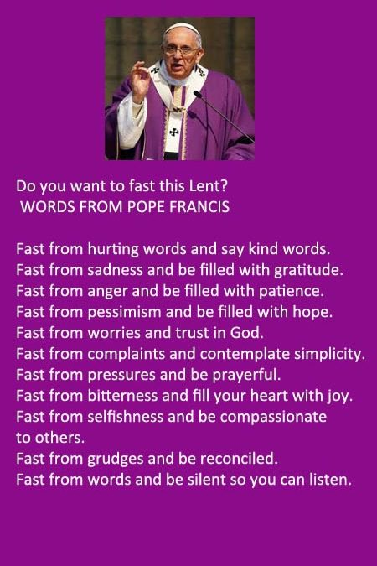
We welcomed Jacqui from CAFOD into school this week and she led an assembly for all the children. In it, Jacqui showed how money raised can be used to provide areas in Bangladesh with flood resistant floating gardens. £231 will help feed a family in Bangladesh for a year. Our Christmas fundraiser resulted in £600 being raised for supporting the work of CAFOD. It was good for the children to see how the money could have been used and to see how we have responded to the Catholic Social Teaching call.
In nursery this week, the children have been learning how to mirror each other during their gymnastics lesson. The children worked in pairs, carefully watching their partner’s movements and copying them as accurately as possible. Reception have had the Living Eggs in class this week and have been very excited to watch 10 chicks hatch. They are very cute! In art, Year 1 have been looking at artwork from Georgia O’Keefe and how she zoomed into flowers. In history, Year 2 have started learning about the Great Fire of London and when it happened. Year 3 in history have started looking at how

the Stone Age ended and became the Bronze age, due to them starting to create bronze. Year 4 have been creative this week and have created Dragon eye amulets using clay.On Tuesday, our Year 5 children went to Jodrell Bank on their school trip. They had a fantastic day learning about space and taking part in some wonderful experiments and activities. It was a brilliant start to their science unit of Earth in Space. Year 6 have had fun learning to do the New Zealand Haka’ dance in PE

Assembly
Jesus was led up by the Spirit into the wilderness to be tempted by the devil. And after fasting forty days and forty nights, He was hungry. Matthew 4:1-2
In this week’s assembly, the children were reminded that Jesus faced challenges in the desert, but each time He was tempted, He chose God. At the start of our Lenten journey, children are invited to follow Jesus’ example by saying ‘Yes!’ to God and to trust in His help in difficult times.

Class Assemblies
On Monday 3H will be leading our KS2 assembly at 9am and 1G will be leading assembly in KS1 at 2.40pm. You are very welcome to join us.

Lenten activities
Our Mini-Clares have decided that they would like to ask all pupils to carry out 20 acts of kindness during the season of Lent. Your child will have been given a sheet for you to note the acts of kindness on. Upon completion, your child will be given a gold cross to symbolise that we are travelling with Christ to the Cross in Lent. The idea is that the acts are spread out over Lent and not all completed within the first week.
The Mini Clare's have also asked if during the season of Lent, you could spend some time at home with your child making a Cross or an Easter scene for us to display around school. This will give you the opportunity to discuss the importance of Lent. As we are called in the encyclical Laudato Si, to care for our common home, we ask you to make your Cross from things that you can recycle in your home – please do not go out spending any money. If you do make one please send it in to your child’s class teacher.
Finally, the Mini-Clares have created Lenten prayer packs which will be sent home for your family to partake in prayers together. "For where two or three are gathered in my name, there am I with them"
We hope that you enjoy completing your acts of kindness, praying together and look forward to seeing what the children create!
We have also ordered the St Joseph Penny boxes which have been sent home today. The boxes are used to collect any spare change that you may have and wish to donate.

Come and pray

Our chapel / KS2 prayer garden is open each Tuesday morning before school for staff, pupils and parents to come and pray privately. Starting the day with God is a
beautiful way to begin the morning. You are very welcome to pop in from 8.15am each Tuesday.

Deanery Mass
A special Deanery Mass will be held in St Clare’s church on Wednesday 4th March at 7.30pm. It is a Station Mass linked to the season of Lent. During Lent we are invited to pray more. You are all invited to attend as members of our community, but Father Jeremiah has requested as many children as possible attend to act as a choir. Please
fill in the consent form to let us know if your child is able to attend.

Family Mass / Mother’s Day
We welcome links with our parish and are very grateful for the many ways we get to work together and share our faith with the children. There is a family mass schedule for Sunday 15th March at 10.30am. As it is Mother’s Day, Father has asked that the children from school lead the parish in this celebration. All children are encouraged to attend the mass and it would be great if they could come and sit with the ‘choir’ for the Mass.

Pupil certificates
 | Pupil of the week | Achievement
N | Noah for being a superstar all week and following every one of our golden rules. We are so proud of you! | Isabelle for being able to read simple CVC words independently!
RDM | Natna for always working hard and being ready to learn! | Michael for brilliant writing about “Jack and the Beanstalk.”
RS | Rosie for making a fantastic Jack and the Beanstalk house in the creative area! | Isla for improving her confidence in talking to her partner on the carpet, she shares so many good ideas now!
1G | Clay for showing everyone in school his beautiful manners and working hard on his first week. | Aria-Rose for her great hot seat answers about Jack and the Baked beanstalk.
Y1S | Joelvy for always putting 100% effort into everything he does and completing amazing work everyday. | Zion for working so hard on his handwriting and showing a fantastic improvement.
Y2C | Tobi for always being ready to learn | Savanna for her amazing division knowledge
Y2D | Olivia S for always being ready and respectful. | Fauziyah for identifying subjects and verbs in our English lesson.
Y3F | Chloe for being an amazing help in the classroom this week, always wanting to do a job | Finley for doing amazing work this week and really concentrating on his handwriting. Keep it up!
Y3H | Leala for writing a detailed description of how bronze is manufactured. | Kai for reading and presenting with great expression.
Y4H | Saffron for being a super star all day, every day! | Curtis for working really hard to understand fractions and having a fantastic attitude to learning!
Y4O | Anthony for being a great partner, always helping and ready to share | Pippa for creating a fantastic dragon eye amulet in art!
Y5KG | Evana for always being respectful, ready to learn and setting high expectations for herself! | Henry for making a huge effort to improve his handwriting by consistently joining up.
Y5L | Grace for a fantastic first week at St Clare’s RC Primary school. | Olivia K for her outstanding enthusiasm, confidence, and clarity when sharing knowledge and information about Space.
Y6S | Bradley for his enthusiasm towards his science learning this week. | Evie for her effort and enthusiasm in her maths work this week, she has worked extremely hard.
Y6W | Oleksandr for his fantastic attitude towards his work and always trying to improve his understanding. | Elsie for her great effort in her writing this week, always trying to improve her grammar and vocabulary.

Headteacher Awards
Denylson in RS for making great progress in his phonics!
Uhmiana in 1S for being an amazing friend who always cares for others and makes sure no one is left out.
Samad in 4H for a great piece of descriptive writing using excellent vocabulary.
Lacey in 6W the children have for always giving 100% in everything she does.

Caritas Award 
The Caritas Award is presented each week to a child in recognition of their outstanding achievement in putting love into action. This week the award goes to Tyler in Y5 for being vigilant and helpful when someone tried to take something that was not theirs.

Attendance
Overall whole school attendance this week is 94.1%. The best class for attendance this week is 6S with 99%. Well done to them, they will have a longer break as a treat.

School doors open at 8.40am to give the children time to take off their coats and be ready at their desks for an 8.45am start. The doors close promptly at 8.45am.
Under the UN Convention on the Rights of the Child (UNCRC), Article 29, children have the right to an education. If you are experiencing any difficulties or require any additional support with attendance or punctuality, please contact our Attendance Officer, Mrs Burgess Hamlett.

Photographer
Just a reminder that the photographer will be in school on Monday taking class photos. I know that some of you like to do your child’s hair differently and ensure they are more smart than usual for the photograph. 

World Book Day
Thursday 5th March is World Book Day. During the course of the day, children will rotate around different classes focusing on a different author / book and complete activities linked to it.
Our dress-up theme last year was to "dress up as a word", this year to keep things to a minimal cost, our pupils can come to school dressed as a word (like last year), as a book character, wearing only a character's accessories (e.g Harry Potter's glasses), or in their pyjamas ready for bedtime stories. The choice of options enables the children to use things they already have at home so families do not have to buy anything special.

Online safety advice
Thank you to everyone who attended the parent session led by Mr Flint on online safety this week.
If you were unable to attend, he has posted the powerpoint on our website. https://st-clares.manchester.sch.uk/parents/e-safety
There is further support and guidance for parents available about managing your child’s digital life. The following link will give you some advice if needed.
https://www.childrenscommissioner.gov.uk/resource/what-i-wish-my-parents-or-carers-knew-a-guide-for-parents-and-carers-on-managing-childrens-digital-lives/

Our children were also treated to an online safety performance today entitled ‘Tangled Web’ which re-iterated the need to be safe online.

Support
As a school we are here for both your children and your family. If you are experiencing any difficulties or have any anxieties, please get in touch with Mrs Sylvester for a private conversation. Her email address is c.sylvester@st-clares.manchester.sch.uk or you can ring the school number or message via the school app. If we are unable to help you, we may be able to refer you to somebody who can.

Safeguarding
Safeguarding children is everyone’s responsibility. If you have any concerns regarding the safety of a child, please report it. You are able to refer concerns directly to children’s services or via school.

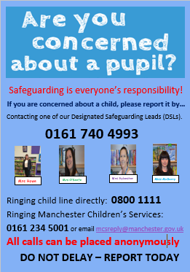

I hope that you all have a peaceful weekend.
God bless,
Mrs Howe

Upcoming dates
2nd March – Class photographs
4th March – Parish deanery Mass
5th March – World Book Day
15th March – Family Mass (Mother’s Day) 10.30am

The weekly newsletter is also available on our school website Newsletters



Lenten prayer:

God of all wholeness,

heal our hearts

of all that prevents us responding

to our sisters and brothers

excluded by poverty

and prevented from living a full and healthy life.

This Lent, may we:

implore justice through our prayer,

stand in solidarity through our fasting,

and reach out through our giving.

Send your life-giving power

to revive the weary,

restore the broken

and renew the face of the earth.

We ask this through Christ our Lord.

Amen.


