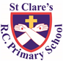
ST CLARE’S R.C.P NEWSLETTER
Our School Mission Statement: Guided by Jesus Christ, our teacher, we journey together learning to dream, believe and achieve. Friday 15th March 2024
Friday 24th November 2023

It has been assessment week this week for most of our pupils. This is where the children get to show what they have learnt and the teacher learns if there is anything that needs a greater focus. We are super proud of our pupils who always do their best.
As part of their RE topic, Nursery have been looking at what we need to grow. Similarly, Reception have been linking how seeds grow to how we grow closer to Jesus during Lent. In dance, Year 1 have been using parts of their body to form positions. In history, Year 2 have sequenced the main events of the Great Fire of London. As part of their science topic, Year 3 have been investigating how plants grow without light and / or water. In Year 4, pupils have been linking their science and geography topic by looking at habitats in rivers. In dance, Year 5 have been using over-exaggerated movements to represent different characteristics. In RE, Year 6 have bee identifying the key aspects of receiving the Eucharist.
Assembly
Our assemblies this week were led by RDM and 3F and dedicated to all the special ladies in our lives who love and care for us. We are blessed with so many people who play an important part in our lives and should remember to thank God for bringing them into our lives and thank you for all they do for us. Thank you to RDM and 3F who were amazing.

Creation Walks
During Lent we are invited to pray more. As parents, you will be invited into school to share a Creation Walk
with and led by your children. During this walk, we will pray and reflect on three areas: our wonderful world; those people in the world who experience problems –

hunger, sickness, homelessness; and caring for our world. We will notify you of the dates. Thank you to everyone who has joined us so far.

Acts of kindness
Children have started to return their 20 Acts of Kindness sheets detailing how they have shown kindness on different days. They have been rewarded with a small, gold badge to represent that they have followed in Jesus’s footsteps.

St. Joseph’s Penny
Children have been given St Joseph Penny boxes for them to fill during Lent and return when we finish for Easter. The money goes to CARITAS.

Francis House
The crème egg chicks have arrived! They are on sale in the school playground or from the main office in aid of Francis House. They cost £2 each. Thank you for your generosity so far.

Morning Prayers
Our school chapel is open every Tuesday morning from 8.30 -9.00am for parents (and children) to come into school for some private prayer, some time alone with God or quiet reflection.
Stations of the Cross
Our Year 5 pupils will be leading us in the Stations of the Cross on Monday 25th March at 9.15am. You are very welcome to join us in church.

Pupil certificates
 | Pupil of the week | Achievement
N | Makayla for always being so enthusiastic about her learning! | Nancy for trying really hard during our RWI sessions!
RDM | Joel for fantastic singing and dancing at our class assembly | Poppy for fantastic sentence writing
RS | Noarh for great blending in Phonics | Iris for amazing independent writing this week
Y1D | Maggie for working hard to stay focussed, be ready to learn and complete all work set. | Elijah for always using capital letters and full stops correctly in his writing.
Y1G | Yaroslav for trying hard in all his assessments this week. | Kendrick for his amazing maths skills this week.
Y2C | Harlen for being such a kind and caring member of our class | Pixie for super focus in her reading quizzes!
Y2O | Joy for being such a caring member of our class this week, making sure everyone else is okay! | Daylia for an amazing letter to King Charles II about the great fire of London
Y3F | Tyler for trying really hard this week during his assessments | Maria for producing a wonderful story based on our class book, ‘The boy who grew Dragons’
Y3H | Logan, for showing fantastic sportsmanship in a PE lesson this week. | George, for some fantastic adverb and adjective ideas to improve his sentences.
Y4H | Arwaa for some beautiful behaviour this week, and for trying hard in lessons. | Casie for trying really hard in maths, I have been so impressed!
Y4S | Archie for being a wonderful role model to everyone, always following our school rules and being so kind to everyone! | Isla for a brilliant double spread page about a habitat in science.
Y5G | Charlie for growing in confidence this week, sharing ideas, working well with her learning partner and even performing in a group! | Zion for showing great progress in his reading and writing during assessment week.
Y5W | Harry for a fantastic week, working hard in his reading and being a role model for behaviour. | Tope for a fantastic improvement in his reading scores.
Y6K | Jaxon, for some excellent defensive work for his team in our invasion games PE lesson this week. | Bella, for a very pleasing improvement in her Maths assessment scores this week!
Y6S | Alfie for a fantastic effort made in all of his assessments this week! | John Joe for improving his handwriting and taking care with his presentation.

Headteacher’s awards:
Caritas Award
The Caritas is awarded each week in recognition of someone in school who has shown kindness to others by putting love into action. The award this week goes to Molly in 4S for being kind to everyone and supporting others in class when needed.
Anaya in RDM for growing in confidence and being a kind friend.
Ethel in 1G for always being kind and ready to help.
Keriane in 2O for great grammar, punctuation and spelling in her work.
Esra in 3F for showing concern and kindness to an injured friend.
Tianna in 5G for showing love to others by purchasing gift boxes for the rosary beads which are being sent to the Ugandan orphanage.
Dennan in 6K for operating the powerpoint in hymns so well,

Attendance
This week our whole school attendance is 95%. This is slightly lower than last week. The best class this week is 5W with an amazing 100%. This is the second week in a row, which is an amazing achievement. They will be rewarded with an own clothes day next Friday and going for the hatrick! Well done 5W!

Parents’ evening
On Wednesday we are holding our Parents’ Evening after school. Please ensure that you have booked an appointment with your child’s class teacher. Education is a partnership, so it is really important that you attend to discuss your child. Celebrate their successes!

Reconciliation
Next Thursday 21st March, pupils who are following the Sacramental Programme will make their first confessions in the Sacrament of Reconciliation. These will be at 6pm in the church. We pray for all our children on their faith journey this year.
To help them prepare for this special occasion, pupils will attend a day with the parish catechists on Saturday 16th March 9.30am -2pm

Prayer garden
Our St Francis prayer garden has been renovated this week. We are delighted with the results. Follow the link to our website to see before and after photographs https://st-clares.manchester.sch.uk/religious-life-at-st-clare-s

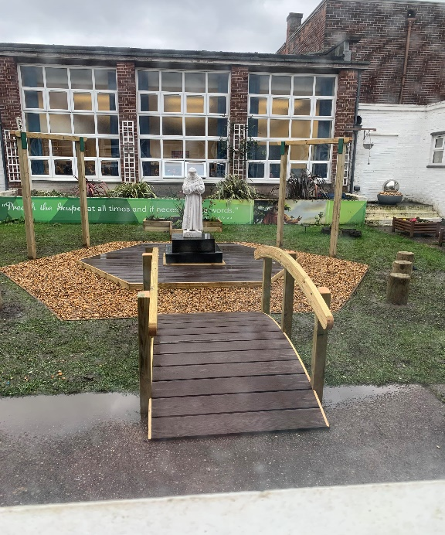

Next week, a brand new prayer garden will be installed in the Key Stage 1 outdoor area, so that our younger pupils can use the outdoor space to offer prayers to God.

Support
As a school we are here for both your children and your family. If you are experiencing any difficulties or have any anxieties, please get in touch with Mrs Sylvester for a private conversation. Her email address is c.sylvester@st-clares.manchester.sch.uk or you can ring the school number or message via the school app. If we are unable to help you, we may be able to refer you to somebody who can.

Safeguarding
Safeguarding children is everyone’s responsibility. If you have any concerns regarding the safety of a child, please report it. You are able to refer concerns directly or you can contact one of the Designated Safeguarding Leads in school. Please see the poster below for more details.

I hope that you all have a lovely weekend,
Mrs Howe

Upcoming dates:
Saturday 16th March – Sacramental Programme Day
Tuesday 19th March – Y4 trip to Blackpool Zoo
Wednesday 20th March – parents evening
Thursday 21st –Reconciliation 6pm
Wednesday 27th March – finish for Easter 1.15pm

