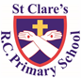

ST CLARE’S R.C.P NEWSLETTER

Our School Mission Statement: Guided by Jesus Christ, our teacher, we journey together learning to dream, believe and achieve. Friday 7th March 2025

Friday 24th November 2023

World Book day was a great success – the children (and staff) looked amazing and had some very creative costumes linked to words. All the children read the book ‘Bloom’ and completed some activities linked to the it. The theme was kindness and how by giving a flower compliments, it grew. There was an array of activities including making kindness / compliment flowers and writing a complimentary letter to someone in need of kind words.

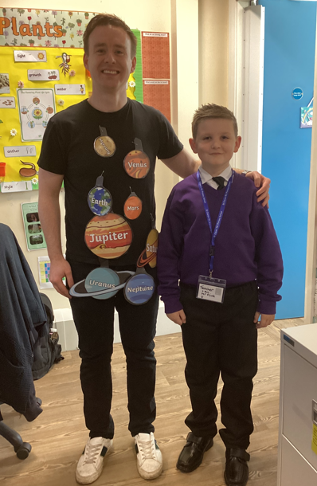 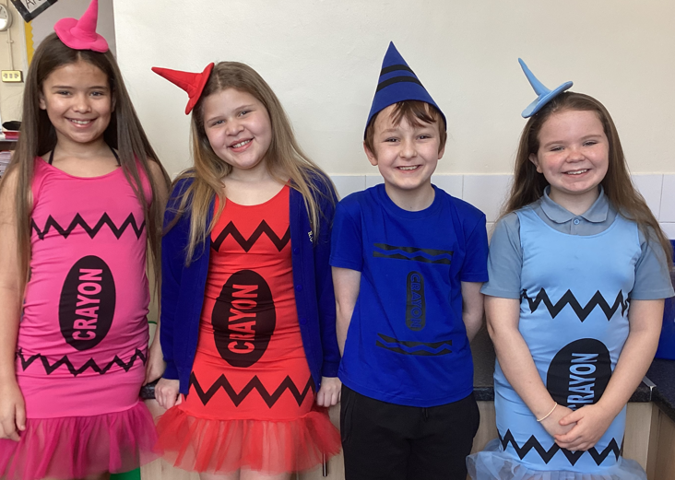

 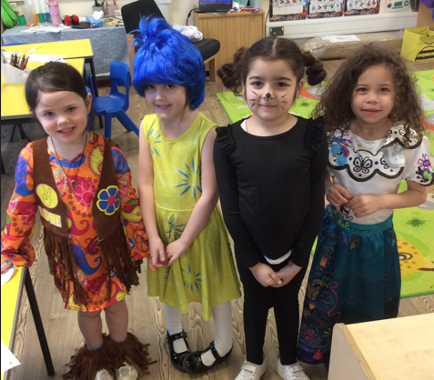

Wednesday marked the beginning of Lent – a time for us to pray more, fast and give alms. The children received their ashes from Father Giles.

Our girls football team took part in a competition on Wednesday evening and performed admirably**. Under the United Nations Convention on the Rights of the Child, Article 15, children have the right to join groups.** The girls won 3 matches, drew 4 and did not concede a goal! Well done to our girls who represented St Clare’s with pride and great enthusiasm.

In Nursery, the children made a large compliment flower and discussed how we can be kind to each other. Reception have been learning different ways to make up the numbers 9 and 10. In science, Year 1 have planted seeds so that they can watch them grow and identify the parts of a plant. In history, Year 2 have written a recount of the Great Fire of London. In Year 3, as part of their science topic, the pupils have set up an investigation to see whether seeds need water and sunlight to grow healthily. In geography, Year 4 have been learning about the uses of rivers in different parts of the world. In art, Year 5 have been experimenting with different art techniques to help them paint the planets of the solar system. In year 6, the children have been locating the countries of South America.

**Assembly**

On Tuesday, 1G will be leading the Key stage 1 assembly at 2.40pm. You are very welcome to join us.

**Chapel / prayer garden**

Our chapel / KS2 prayer garden is open each Tuesday morning before school for staff, pupils and parents to come and pray privately. Starting the day with God is a beautiful way to begin the day. You are very welcome to pop in from 8.15am each Tuesday.

**Pupil Certificates**

|  |  |  |
| --- | --- | --- |
|  | Pupil of the week | Achievement |
| N | Bobby for being such a smiley, happy boy who is a delight to have in the classroom. | Cerah for a wonderful homemade World Book Day costume |
| RDM | Jessen for always being such a kind and thoughtful member of the class | Layla-Mae for brilliant independent writing |
| RS | Chukwu for being such an enthusiastic learner! | Mila for spelling more tricky words correctly all by herself! |
| Y1G | Diana for her enthusiastic singing and positive attitude. | Chidumebi for always trying to extend her sentences using and. |
| Y1S | Szymon for being a brilliant friend and looking after everyone in his class. | Shifa for trying very hard with her writing this week. |
| Y2C | Yarrick for always trying his hardest with his work | Kai for amazing understanding of number |
| Y2D | Macey for always being a superstar! | Tommy for working hard on your reading! |
| Y3F | Kian for his brilliant attitude this week, his listening skills have been amazing, especially during our Ash Wednesday service. | Pixie for really trying her hardest in maths lessons. Even when she is struggling she is persevering and trying to do her best. |
| Y3H | Rehoboth, for wonderful listening and contribution to lessons this week. | Jamie, for producing an outstanding piece of work in RE about Saint Maximilian Kolbe |
| Y4H | Olivia K for always behaving beautifully and treating everyone around her with kindness and respect. | Michael, for always trying hard in everything he does and achieving great results- his maths has been excellent this week! |
| Y4O | Layla for being great at converting mixed number fractions to improper fractions. | Rudi for answering lots of questions in lessons this week! |
| Y5G | Excel for always being ready to learn and never giving up with any task. | Alexis for amazing work ordering decimals in maths. |
| Y5K | Majesty for putting in 100% effort into everything he does, showing how he is such a good role model. | Ire for his mathematical work on ordering decimals, always challenging himself, wanting to do better. |
| Y6S | Nneoma for being such a fantastic role model for the class, always doing the right thing. | Jayden for great work in science this week, researching adaptations across a range of species. |
| Y6W | Valeria for showing her kindness on World Book Day. | Ava for her hard work during the decimal and fractions topic in maths. |

**Caritas Award**

The Caritas Award is presented each week to a child in recognition of their outstanding achievement in putting love into action. This week the award goes to Sam in 6W for taking the initiative to help and teach a child who was struggling with their work.

**Lent**

The liturgical season of Lent has started and we have lots going on to mark this special season.

Our Mini-Clares have decided that, once again, they would like to ask all pupils to carry out 20 acts of kindness during the season of Lent. Your child have been given a sheet for you to note the acts of kindness on. Upon completion, your child will be given a gold cross to symbolise that we are journeying with Christ to the Cross in Lent. The idea is that the acts are spread out over Lent and not all completed within the first week.

If you would like to make a cross at home as a family which we can display around school during Lent, please send it into your child’s class teacher as soon as possible.

Our Mini-Clares will also be inviting parents into a ‘stay and pray’ session. More details will follow.

St Joseph’s Penny boxes have been sent home for your family to put any loose change you may have into. Again, the boxes do not need to be filled overnight. They can, if you are able, be returned to school when we finish for the Easter holidays.

The Easter raffle this year will be supporting a different charity. Funds raised are going to be sent to The Lilly Foundation. This charity is close to our hearts because one of our much loved pupils, Alba in Year 1, suffers from mitochondrial disease which this charity supports. Hopefully, our fundraising efforts will help to support the children and families affected by this condition.

Easter chicks will also be on sale in aid of Francis House. The cost will be £2 each – this is the price set by Francis House.

**Attendance**

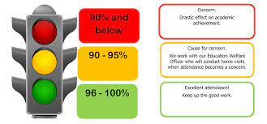

Overall whole school attendance this week is 95.16%. Please remember that school doors open at 8.40am, so aim to get you child here for that time. We have a group of children who are frequently a couple of minutes late, please make a concerted effort to arrive for 8.40am. Children do not like walking into class late when the others are already working.

**Under the** **UN Convention on the Rights of the Child (UNCRC), Article 29, children have the right to an education**. If you are experiencing any difficulties or require any additional support with attendance or punctuality, please contact our Attendance Officer, Mrs Burgess Hamlett.

The best class for attendance this week is 6S will 100% - a big well done to them. They will receive a dough-nut as a treat and a longer break-time.

**Support**

As a school we are here for both your children and your family. If you are experiencing any difficulties or have any anxieties, please get in touch with Mrs Sylvester for a private conversation. Her email address is [c.sylvester@st-clares.manchester.sch.uk](mailto:c.sylvester@st-clares.manchester.sch.uk) or you can ring the school number or message via the school app. If we are unable to help you, we may be able to refer you to somebody who can.

If you are struggling to buy food at the moment, please contact school. We do not want any families to go without food. We do have contact with some food banks who may be able to offer support.

**Junior Bake Off**

Love Productions (the production company behind The Great British Bake Off, The Great British Sewing Bee and The Great Pottery Throw Down) are looking for any budding bakers between the ages of 9-15 to take part in their next series. Filming will take place from July, but applications have to be submitted by Sunday 23rd March.

Interested bakers can apply online at  [www.applyforjuniorbakeoff.co.uk](http://www.applyforjuniorbakeoff.co.uk/)

**Safeguarding**

**Under the United Nation Convention on the Rights of a Child, all children under the age of 18 have a right to be protected from violence, abuse and neglect (Article 19) and a right to be alive (Article 6).**

There are many forms of abuse – sexual, neglect, emotional, physical, online – and it is everyone’s responsibility to safeguard children from any harm.

If you have any concerns regarding the safety of a child, please report it. You are able to refer concerns directly or you can contact one of the Designated Safeguarding Leads in school. Contact details can be found below.

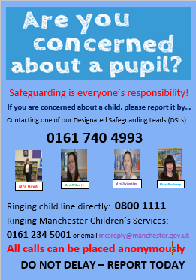

Please remember to keep Pope Francis in your prayers as he remains in hospital due to ill-health.

Enjoy the weekend break.

Mrs Howe

**Upcoming dates:**

Sunday 9th March – Family Mass 9.30am in church

Saturday 15th March – Sacramental Programme meeting 8.30am-12pm for pupils making their First Holy Communion.

Tuesday 1st April – Year 4 trip to Blackpool Zoo.

Friday 4th April – Balance Bike Day Year 1

Wednesday 9th April – Parents evening 3.30 -7pm

Sunday 13th April – Family Mass in church 10.30am

Wednesday 15th April – Year 5 will lead Stations of the Cross in church 9.15am

***The weekly newsletter is also available on our school website***[*https://st-clares.manchester.sch.uk/parents/newsletters/newsletters-2024-2025*](https://st-clares.manchester.sch.uk/parents/newsletters/newsletters-2024-2025)

**A Prayer of Hope**

