ST CLARE’S R.C.P NEWSLETTER
Our School Mission Statement: Guided by Jesus Christ, our teacher, we journey together learning to dream, believe and achieve. Friday 13th March 2026
Friday 24th November 2023

The holy season of Lent has begun and we are reminded of the late Pope’s advice on fasting:
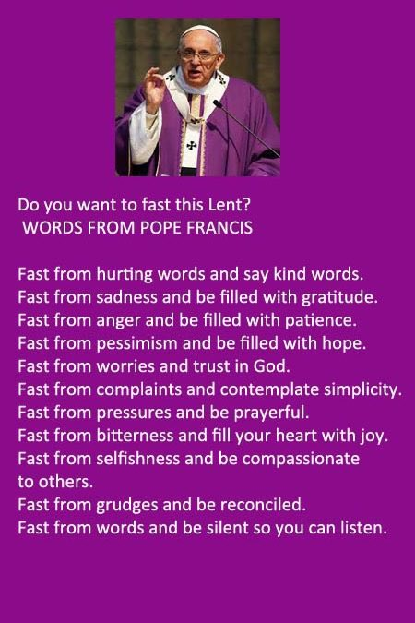
This week was British Science Week. The theme was ‘Innovation and the NHS.’ Every year group had a specific, hands-on "Innovation Challenge" to complete during the week:
Nursery & Reception: Germ-fighting "Bubble Labs" and Teddy Bear Clinics.
Year 1 & 2: Sense-testing stations and designing the "Ambulance of the Future."
Year 3 & 4: Engineering "Bionic Arms" and building functional heart-valve models.
Year 5 & 6: Microbiology investigations and "Smart Hospital" electrical circuit alarms.
There were also live chats with scientists and career focused activities linked to the NHS. Thanks to Mrs Salza for organising the activities.

Assembly

Jesus answered her, ‘If you knew the gift of God, and who it is that is saying to you, “Give me a drink”, you would have asked Him, and He would have given you living water.’ John 4:10
In this week’s Gospel reading, the Samaritan woman experienced that Jesus’ love is for everyone. He

does not judge us on our past mistakes. The children have the opportunity to accept the love Jesus offers and shares this love with others. This Lent, we can say ‘Yes!’ to Jesus’s transforming love in our lives.

Lenten activities
Our Mini-Clares have decided that they would like to ask all pupils to carry out 20 acts of kindness during the season of Lent. Your child will have been given a sheet for you to note the acts of kindness on. Upon completion, your child will be given a gold cross to symbolise that we are travelling with Christ to the Cross in Lent. The idea is that the acts are spread out over Lent and not all completed within the first week.

The Mini Clare's have also asked if during the season of Lent, you could spend some time at home with your child making a Cross or an Easter scene for us to display around school. This will give you the opportunity to discuss the importance of Lent. As we are called in the encyclical Laudato Si, to care for our common home, we ask you to make your Cross from things that you can recycle in your home – please do not go out spending any money. If you do make one please send it in to your child’s class teacher.

Finally, the Mini-Clares have created Lenten prayer packs which will be sent home for your family to partake in prayers together. "For where two or three are gathered in my name, there am I with them"
We hope that you enjoy completing your acts of kindness, praying together and look forward to seeing what the children create!
We have also ordered the St Joseph Penny boxes which have been sent home. The boxes are used to collect any spare change that you may have and wish to donate to Caritas.

We have a selection of Easter hampers which we are going to raffle. Tickets are on sale for £1 each. Thank you to Mrs Pollard for her very kind donations and to the members of staff who have also donated eggs.
We are hoping to send some of the money raised to Mary’s Wheels and Caritas. We are also hoping to retain some for a new speaker system in our Key Stage 1 building.

Come and pray
Our chapel / KS2 prayer garden is open each Tuesday morning before school for staff, pupils and parents to come and pray privately. Starting the day with God is a
beautiful way to begin the morning. You are very welcome to pop in from 8.15am each Tuesday.

Mother’s Day
We welcome links with our parish and are very grateful for the many ways we get to work together and share our faith with the children. There is a family mass schedule for Sunday 15th March at 10.30am. As it is Mother’s Day, Father has asked that the children from school lead the parish in this celebration. All children are encouraged to attend the mass and it would be great if they could come and sit with the ‘choir’ for the Mass.

Pupil certificates

 | Pupil of the week | Achievement
N | Rhiley for being an amazing role model to all. | Louie for accessing our writing area so beautifully!
RDM | Storm for trying hard in all that she does! Well done! | Samuel for wonderful sentence writing and handwriting!
RS | Ayoyimika for always being a fantastic role model! | Bobby for being a phonics superstar, he has been trying so hard!
Y1G | Yasir for being a positive and happy member of our class. | Hamdala for her precision and concentration during our painting art lesson.
Y1S | Makayla for trying her hardest in all her work this week and showing lots of determination. | Reuben for fantastic spelling work!
Y2C | Bonnie for always having an amazing attitude to her learning | Ziyan for showcasing his super oracy skills
Y2D | Gilly for being ready to learn and for contributing to our lessons. | Eliza for working hard to improve your arithmetic skills.
Y3F | Hugo for showing amazing commitment to his work, even when he finds it hard | Nellie for doing amazing work in maths this week on perimeter
Y3H | Isabella for writing some super instructions of how to grow a dragon! | Phoenix, for excellent listening and always being ready to learn.
Y4H | Deborah for making responsible and mature choices in class! | Dawid for a super improvement in his reading skills!
Y4O | Brody for really impressing me with his understanding and knowledge in his reading paper. Superstar! | Keriane for swimming 25 metres!
Y5KG | Kodie for showing lots of empathy by caring about one of his classmates and speaking up for the right thing. | Josephine for a fantastic effort in all of her assessments this week and for impressing me in dance lessons.
Y5L | Michael for his fantastic questioning during our Alexander Fleming oracy lesson. | Jake for a fantastic improvement in his reading assessment score this week.
Y6S | Adam for asking great scientific questions during our online chat with scientists for British Science Week. | Christopher for putting 100% effort into his maths work this week!
Y6W | Ire for a fantastic attitude towards his reading and quizzing this week. | Annie for a fantastic improvement in her reading assessment score.

Headteacher Awards
Luke in 1G for planting seeds at home and explaining to the class how to care for them to ensure that they grow.
Eryn in 2D for always inviting people to play and making sure everybody has a friend at breaktimes.
Jaxon in 4O for trying extremely hard in his maths assessment this week.
Olivia K in 5L for putting 100% effort into all her end of term assessments this week.
Dale in 6W for for showing kindness to a member of the class and presenting a great persuasive argument.

Caritas Award 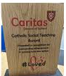
The Caritas Award is presented each week to a child in recognition of their outstanding achievement in putting love into action. This week the award goes to Tare in 1G for thinking of others feelings and being a caring friend.

Dancers
We have many children in school with amazing talents. Last week Isla and Felicity in Year 5 have taken part in dance competitions. Isla has recently been filmed for a music video by Skye Newman. She has also competed in a dance competition where she finished in 3rd place out of 21 dancers and made 7 dance finals. Felicity came first with two teams in her Pom Dancing with one of the teams finishing as grand champions. Well done girls!

Attendance
Overall whole school attendance this week is 94.36%. The best class for attendance this week is 6W with 99.26% Well done to them, they will get a longer break as a reward.

School doors open at 8.40am to give the children time to take off their coats and be ready at their desks for an 8.45am start. The doors close promptly at 8.45am.
Under the UN Convention on the Rights of the Child (UNCRC), Article 29, children have the right to an education. If you are experiencing any difficulties or require any additional support with attendance or punctuality, please contact our Attendance Officer, Mrs Burgess Hamlett.

Let’s Talk
Over the past year, we have had an increased focus on children’s oracy skills - the vital skill of learning to talk, and learning through talk. Effective communication is more than just "chatting." It’s about learning to argue a point, listen actively, and express ideas clearly. These skills are essential for success in the classroom and beyond.
Oracy doesn't stop at the school gates! To support this journey, look out for our new "Let’s Talk" section in our newsletter. Each week, we’ll provide a fun, thought-provoking discussion prompt designed for families to dive into at home.
Whether it's during a car journey or around the dinner table, these small conversations make a big difference in building your child's confidence.

Here is our next suggestion:

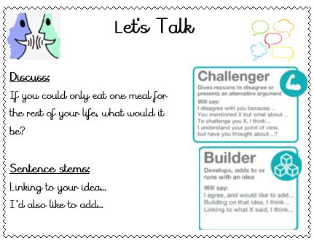

Parents Evening
Parents evening is on Wednesday 25th March. You have been sent out the details by the office for selecting your appointment slot. Parents evening is always well attended and a great opportunity for you to celebrate the work your child has done so far this year and speak to the class teacher about your child.

Statutory assessments
There are certain tests that children have to complete at a given time and date by the government. We have no choice over the dates chosen.
Year 6 SATS begin on Monday morning 11th May and finish at lunchtime on Thursday 14th May. It is imperative that you child is in school for these assessments and is on time.
Year 1 phonics screening check takes place the week commencing Monday 8th June. The Year 4 multiplication times table checker also takes place this same week. Again, children have to be in school for the assessments.
Thank you for your support with this matter.

Support
As a school we are here for both your children and your family. If you are experiencing any difficulties or have any anxieties, please get in touch with Mrs Sylvester for a private conversation. Her email address is c.sylvester@st-clares.manchester.sch.uk or you can ring the school number or message via the school app. If we are unable to help you, we may be able to refer you to somebody who can.

Safeguarding
Safeguarding children is everyone’s responsibility. If you have any concerns regarding the safety of a child, please report it. You are able to refer concerns directly to children’s services or via school.



Wishing you peace and joy this weekend,
God bless,
Mrs Howe

Upcoming dates
15th March – Family Mass (Mother’s Day) 10.30am
18th March – Nursery parents invited in to Dough Disco
19th March – Year 3 trip to Kenyon Hall
19th March – Year 4 parents invited to Multiplication times table checker information session.
19th March – Reception maths workshop and stay and play session.
25th March – Parents Evening
27th March – Year 2 trip
31st March – Stations of the Cross in church led by Year 5 9am
Wednesday 1st April – finish for Easter at 1.15pm

The weekly newsletter is also available on our school website Newsletters



Lenten prayer:

God of all wholeness,

heal our hearts

of all that prevents us responding

to our sisters and brothers

excluded by poverty

and prevented from living a full and healthy life.

This Lent, may we:

implore justice through our prayer,

stand in solidarity through our fasting,

and reach out through our giving.

Send your life-giving power

to revive the weary,

restore the broken

and renew the face of the earth.

We ask this through Christ our Lord.

Amen.


