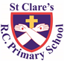
ST CLARE’S R.C.P NEWSLETTER
Our School Mission Statement: Guided by Jesus Christ, our teacher, we journey together learning to dream, believe and achieve. Friday 22nd March 2024
Friday 24th November 2023

There is a buzz in our Reception class this week as the live eggs have arrived. So far, nine of the ten eggs have hatched. The children are very excited about them and love having the chicks in their classroom. In nursery, the children have been learning about capacity in terms of empty and full. As part of their maths lessons, Year 1 have been measuring objects with rulers. Year 2 have dissected a bulb to identify what they contain. In their art lesson, Year 3 have painted their final piece based on Monet’s work concentrating on blurred effects. After a rainy start to the day, Year 4 spent Tuesday at Blackpool Zoo. Fortunately, the rain held off and they had a great day learning about different habitats. In RE, Year 5 have been reading Scripture about the temptation of Jesus and related it to how we are tempted in our daily lives. Year 6 have been working out the areas and perimeters of shapes in their maths lessons.
Assembly

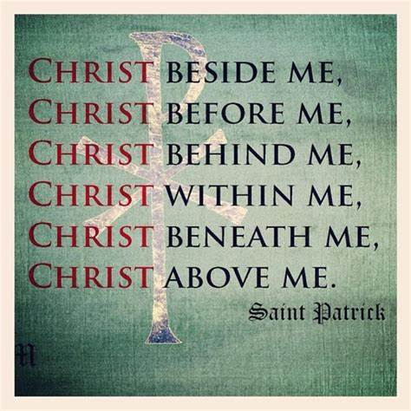
Our assembly this week focused on St Patrick whose saint’s day was celebrated on Sunday. St Patrick was actually born in Wales and sold to be a slave in Ireland. Following his call from God, he took Catholicism to Ireland by travelling around teaching the Good News that Jesus gave. The children know that with God all things are possible.

Creation Walks
Our Lenten Creation Walks are coming to a close. We have used Lent as a time to come together to pray. Thank you to everyone who was able to join your child’s class on this prayerful reflection.

Acts of kindness
If your child has completed 20 acts of kindness during Lent, recorded them on their sheet and had the form signed by you, they can now return them to school. In return the children will each receive a small, gold badge to reflect that they are following in Jesus’s ways.

St. Joseph’s Penny / Crazy Hair Day
Children have been given St Joseph Penny boxes for them to fill during Lent and return when we finish for Easter. The money goes to CARITAS.
We are also holding a crazy hair day (and own clothes) on Tuesday 26th March to support this worthy charity. The suggested amount to donate is £1. Thank you for your kindness.

Francis House
We still have crème egg chicks for sale in aid of Francis House. They have sent us 500 to sell at £2 each.
Francis House supports approximately 2,000 people at any one time with respite care, homecare, sibling support, end of life care and emotional and bereavement support.
Thank you if you have already purchased an egg and if you are able to buy one, they are available from the school office.

Morning Prayers
Our school chapel is open every Tuesday morning from 8.30 -9.00am for parents (and children) to come into school for some private prayer, some time alone with God or quiet reflection.
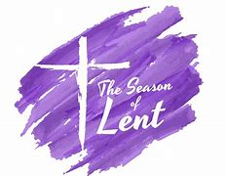
Stations of the Cross
Our Year 5 pupils will be leading us in the Stations of the Cross on Monday 25th March at 9.15am. You are very welcome to join us in church.

Pupil certificates
 | Pupil of the week | Achievement
N | Theo for always sitting beautifully on the carpet, showing he is ready to learn. | Ariana for amazing name writing
RDM | Penelope for setting a great example to her peers | Rosie for amazing independent writing
RS | Lily for being a kind friend to all. | Nathan for trying really hard with his ‘Sunflowers’ painting.
Y1D | Teti for always being so enthusiastic during our Science and Religion lessons. | Nellie Lou for trying hard to improve your handwriting and to present your work neatly.
Y1G | Eliana for always listening and having high standards of behaviour and learning. | Jakub for writing a lovely free verse poem about his mum.
Y2C | Julia for believing in herself and being proud of her work | Shay for his amazing vocabulary in our writing
Y2O | Anna for always following our school rules and being a great role model. | Anthony for creating a beautiful two page spread on the Great Fire of London
Y3F | Elisa for always being respectful and having wonderful manners | Henry for doing some wonderful maths work around mass this week
Y3H | Avayah for gaining lots of confidence in maths | Mikaela for outstanding progress in her writing.
Y4H | Emilie for consistent beautiful behaviour, she is a brilliant role model! | Troy for trying really hard with his writing, and making great improvements.
Y4S | All of 4S, for fantastic behaviour at the zoo and showing everyone how amazing the children at St Clare’s are! | Adam for trying really hard in writing this week and producing a brilliant persuasive letter.
Y5G | Halle for always being a shining example to others and a beautiful representative of our school. | Alexa for creating a beautiful double page about daily life in Benin and for demonstrating great batting and fielding skills in rounders.
Y5W | Enzo for a massive improvement in his attitude and behaviour | Jessica for always producing fantastic work and helping out around the classroom.
Y6K | Harris, for being an amazing example of how to conduct yourself in school. | Mitchell, for settling in very well to life at St Clare’s!
Y6S | Oliver M for always being kind and caring to everybody around him | Amaya for great work in Maths Calculating the area of triangles.

Headteacher’s awards:
Amina in Nursery for great language development and confidence.
Noarh in RS for always using beautiful manners.
Ugochi in 1D for a lovely free verse poem about walking.
Felicity in 3H for showing great support to others in PE by coaching and encouraging them.
Joel in 4S for working hard on his persuasive letter to parents asking them not to go on holiday.
Lennon in 6S for showing strength and resilience in times of difficulty.
Caritas Award
The Caritas is awarded each week in recognition of someone in school who has shown kindness to others by putting love into action. The award this week goes to Sophia in nursery who is constantly kind to everyone. How lovely Sophia!

Attendance
This week our whole school attendance is 96.8%. This is better than last week. The best classes this week are 5W, 4H and 2O with 99%. 5W very nearly had 100% attendance for the third week running. They will be rewarded with a longer play. Well done!

Parents’ evening
Thank you to everyone who attended parents evening on Wednesday. There was a great turn out with 90% for parents attending. It is vital that teachers and parents have an opportunity to talk about children, their progress, their wellbeing and attainment.

Reconciliation
We congratulate our pupils who are on their Sacramental journey. Last night, they received the Sacrament of Reconciliation for the first time. Please keep our pupils in your prayers that they may continue to get to know and love God more each day. The parish team complimented the group of children on their knowledge, manners and behaviour.

Support
As a school we are here for both your children and your family. If you are experiencing any difficulties or have any anxieties, please get in touch with Mrs Sylvester for a private conversation. Her email address is c.sylvester@st-clares.manchester.sch.uk or you can ring the school number or message via the school app. If we are unable to help you, we may be able to refer you to somebody who can.

Safeguarding
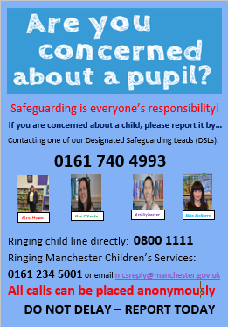
Safeguarding children is everyone’s responsibility. If you have any concerns regarding the safety of a child, please report it. You are able to refer concerns directly or you can contact one of the Designated Safeguarding Leads in school. Please see the poster below for more details.

I hope that you all have a lovely weekend,
Mrs Howe

Upcoming dates:
Monday 25th March -Stations of the Cross in church 9.15am
Tuesday 26th March – crazy hair day / own clothes (£1 donation to St Joseph’s penny)
Wednesday 27th March – finish for Easter 1.15pm
Monday 8th April – school re-opens 8.50am

