ST CLARE’S R.C.P NEWSLETTER
Our School Mission Statement: Guided by Jesus Christ, our teacher, we journey together learning to dream, believe and achieve. Friday 27th March 2026
Friday 24th November 2023

We have certainly had a mixture of the Great British weather this week – sunshine, hail, sleet, frost and rain. Here’s to warmer days!
Thank you to everyone who attended Parents Evening on Wednesday evening. Attendance was 81% across the school. I hope that you enjoyed seeing your child’s books and having the opportunity to speak to their class teacher. We are privileged to have your children at St Clare’s.
There was a lot of excitement in school on Thursday when our pop up book shop arrived. All the children in school were invited to exchange their free vouchers for books of their choice. There was a tremendous amount of choice and the children loved choosing some to take home. The books were kindly donated by the Children’s Book Project. Thank you
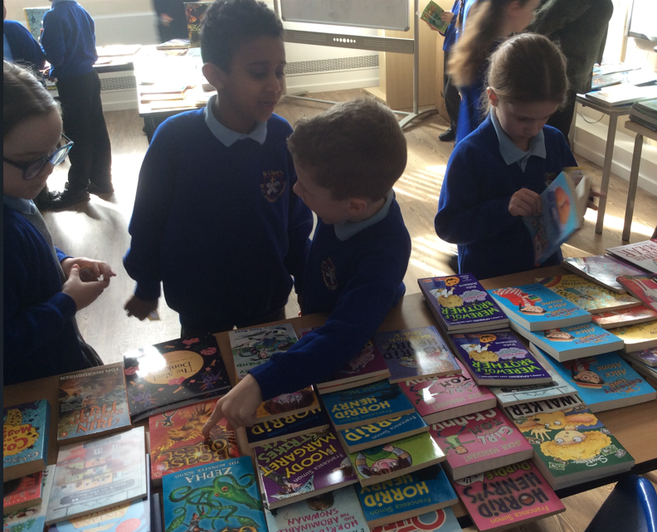
Today, our Science Ambassadors attended Irk Valley Primary to take part in their science week celebrations. It’s lovely to share learning with children from other schools.
In Nursery, the children have been learning about capacity. They have used containers and water to show full, empty, half full, nearly full and nearly empty. Reception children have been reading “Oliver’s Vegetables” this week. They have looked closely at different vegetables, feeling their textures and smelling them, as well as talking about their favourite vegetables to eat. In Year 1, In English, the children have been writing instructions for making an enormous cheese sandwich for a giant! Year 2 went on their school trip to the Fire Museum in Rochdale. They have been learning about the Great Fire of London, so were very excited to go to the museum. Year 3 have been looking at equivalent fractions in maths this week. Year 4 have created wonderful guides in RE based on how we receive

Holy Communion. Year 5 have been rehearsing for next week's “Station of the cross” service. Year 6 have been creating a fact file in science based on a newly discovered ‘creature’ linked to Carl Linneus’ Classification system.

Assembly

Our Mini Clares led the assembly this week based on the story of The Three Trees. Each tree had their own hopes and dreams for the future: one wanted to hold precious treasure – gold and silver; one tree wanted to be a might vessel carrying kings and queens; and the third wanted to stay on the hillside pointing up to God. They were disappointed when their dream did not materialise as they had wished. What they failed to realise is that God’s plans for us are so much better than our own. Each tree got more than they had wished for in the end: one tree was used to make the trough that Jesus lay in – the most precious treasure; one was a fishing boat, but it held the Son of God in the lake when there was a storm; and the third was used to make the cross that Jesus was nailed to. We have to trust in God – he knows us so well and has plans for each of us.

Holy Week
On Sunday we mark the start of Holy Week with Palm Sunday. During Lent we have all been called to pray more, give alms and fast.
On Monday we are holding an own clothes day to collect food for our parish food bank. The Mini Clares are also leading the children in prayer centred around different stations. You are invited in to join us at 2.15pm on Monday.
On Tuesday at 9am, Year 5 will be leading Stations of the Cross in church for Key Stage 2 children. You are most welcome to join us. Our younger children will do the Stations of the Cross in school.
Thank you for supporting your children in their acts of kindness for Lent and for supporting our raffle. The raffle raised £312. We will be sending some of the money to Mary’s Meals and some to Caritas.
The winners of our Easter raffle prizes are:
1. Marco in Nursery
2. Kian in Y5
3 Hope in Y4
4. Brody in Y4
5. Nellie in Y3
6. Elsie in Y6
7 Alex K in Y5

Come and pray
Our chapel / KS2 prayer garden is open each Tuesday morning before school for staff, pupils and parents to come and pray privately. Starting the day with God is a
beautiful way to begin the morning. You are very welcome to pop in from 8.15am each Tuesday.

Pupil certificates
 | Pupil of the week | Achievement
N | Zara for using her listening ears and trying really hard during our P.E lesson | Torvi for always being enthusiastic and engaged during our carpet sessions
RDM | Jomi for being a kind friend | Raya for super name writing this week!
RS | Ronnie for always being a thoughtful and caring friend. | Timi for fantastic knowledge of number bonds.
Y1G | Jessen for setting a fantastic example to his friends. | Ethan for working hard in phonics.
Y1S | Uhmiana for having a brilliant attitude to learning this week and creating beautiful work. | Thea for working very hard on her instruction writing this week.
Y2C | Lily for always having a fantastic attitude to learning | Oskar for a massive improvement in handwriting
Y2D | Florence for working hard all week. | Frankie for writing a lovely persuasive letter.
Y3F | Advika for always willing to help others when they are struggling. | Olivia May for being an excellent example to her peers during Forest school this week.
Y3H | Krystale for writing an excellent evaluation of her art work. | Johann for wonderful work on fractions this week.
Y4H | Dawid for always having a mature, sensible attitude! | Pablo for having an excellent understanding of decimals (tenths)!
Y4O | Grace as her confidence has flourished in the classroom! | Emiley for writing a fantastic narrative on ‘The Egyptian Cinderella.’
Y5KG | Rudi for showing lots of confidence in dance and when sharing his ideas in R.E. and English | Marta for being so focused and determined in her arithmetic group.
Y5L | Henry for approaching every activity with full effort and enthusiasm. | Tyler for his tremendous effort on improving his handwriting.
Y6S | Ludiana for always trying her best in all that she does. | Archie for his maths work on area and perimeter this week. He has challenged himself to complete more reasoning and problem solving style questions.
Y6W | Liza for always putting in 100% effort into every activity. | Oleksandr for his writing and editing in his fact file

Headteacher Awards
Iremide in RS for showing outstanding kindness and support to others during PE.
Miles in 2C for being a kind and caring member of our class to others.
Esey in 5GK for his outstanding efforts in reading! His assessment results reflect his hardwork.
Adam in 6S for a brilliant fact file in science/writing, which incorporated higher level vocabulary.

Caritas Award 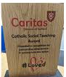
The Caritas Award is presented each week to a child in recognition of their outstanding achievement in putting love into action. This week the award goes to Frankie in Nursery for being so loving towards his new baby brother Ruben
Attendance
Overall whole school attendance this week is 95.5%. The best classes for attendance this week are RS, 2C, 4H, 5L and 6S with 97% . Well done to them, they will get a longer break as a reward.
School doors open at 8.40am to give the children time to take off their coats and be ready at their desks for an 8.45am start. The doors close promptly at 8.45am.
Under the UN Convention on the Rights of the Child (UNCRC), Article 29, children have the right to an education. If you are experiencing any difficulties or require any additional support with attendance or punctuality, please contact our Attendance Officer, Mrs Burgess Hamlett.

Let’s Talk
Good oracy skills is really important. Effective communication is more than just "chatting." It’s about learning to argue a point, listen actively, and express ideas clearly. These skills are essential for success in the classroom and beyond.
Oracy doesn't stop at the school gates! To support this journey, look out for our "Let’s Talk" discussion below.

Here is this week’s suggestion:

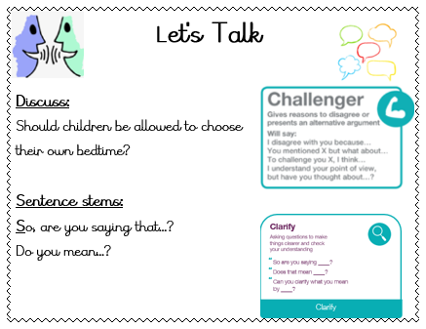

Own Clothes Day
During Lent, we are called to give alms - to help those in need.
Next week is Holy Week, so we plan to have an own clothes day on Monday 30th March as part of our Lenten action prayer.
In return for wearing their own clothes, could your child please bring in an item of food. Any item is gratefully received, but the parish team have indicated that their food bank is short of some food items.
I have suggested an item of food for different children in different classes to provide, but as already stated, anything is gratefully received:

Nursery - tinned meat
Reception -tinned hotdogs
Year 1 - tinned meatballs
Year 2 - tinned vegetables
Year 3 - - tinned meat
Year 4 - tinned hotdogs
Year 5 - tinned meatballs
Year 6 - tinned vegetables

Thank you for your ongoing support and generosity,

Statutory assessments
There are certain tests that children have to complete at a given time and date by the government. We have no choice over the dates chosen.
Year 6 SATS begin on Monday morning 11th May and finish at lunchtime on Thursday 14th May. It is imperative that you child is in school for these assessments and is on time.
Year 1 phonics screening check takes place the week commencing Monday 8th June. The Year 4 multiplication times table checker also takes place this same week. Again, children have to be in school for the assessments.
Thank you for your support with this matter.

Support
As a school we are here for both your children and your family. If you are experiencing any difficulties or have any anxieties, please get in touch with Mrs Sylvester for a private conversation. Her email address is c.sylvester@st-clares.manchester.sch.uk or you can ring the school number or message via the school app. If we are unable to help you, we may be able to refer you to somebody who can.

Safeguarding
Safeguarding children is everyone’s responsibility. If you have any concerns regarding the safety of a child, please report it. You are able to refer concerns directly to children’s services or via school.



Wishing you all a wonderful weekend,
Mrs Howe

Upcoming dates
30th March - Mini Clares prayer stations 2.15pm
31st March – Stations of the Cross in church led by Year 5 9am
Wednesday 1st April – finish for Easter at 1.15pm

The weekly newsletter is also available on our school website Newsletters



Lenten prayer:

God of all wholeness,

heal our hearts

of all that prevents us responding

to our sisters and brothers

excluded by poverty

and prevented from living a full and healthy life.

This Lent, may we:

implore justice through our prayer,

stand in solidarity through our fasting,

and reach out through our giving.

Send your life-giving power

to revive the weary,

restore the broken

and renew the face of the earth.

We ask this through Christ our Lord.

Amen.



