ST CLARE’S R.C.P NEWSLETTER
Our School Mission Statement: Guided by Jesus Christ, our teacher, we journey together learning to dream, believe and achieve. Friday 17th April 2026
Friday 24th November 2023



Welcome back to the summer term! I hope that you enjoyed the Easter holidays and celebrating Jesus’s Resurrection from the dead.
We celebrated our return to school with our whole school Easter Mass on Tuesday led by Father Jeremiah. It was a beautiful service where Father reminded us of Jesus’s words ‘Peace be with you.’ He encouraged us to remember these words in our daily life and pointed out that whatever upset we experience at the hands of others, Christ did too.
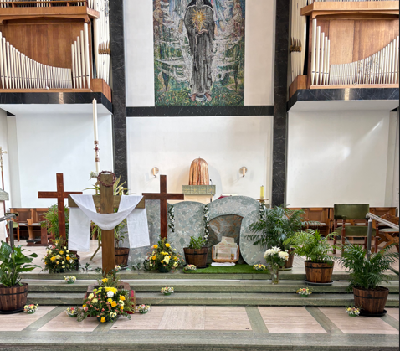
I wish to extend my gratitude for your generosity during the season of Lent. Thank you for supporting our raffle and thank you for the food you sent into school for the parish foodbank. Your generosity never ceases to amaze me.

In class, Nursery have been reading the story ‘Dinosaur Roar’ where we have learnt lots of new vocabulary like extinct and fossils. Meanwhile Reception children have started their new topic “Blast from the past.” They have been finding out about different dinosaurs and looking at pictures of fossils. Year 1 have been learning about our current season, Spring. In maths, Year 2 have started their topic on mass. They have completed exploratory tasks to compare mass and measure in grams. In PSHE Year 3 have been looking at what it means to be a good friend, and created ingredients for a friendship cake. In Science, Year 4 have been researching what the different seasons are like in countries around the world. On Monday, Year 5 visited OLHS and took part in a play in a day activity about space and also worked on biology looking at life cycles. Year 6 have been analysing statistics using line graphs, dual bar charts and pie charts in maths.

Come and pray
Our chapel / KS2 prayer garden is open each Tuesday morning before school for staff, pupils and parents to come and pray privately. Starting the day with God is a
beautiful way to begin the morning. You are very welcome to pop in from 8.15am each Tuesday.

Pupil certificates
 | Pupil of the week | Achievement
N | Kymora for sitting so well during our Easter Mass. | Arthur for developing his communication skills and becoming much more confident.
RDM | Ruben for always setting a wonderful example to others! Well done. | D’Jamela for wonderful independent writing in the role play area.
RS | Desire for always having beautiful manners | Azlan for super work on doubling in maths this week.
Y1G | Yasir for including everyone in discussions. | Gerald for using a super running technique during athletics.
Y1S | Waliya for always doing the right thing and being a kind respectful friend to everyone. | Chuckwu for trying so hard with his handwriting.
Y2C | Oskar for always having an amazing attitude to his work | Miles for showing off his times table knowledge
Y2D | Even for having a great first week back! | Ella for working hard in our maths lesson weighing objects. You were a great team player!
Y3F | Tommy for really trying hard with his work this week, especially his handwriting | Cora for doing some amazing RE work this work concentrating on scripture linked to the breaking of the bread
Y3H | Esther for sketching some beautiful mosaic patterns | Yaroslav for great Roman dancing in PE!
Y4H | Dawid for a super start to the term in all his lessons! | Curtis for great participation in our R.E lessons!
Y4O | Maria for making massive improvements in her handwriting. | Akongwi for his participation and great moves in dance this week.
Y5KG | Azra for always being polite and kind - she is an excellent wellbeing buddy! | Scarlet for creating an excellent model of the Earth, sun and moon and then helping her classmates with theirs.
Y5L | Amber for guiding and supporting her peers with their work this week. | Luca for his engagement in this week's athletics lesson.
Y6S | Excel for always trying her best in everything that she does. | Evie for fantastic vocabulary used in her narrative
Y6W | Lily for a fantastic start to the term, demonstrating a fantastic attitude towards her learning, especially in her reading this week. | Tolani for a fantastic narrative, with lots of advanced vocabulary.

Headteacher Awards
Maverick in Nursery for engaging in his home reading every single day—showing great consistency and effort.
Gia in 1G for always being supportive of her friends and trying her best.
Joshua in 3H for fantastic singing and actions in the choir at Easter Mass.
Carter M in 4H for great mental mathematical reasoning and explanation.

Caritas Award 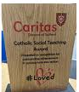
The Caritas Award is presented each week to a child in recognition of their outstanding achievement in putting love into action. This week the award goes to Nadia K in RDM who is always such a kind and thoughtful friend. This week she saw that someone was alone and invited them to play with her - this is something Nadia has done many times before. Well done Nadia!
Attendance
Overall whole school attendance this week is 94.2%. The best classes for attendance this week is 5L with 98% . Well done to them, they will get a longer break as a reward.
School doors open at 8.40am to give the children time to take off their coats and be ready at their desks for an 8.45am start. The doors close promptly at 8.45am.
Under the UN Convention on the Rights of the Child (UNCRC), Article 29, children have the right to an education. If you are experiencing any difficulties or require any additional support with attendance or punctuality, please contact our Attendance Officer, Mrs Burgess Hamlett.

Let’s Talk
Good oracy skills is really important. Oracy doesn't stop at the school gates! To support this journey, look out for our "Let’s Talk" discussion below.

Here is this week’s suggestion:

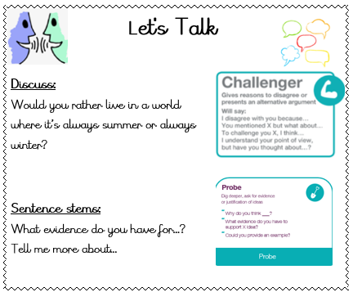

Statutory assessments
There are certain tests that children have to complete at a given time and date by the government. We have no choice over the dates chosen.
Year 6 SATS begin on Monday morning 11th May and finish at lunchtime on Thursday 14th May. It is imperative that you child is in school for these assessments and is on time.
Year 1 phonics screening check takes place the week commencing Monday 8th June. The Year 4 multiplication times table checker also takes place this same week. Again, children have to be in school for the assessments.
Thank you for your support with this matter.

Online safety
'What I wish my parents or carers knew…': a guide for parents and carers on children's digital lives (Children's Commissioner) The Children's Commissioner, Dame Rachel de Souza, has published a guide to help parents and carers navigate the challenge of managing children's everyday online habits. Written with direct input from children and young people, including teenagers consulted in schools and the Commissioner's Youth Ambassadors. The guide is designed to make difficult conversations easier and more regular.

Please click on the link for more information https://www.childrenscommissioner.gov.uk/resource/what-i-wish-my-parents-or-carers-knew-a-guide-for-parents-and-carers-on-managing-childrens-digital-lives/

Support
As a school we are here for both your children and your family. If you are experiencing any difficulties or have any anxieties, please get in touch with Mrs Sylvester for a private conversation. Her email address is c.sylvester@st-clares.manchester.sch.uk or you can ring the school number or message via the school app. If we are unable to help you, we may be able to refer you to somebody who can.

Safeguarding
Safeguarding children is everyone’s responsibility. If you have any concerns regarding the safety of a child, please report it. You are able to refer concerns directly to children’s services or via school.



I hope that you have a lovely weekend,
Mrs Howe

Upcoming dates
Wednesday 22nd April – Earth Day in school
Thursday 23rd April – Reception trip to Smithills Farm
Friday 24th April – Year 4 trip to Blackpool Zoo
Thursday 7th May – Nursery and Reception Tales Toolkit / Stay and Play
Saturday 9th May – First Holy Communion rehearsal 10am-12pm
Saturday 16th and 23rd May – First Holy Communion 12.30pm

The weekly newsletter is also available on our school website Newsletters

