ST CLARE’S R.C.P NEWSLETTER
Our School Mission Statement: Guided by Jesus Christ, our teacher, we journey together learning to dream, believe and achieve. Friday 1st May 2026
Friday 24th November 2023

Welcome to May – the month dedicated to Our Lady!
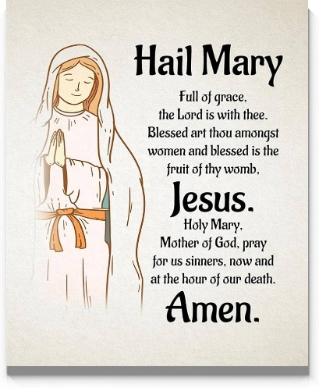
Our Nursery children have been playing a rhyming bingo game to develop their understanding of rhyming words. Reception children have been rotating 2d shapes in maths and creating pictures with their shapes. The Willow Room held a stay and play this week and loved having their parents share their learning experience. In PE, Year 1 have been exploring different jumping techniques. Year 2 have been writing independent biographies about Mary Seacole and have compared her to Florence Nightingale. In history, Year 3 have been learning about why the Romans invaded Britain including Julius Caesar’s failed invasions in 54 and 55BC. Year 4 have been designing Egyptian scrolls and writing their names in hieroglyphics in art. Year 5 have applied their retrieval and inference skills during a reading comprehension whilst analysing the lyrics to the song ‘Pompeii’ by Bastille. In their writing, Year 6 have created internal monologues based on the character Alma.

Assembly
Class 4OH led our Monday assembly this week focusing on May being the month dedicated to Our Lady. They spoke of the many qualities that Mary showed in her life including faith, trust in God, courage and love and how we should emulate her in our everyday lives.

Come and pray
Our chapel / KS2 prayer garden is open each Tuesday morning before school for staff, pupils and parents to come and pray privately. Starting the day with God is a
beautiful way to begin the morning. You are very welcome to pop in from 8.15am each Tuesday.

Pupil certificates
 | Pupil of the week | Achievement
N | Maverick, for being such a sensible boy on our trip to church and for always having a beautiful smile on his face. | Rupert for a good understanding of ‘more than’ in Maths.
RDM | Natna for gaining in confidence every week. Well done Natna! | Ainsley for fantastic dancing in PE this week
RS | Kerry for being a kind and caring friend. | Michal for improving his oracy skills during carpet time!
Y1G | Clay for being able to clearly explain to others his learning to support his friends. | Lacey for demonstrating a great jumping technique in PE.
Y1S | Joel for trying his best in all of his work this week and even helping others in the class when they are in need. | Uhmiana for working very hard in English and writing brilliant independent sentences.
Y2C | Alba Downie for always having an amazing attitude to her learning | Zion for amazing understanding of how to decompose different numbers
Y2D | Briony for working hard all week, especially in your phonics! | Isaac for writing a wonderful biography on Mary Seacole.
Y3F | Ellis for always trying his best and being an amazing example to others | Ugochi for producing some wonderful RE work about the Holy Trinity.
Y3H | Annie-Rose for a wonderful diagram and explanation of how plants reproduce. | Joseph for writing a superb biography in English
Y4H | Fabian for giving 100% effort in all of his work! | Grace for having an excellent understanding of decimals!
Y4O | Pippa for trying extremely hard in all subjects | Delina for carrying out some fantastic work in maths on decimals.
Y5KG | Phoebe for setting a great example with our classroom routines making sure she’s always ready to learn. | Lamaik for making great improvements to the accuracy and presentation of his work.
Y5L | Felicity for applying herself with genuine enthusiasm and a positive spirit in every challenge. | Grace for producing some fantastic work on human development in Science.
Y6S | Eunice for always being kind and caring to everybody in class. | Evie for a fantastic internal monologue in her English work this week!
Y6W | James for always demonstrating 100% effort in all his work. | Majesty for a fantastic fact file about Mary Anning

Headteacher Awards
Isla in RS for always being the most helpful pupil at tidy up time, she keeps our classroom sparkling!
Nancy in 1S for always looking out for others and being a wonderful friend.
Sofia in 3F for always being an amazing helper to other adults and children- an absolute pleasure to have in the classroom.
Lily in 6W for always having the confidence to share her ideas and for her enthusiasm during her group work.

Caritas Award 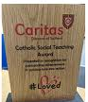
The Caritas Award is presented each week to a child in recognition of their outstanding achievement in putting love into action. This week the award goes to Arly in Year 3 for following Pope Francis’s call in Laudato Si to care for our common home by regularly picking up litter in the playground to look after our environment
Attendance
Overall whole school attendance this week is 94.4%. The best class for attendance this week is 1S with 100% which is amazing! . Well done to them, they will get an own clothes day next Friday and a treat.
School doors open at 8.40am to give the children time to take off their coats and be ready at their desks for an 8.45am start. The doors close promptly at 8.45am.
Under the UN Convention on the Rights of the Child (UNCRC), Article 29, children have the right to an education. If you are experiencing any difficulties or require any additional support with attendance or punctuality, please contact our Attendance Officer, Mrs Burgess Hamlett.

Let’s Talk
Good oracy skills are really important. Oracy doesn't stop at the school gates! To support this journey, look out for our "Let’s Talk" discussion below.

Here is this week’s suggestion:

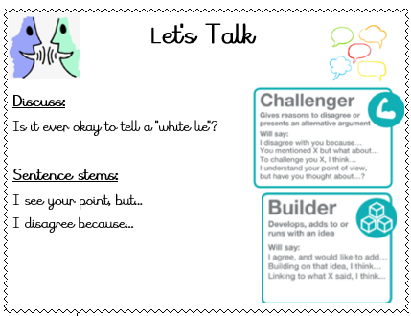

Statutory assessments
There are certain tests that children have to complete at a given time and date by the government. We have no choice over the dates chosen.
Year 6 SATS begin on Monday morning 11th May and finish at lunchtime on Thursday 14th May. It is imperative that you child is in school for these assessments and is on time. Year 6 children will be allowed into school early for breakfast on test days.
Year 1 phonics screening check takes place the week commencing Monday 8th June. The Year 4 multiplication times table checker also takes place this same week. Again, children have to be in school for the assessments.
Thank you for your support with this matter.

Online safety
'What I wish my parents or carers knew…': a guide for parents and carers on children's digital lives (Children's Commissioner) The Children's Commissioner, Dame Rachel de Souza, has published a guide to help parents and carers navigate the challenge of managing children's everyday online habits. Written with direct input from children and young people, including teenagers consulted in schools and the Commissioner's Youth Ambassadors. The guide is designed to make difficult conversations easier and more regular.

Please click on the link for more information https://www.childrenscommissioner.gov.uk/resource/what-i-wish-my-parents-or-carers-knew-a-guide-for-parents-and-carers-on-managing-childrens-digital-lives/

Miss Conway
This week we said goodbye to Miss Conway for a while as she began her maternity leave. We can’t wait to meet baby Conway when he arrives. We wish Miss Conway good health and happiness during her time away from school.

Support
As a school we are here for both your children and your family. If you are experiencing any difficulties or have any anxieties, please get in touch with Mrs Sylvester for a private conversation. Her email address is c.sylvester@st-clares.manchester.sch.uk or you can ring the school number or message via the school app. If we are unable to help you, we may be able to refer you to somebody who can.

Safeguarding
Safeguarding children is everyone’s responsibility. If you have any concerns regarding the safety of a child, please report it. You are able to refer concerns directly to children’s services or via school.

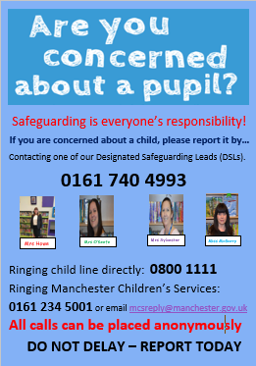

Remember that we are closed on Monday. Enjoy the Bank holiday weekend. God bless,
Mrs Howe

Upcoming dates
Thursday 7th May – Nursery and Reception Tales Toolkit / Stay and Play
Saturday 9th May – First Holy Communion rehearsal 10am-12pm
Monday 11th May – SATS week
Saturday 16th and 23rd May – First Holy Communion 12.30pm

The weekly newsletter is also available on our school website Newsletters

