ST CLARE’S R.C.P NEWSLETTER
Our School Mission Statement: Guided by Jesus Christ, our teacher, we journey together learning to dream, believe and achieve. Friday 18^{h} September 2026
Friday 24th November 2023

Well the sunshine in school is being brought by the children and we are making up for the good weather we had over the summer with rain.
This week, we celebrate our back to school welcome Mass with Father Giles. The Gospel reding was about Jesus being ‘lost’ in the temple. We are reminded that we can all feel lost at times, but there is a network of support through family, friends and school.
Our science ambassadors spent the morning at a recycling centre focusing on renewable energy on Wednesday.
In Reception, the children have been learning how God created our world in RE. Year 1 have been learning all about character descriptions and have been writing sentences to describe Bog Baby. In science, Year 2 have been learning about materials and their suitability for a job. Meanwhile, Year 3 have been learning to use cross hatching in our art topic about Hokusai. Year 4 have been retelling the story of ‘The Incredible Book Eating Boy’ by Oliver Jeffers and have created some amazing pieces of writing. In science, Year 5, through hands-on testing, have explored conductivity, magnetism, and transparency. Year 6 have been exploring reflection and how we see things in their science learning this week.

Come and pray
Spending some quiet time with God is a great way to start each day. You are invited into our chapel each
Tuesday morning from 8.15am to start your day with individual prayer.
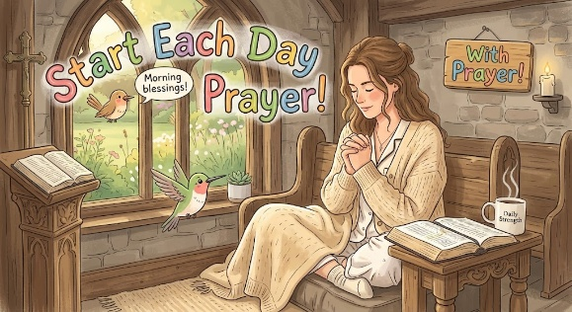

Pupil certificates
 | Pupil of the week | Achievement
N | Bodi for being so settled and happy in Nursery, we are so proud of him! | Noah for wonderful sharing with all of his friends!
RDM | Isabelle for always setting a great example to others! You are a superstar! | Zion for super maths work!
RS | Subhan for great behaviour this week. | Victoria for super maths work!
Y1G | Jesse for being a fantastic independent learner. | Myla- Mae for her great use of mathematical language.
Y1M | Freya for setting a good example in school | Jayce for writing some super sentences independently
Y2C | Rocco for a great attitude to his learning in Year 2 | Zion for super letter formation
Y2D | Milton for always being ready to learn. | Ariana for writing some amazing instructions on how to make a jam sandwich.
Y3F | Loana for always being ready to learn | Zion for being an amazing mathematician during our maths lessons.
Y3H - caritas | Romeo for always setting a perfect example to others. | Olivia S for showing great resilience to solve a tricky maths problem.
Y4H | Sofia for always listening and consistent beautiful behaviour. | Nellie for being an amazing, confident swimmer.
Y4O’H | Ethel for always sharing her ideas and opinions in class, joining in discussions and considering our guidelines for talk throughout. | Hajra for overcoming her fears and doubts when swimming. She’s doing fantastic!
Y5W | Macie for her determination in improving her mathematical understanding. | Jacob G for his work on rounding numbers this week showing a fantastic amount of progress
Y5L | Jamie for being a fantastic class role model to his peers. | Pippa for outstanding teamwork and leadership in this week’s Science lesson.
Y6S | Jake for always being a polite, well-mannered member of our class. | Elena for using a range of higher level vocabulary and punctuation in her writing this week
Y6GK | Daniel for fantastic participation in every lesson, instigating discussions and giving thoughtful ideas. | Rudi for fantastic work on multiplication and becoming more independent in all his subjects.

Headteacher’s Awards
Jomi in Reception for being kind to her friends when they need help or are a little sad.
Jessen in 2D for always setting a good example to others.
Olivia W in 3F for making a great start to life at St Clare’s and always willing to help others.
Ophelia in 5L for demonstrating outstanding perseverance and resilience in Mathematics. Which has enabled her to work through challenging problems.

Caritas Award 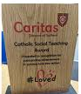
The Caritas Award is presented each week to a child in recognition of their outstanding achievement in putting love into action. This week the award goes to Lucas in Reception for always being a kind friend to everyone. When the children are playing, Lucas is always on the look out for anyone who is alone and will invite them to play with a big smile on his face! How beautiful!

Attendance
Overall whole school attendance this week 94.87% The best classes for attendance this week is 2C with 99%. Well done – they will get a longer break.
School doors open at 8.40am to give the children time to take off their coats and be ready at their desks for an 8.45am start. The doors close promptly at 8.45am. This week there were 59 occasions of children being late before 9am and 20 children late after 9am.
Under the UN Convention on the Rights of the Child (UNCRC), Article 29, children have the right to an education. If you are experiencing any difficulties or require any additional support with attendance or punctuality, please contact our Attendance Officer, Mrs Burgess Hamlett.
There are strict procedures in place issued by the government for schools to follow in the event of poor absence which may not be due to genuine illness. Parents can be fined or face legal action. We do not want this to happen, so please work with us if you are struggling getting your child to school or you personally need any support. Contact Mrs Burgess Hamlett.

Sacramental Programme
The registration meeting for this year’s Sacramental Programme is on Thursday 24th September at 6pm in the church hall for parents and children to attend . Children in Year 3 and those children in older years wishing to take part in the next stage of their faith journey should attend.
St Francis Mass
This year marks 800 years since the death of St Francis and has been declared a special jubilee year by Pope Leo. Bishop John is coming to our parish to celebrate this special occasion on Sunday 4th October at 10.30am. You are all welcome to attend. We will be asking the choir and Mini Clares to come along and join the parish acting as a choir.
Macmillan coffee morning
We are hosting our annual coffee morning to raise funds for Macmillan Cancer. This is always a really successful morning led by Leo’s Leaders – our Year 6 pupils.
We do rely on your generosity which never ceases to amaze us. If you could please donate cakes and bring them into school on Thursday 24th or Friday 25th September, we would greatly appreciate it. Your child then has the pleasure of buying them back. We are a nut free school and are mindful of children’s allergies and intolerances, so please ensure that your cakes are nut-free. You are very welcome to join us from 9am-11am in both halls. If your child can bring in £1, they will receive a drink and a cake.
Benedict’s Law
The campaign was established by the family of Benedict Blythe, a five-year-old boy who tragically passed away from an allergic reaction at school in 2021. His family fought for clear national rules so that no family has to go through a similar experience, ensuring every child with allergies is safely supported at school.

What Schools Are Required to Do
Under the guidance, all schools must follow strict safeguards to manage allergy risks and emergency responses:
- Mandatory Staff Training: teachers, lunch staff, and support personnel must undergo regular training to recognise early signs of allergic reactions and respond immediately.
- Spare Adrenaline Auto-Injectors (AAIs): Schools must hold accessible, non-prescribed spare emergency injectors on site.
- Individual Healthcare Plans (IHPs): Clear, structured action plans must be created in partnership with parents for any child with a diagnosed allergy.
- Near-Miss & Incident Logging: Schools must formally record and review any allergy-related incidents or near-misses to continuously improve safety procedures.

How You Can Help Us Keep All Children Safe
While our staff are fully trained on emergency protocols, parent partnership is essential to keeping our school environment safe:
- Keep Us Updated: If your child develops a new allergy or their prescription details change, notify the main office immediately so we can update their Individual Healthcare Plan.
- Check Expiry Dates: Ensure any medication, inhalers, or auto-injectors kept at school are up to date.
- Be Mindful of Packed Lunches: Avoid sending nuts, sesame, or common high-risk allergens in packed lunches or for class celebrations.

Our Lady’s High School Open Evening
Our Lady's Open Evening is being held in school on Thursday 24th September from 4.30 until 7pm giving all parents of primary children in years 4, 5 and 6 the chance to look around school, meet the teachers and hear from the headteacher. There is also the opportunity to come for a tour around our school during the school day to give you a better understanding of what life is like for a pupil at Our Lady's. You can make bookings by following this link or via the school website: https://forms.gle/j46K38vEUofdhQLq5
High School applications
Parents of children in Year 6 MUST apply for a high school place by 31st October. The web link is manchester.gov.uk/admissions
Let’s Talk
Good oracy skills are really important. Oracy doesn't stop at the school gates! Having conversations with your children really supports their learning journey in so many ways. Why not try our suggested "Let’s Talk" discussion below?

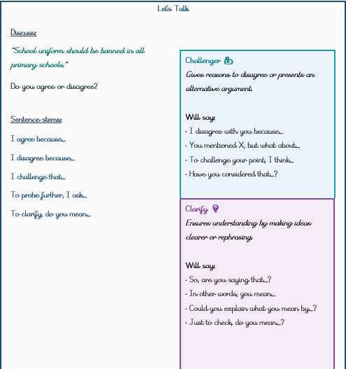
Statutory assessments
As you are aware, children are not authorised to take term-time holidays. During the summer term, there are statutory assessments which we have to administer at set dates / weeks. It is imperative that your child is in for these tests.
Year 1 phonics check – 14th -18th June.
Year 2 phonics check for those who did not pass it in Year 1 – 14th-18th June
Year 4 multiplication tables check -7th – 18th June
Year 6 SATs – 10th-13th May
Thank you for your understanding and support with these very important dates.
Support
As a school we are here for both your children and your family. If you are experiencing any difficulties or have any anxieties, please get in touch with Mrs Sylvester for a private conversation. Her email address is c.sylvester@st-clares.manchester.sch.uk or you can ring the school number or message via the school app. If we are unable to help you, we may be able to refer you to somebody who can.

Safeguarding
Safeguarding children is everyone’s responsibility. If you have any concerns regarding the safety of a child, please report it. You are able to refer concerns directly to children’s services or via school.

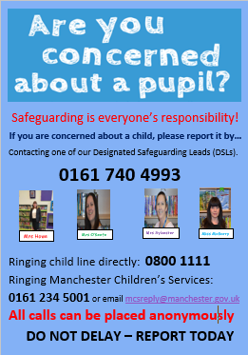

Mrs Howe

Upcoming dates
Friday 25th September – Macmillan coffee morning
Friday 2nd October – own clothes day in return for food items for the parish food bank.
Sunday 4th October – St Francis Mass 10.30am
Tuesday 6th October – whole school St Francis Mass 9.00am
Sunday 11th October – Family Mass (Sacramental Programme) 10.30am
Tuesday 20th October – Harvest Service in church 9.00am
Wednesday 21st October – parents evening

The weekly newsletter is also available on our school website Newsletters

