ST CLARE’S R.C.P NEWSLETTER
Our School Mission Statement: Guided by Jesus Christ, our teacher, we journey together learning to dream, believe and achieve. Friday 8th May 2026
Friday 24th November 2023

May – the month dedicated to Our Lady!
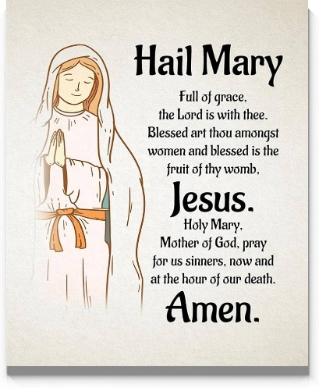
On Thursday, Nursery and Reception invited parents in for a stay and play. They got the chance to see ‘Tales Toolkit’ in action. Thanks to everyone who was able to join us for this. Year 1 have been writing letters to Beegu so he is prepared to come to planet earth! Year 2 in Maths have been learning about fractions of shapes and amounts. In science, Year 3 have been learning about pollination and seed dispersal. Meanwhile in Year 4, the children have been creating their own paper, using the methods used in Ancient Egypt. In Athletics, Year 5 have been learning about the shot-putt and how to throw with force and accuracy. In history, Year 6 have been exploring Darwin’s voyage on the HMS Beagle and the discoveries that he made during his expedition

Assembly
RDM class will be leading the assembly on Monday afternoon at 2.30pm. You are most welcome to join us for this celebration.

Come and pray
Our chapel / KS2 prayer garden is open each Tuesday morning before school for staff, pupils and parents to come and pray privately. Starting the day with God is a
beautiful way to begin the morning. You are very welcome to pop in from 8.15am each Tuesday.

Pupil certificates
 | Pupil of the week | Achievement
N | Marco for always being ready to learn. | Ivy Mae for using amazing new vocabulary during our carpet sessions
RDM | Nadia S for making wonderful progress in all areas! | Mayah for fantastic discussions in RE this week
RS | Elana for always coming to school with a big smile on her face every day - she lights up the classroom with her positivity! | Denylson for great jumping skills in PE this week!
Y1G | Isabella for always challenging herself and having great ideas on the carpet. | Molly-Mae for always trying to complete work independently before asking for help.
Y1S | K’cey for a fantastic attitude all week and being so focussed with all her work. | Joel for fantastic writing in English.
Y2C | Lily for always having an amazing attitude to learning | Mickey for amazing understanding of fractions
Y2D | Olivia S for always being ready to learn and always presenting her work beautifully. | Luka for listening carefully to our scripture during Celebration of the Word and being able to explain the message behind it.
Y3F | Victor for having a much-improved week with his concentration and work ethic. Keep it up! | Sofia for doing some amazing homework. Sofia has made a Roman shield and sword!
Y3H | Lyla for making an excellent effort in all of her learning. | Krystale for excellent work on fractions.
Y4H | Jacob G for perseverance and determination during our swimming lesson! | Jennifer for a significant improvement in multiplication scores!
Y4O | Keriane for her confidence and communication skills when participating in our oracy task in English. | Akrina for creating a wonderful fact file on air pollution in science.
Y5KG | Elisa for demonstrating fantastic confidence and instigator skills during our debate on deforestation. | Evana for a beautiful piece of homework on the human body.
Y5L | Amelia for showing fantastic effort, creating a short write that was clear, organised, and a pleasure to read. | Olivia W and George for producing a wonderful collaborative Kennings poem.
Y6S | Julia for fantastic efforts during our drama lesson. | Constantine for using a wide variety of Alan Peat sentence types in English
Y6W | Shae for always being on task and putting in 100% effort into every activity. | Majesty for his fantastic work in science this week and his skills when drawing animal sketches.

Headteacher Awards
Ariana in 1G for being an amazing role model to everyone.
Miles in 2C for being incredibly caring and kind to everyone and, for this week, having an aim of ‘being like Jesus.’
Scarlet in 5GK for being such a determined, resilient learner and excelling this week learning about angles.
Eunice in 6S for her dedication towards her SAT’s revision!

Caritas Award 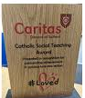
The Caritas Award is presented each week to a child in recognition of their outstanding achievement in putting love into action. This week the award goes to Chidumebi in Year 2 for being kind and caring to others – following in Jesus’ footsteps.
Attendance
Overall whole school attendance this week is 93.6%. The number of children arriving late this week has fallen – thank you for your punctuality. The best class for attendance this week is 6W with 100% which is amazing! Well done to them, they will get an own clothes day a week on Monday and a treat.
School doors open at 8.40am to give the children time to take off their coats and be ready at their desks for an 8.45am start. The doors close promptly at 8.45am.
Under the UN Convention on the Rights of the Child (UNCRC), Article 29, children have the right to an education. If you are experiencing any difficulties or require any additional support with attendance or punctuality, please contact our Attendance Officer, Mrs Burgess Hamlett.

Let’s Talk
Good oracy skills are really important. Oracy doesn't stop at the school gates! To support this journey, look out for our "Let’s Talk" discussion below.

Here is this week’s suggestion:

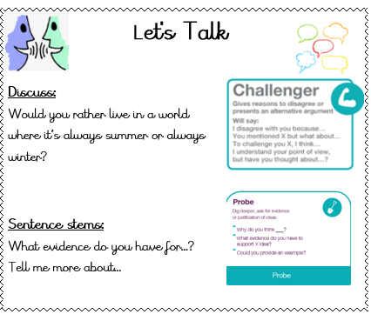

Statutory assessments
Year 6 SATS begin on Monday morning 11th May and finish at lunchtime on Thursday 14th May. It is imperative that you child is in school for these assessments and is on time. Year 6 children will be allowed into school early for breakfast on test days. The children (and staff) have been working incredibly hard and they will get the opportunity to showcase their learning. We do not want any children to be worried about the tests, we know they are all wonderful regardless of the outcomes.

Year 1 phonics screening check takes place the week commencing Monday 8th June. The Year 4 multiplication times table checker also takes place this same week. Again, children have to be in school for the assessments.
Thank you for your support with this matter.

St Francis Mission Day
2026 is the Jubilee Year of St. Francis of Assisi, commemorating the 800th anniversary of his death in 1226. Declared by Pope Leo XIV, this special year runs from 10 January 2026 to 10 January 2027, focusing on themes of peace, ecology, and spiritual renewal. St Clare was a follower of St Francis and our priests belong to the Franciscan Order, so we have a close affiliation to St Francis. Next Friday 15th May we are dedicating a day to St Francis. The children may come to school in their own clothes in return for an item of food for the parish foodbank. Throughout the day the children will be led in an assembly or prayer trail by Sister Anne and Ann and will complete various fun activities linked to St Francis and the ideas he promoted.

Online safety
'What I wish my parents or carers knew…': a guide for parents and carers on children's digital lives (Children's Commissioner) The Children's Commissioner, Dame Rachel de Souza, has published a guide to help parents and carers navigate the challenge of managing children's everyday online habits. Written with direct input from children and young people, including teenagers consulted in schools and the Commissioner's Youth Ambassadors. The guide is designed to make difficult conversations easier and more regular.

Please click on the link for more information https://www.childrenscommissioner.gov.uk/resource/what-i-wish-my-parents-or-carers-knew-a-guide-for-parents-and-carers-on-managing-childrens-digital-lives/

Support
As a school we are here for both your children and your family. If you are experiencing any difficulties or have any anxieties, please get in touch with Mrs Sylvester for a private conversation. Her email address is c.sylvester@st-clares.manchester.sch.uk or you can ring the school number or message via the school app. If we are unable to help you, we may be able to refer you to somebody who can.

Safeguarding
Safeguarding children is everyone’s responsibility. If you have any concerns regarding the safety of a child, please report it. You are able to refer concerns directly to children’s services or via school.



Have a lovely weekend,
Mrs Howe

Upcoming dates
Saturday 9th May – First Holy Communion rehearsal 10am-12pm
Monday 11th May – SATS week
Saturday 16th and 23rd May – First Holy Communion 12.30pm

The weekly newsletter is also available on our school website Newsletters

