ST CLARE’S R.C.P NEWSLETTER
Our School Mission Statement: Guided by Jesus Christ, our teacher, we journey together learning to dream, believe and achieve. Friday 15th May 2026
Friday 24th November 2023

May – the month dedicated to Our Lady!
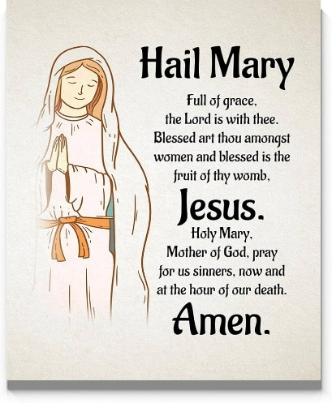
Well done to our Year 6 pupils this week on completing their SATS. We are super proud of them all. They showed calmness, determination and resilience. They all did the very best they could and knew that God and the staff were with them every step of the way. Thanks also to you as parents and the staff for preparing the children so well. SATS measure what a child knows or can recall on a particular day. They do not measure how very special each child is and the many beautiful qualities and talents they all have. We are privileged to see them shining every day.
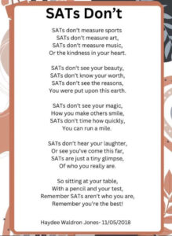

On Thursday, we celebrated the Feast of the Ascension together in church. We were reminded that we are not alone; God is always with us.
On Friday, the whole school celebrated St Francis. St Francis has strong connections with our school. St Clare

was inspired by him and was one of his followers. Our priests also belong to the Franciscan order. We welcome Sister Anne and Ann who led us in an assembly and prayer trails linked to St Francis’s passions.
Our Nursery children have been using their Oracy skills to discuss which animals are most suitable to have as pets. Oracy was also a focus in Reception where they have been using their oracy skills to discuss life in the past and compare it to life today, using the nursery rhyme Jack and Jill as a stimulus. In PE, Year 1 have been learning how to throw a javelin in PE. As part of their history topic, Year 2 have compared Florence Nightingale to Mary Seacole in History. Year 3 have learnt why the Romans built new roads and towns in history this week. Meanwhile, Year 4 have created their final Egyptian scrolls in art on paper they created themselves! Year 5 this week have continued to develop their understanding on deforestation, during Geography and English whilst also learning about child growth and development in Science. Year 6 survived SATs!

Assembly
On Monday children from 5L and 1S will be leading our assemblies. You are very welcome to join us. 5L will be leading us at 9am, whilst 1S will be at 2.40pm

Come and pray
Our chapel / KS2 prayer garden is open each Tuesday morning before school for staff, pupils and parents to come and pray privately. Starting the day with God is a
beautiful way to begin the morning. You are very welcome to pop in from 8.15am each Tuesday.

Pupil certificates
 | Pupil of the week | Achievement
N | Lilly-May for being a wonderful role model within Nursery, always doing the right thing. | Giacomo for his excellent phonics skills in segmenting and blending simple CVC words
RDM | Jomi for trying hard in all that she does! | Daniel for trying so hard to use a loud, clear voice in our assembly!
RS | Daniel for trying his best in all areas of his learning! | Nazarii for improving his communication skills!
Y1G | K-J for a super week of learning. | Daisy for being a great dance leader in PE.
Y1S | Danica for being a superstar, who always does the right thing and is respectful and kind to everyone. | Theodore for lovely, thoughtful work in RE.
Y2C | Norah for always having an amazing attitude to her learning | Billy-Jo for showing off his amazing fraction knowledge
Y2D | Romeo for always being ready and respectful. | Gilly for creating amazing beats during our music lessons.
Y3F | Chloe for being an excellent example to the rest of the class. | Hugo for doing some amazing homework on our Roman topic.
Y3H | Ollie for good listening and participation in lessons this week. | Isabelle L for converting pounds to pence really well in maths
Y4H | Shay for being interested and enthusiastic in lessons. | Curtis for fantastic effort in his English work!
Y4O | Emiley for working so hard and achieving her pen license. | Louie for creating a fantastic two page spread on the river Nile in History
Y5KG | Tyler for being so reverent in prayer and liturgy and confidently giving a great answer in church. | Maria for writing an excellent balanced argument about deforestation in the Amazon Rainforest
Y5L | Henry for always being a positive role model to his peers. | Grace for creating a lovely double page spread on Carlo Acutis’ discipleship.
Y6S | All of 6S for their fantastic efforts made during the SAT’s | All of 6S for their fantastic efforts made during the SAT’s
Y6W | All of 6W for their fantastic efforts made during the SAT’s | All of 6W for their fantastic efforts made during the SAT’s

Headteacher Awards

Caritas Award 
Noah in Nursery for being a superstar, following our golden rules and also using some wonderful vocabulary.
Eliza in 2D for being a great friend
Isabelle O in 3H for writing a super acrostic poem about Romans.
Dawid in 4H for showing fantastic interest in history work and producing amazing pieces of homework!
The Caritas Award is presented each week to a child in recognition of their outstanding achievement in putting love into action. This week the award goes to Gia in Year 1 for having her hair cut and donating it to the Princess Trust to help others. What a thoughtful, beautiful act of love and kindness!
Holy Communion
This Saturday and next Saturday, the children who have been following the Sacramental Programme this year will be making their First Holy Communion in church at 12pm. This is another important step for them on their faith journey. Please include the children in your prayers.
If any of our wonderful singers in school are able to join us at the Mass to act as a choir, that would be wonderful. We always have a good attendance at Mass for events like this and our brilliant singers help to make a very special day even more special. If your child is able to attend, please just send them down to sit in the choir section of the church near the organ.
Attendance
Overall whole school attendance this week has improved this week to 94.9%. The best class for attendance this week, once again, is 6W with 100% which is amazing! Well done to them, they will get an own clothes day on Monday and Tuesday next week.
We had 42 pupils late 54 times and 7 pupils late after the registers close 13 times. School doors open at 8.40am to give the children time to take off their coats and be ready at their desks for an 8.45am start. The doors close promptly at 8.45am.
Under the UN Convention on the Rights of the Child (UNCRC), Article 29, children have the right to an education. If you are experiencing any difficulties or require any additional support with attendance or punctuality, please contact our Attendance Officer, Mrs Burgess Hamlett.

Let’s Talk
Good oracy skills are really important. Oracy doesn't stop at the school gates! To support this journey, look out for our "Let’s Talk" discussion below.

Here is this week’s suggestion:

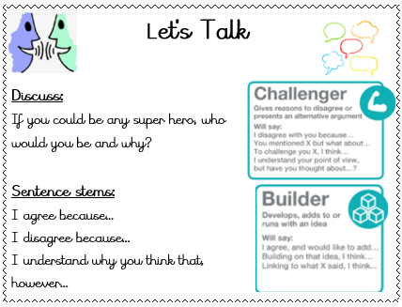

Statutory assessments

Year 1 phonics screening check takes place the week commencing Monday 8th June. The Year 4 multiplication times table checker also takes place this same week. Tests have to be completed during this window, so children have to be in school for the assessments.
Thank you for your support with this matter.

Year 6 dates
This half term is very busy for our Year 6 pupils as they come ever closer to moving on from St Clare’s. Please note the following dates:
Condover - 20-22 May
Bikeability - 8-12 June (one day each in groups)
Mini Clares to Our Ladys' - 12th June
End of year retreat in school - 29 June and 3 July
Our Lady's transition - 30 June
KS2 sports day - 26 June
Young Enterprise - 7 July
Leavers service in church - 8 July 5pm
Leavers play - 15 July 9.15am
Forest Fest - 15 July 5-7pm
Fun day whole school - 13 July
14 July - end of year Mass whole school 9am

Online safety
'What I wish my parents or carers knew…': a guide for parents and carers on children's digital lives (Children's Commissioner) The Children's Commissioner, Dame Rachel de Souza, has published a guide to help parents and carers navigate the challenge of managing children's everyday online habits. Written with direct input from children and young people, including teenagers consulted in schools and the Commissioner's Youth Ambassadors. The guide is designed to make difficult conversations easier and more regular.

Please click on the link for more information https://www.childrenscommissioner.gov.uk/resource/what-i-wish-my-parents-or-carers-knew-a-guide-for-parents-and-carers-on-managing-childrens-digital-lives/

Support
As a school we are here for both your children and your family. If you are experiencing any difficulties or have any anxieties, please get in touch with Mrs Sylvester for a private conversation. Her email address is c.sylvester@st-clares.manchester.sch.uk or you can ring the school number or message via the school app. If we are unable to help you, we may be able to refer you to somebody who can.

Safeguarding
Safeguarding children is everyone’s responsibility. If you have any concerns regarding the safety of a child, please report it. You are able to refer concerns directly to children’s services or via school.

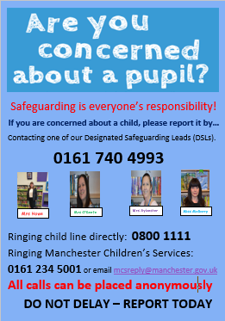

Enjoy the weekend,
Mrs Howe

Upcoming dates
Saturday 9th May – First Holy Communion rehearsal 10am-12pm
Monday 11th May – SATS week
Saturday 16th and 23rd May – First Holy Communion 12.00pm

The weekly newsletter is also available on our school website Newsletters

