ST CLARE’S R.C.P NEWSLETTER
Our School Mission Statement: Guided by Jesus Christ, our teacher, we journey together learning to dream, believe and achieve. Friday 22nd May 2026
Friday 24th November 2023

May – the month dedicated to Our Lady!
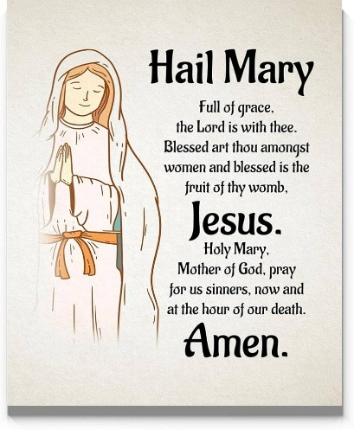
On Saturday, our final group of children will make their First Holy Communion in church. This is an important step for them on their faith journey. Our first group of children received the Sacrament for the first time last Saturday. It was a beautiful Mass and celebration of their faith. Please keep the children and their families in your prayers.
If any of our brilliant singers in school are able to come and join us for the 12 o’clock Mass on Saturday, it would be wonderful.
This week, our amazing Year 6 children have been on their residential trip to Condover in Shropshire. They’ve had a taste of independence – being responsible for getting themselves ready for the day ahead. We have had a very busy, fun-filled 3 days where the children have done kayaking, zip-wiring, archery, aero-ball and abseiling to name a few. There are lots of photographs of the children on X. I am sure that the children will take away many wonderful memories with them from Condover. They were perfectly behaved (apart from messy rooms and not sleeping on the first night!) and were a credit to both you and the school. Thank you to all our wonderful staff who gave up their time to offer our children this fantastic experience.
In honour of Our Lady and May being the month of Mary, our Mini-Clares led the whole school in saying a decade of the Rosary. They help to lead the faith in our school well with the support of Miss Sabor and Mrs Albuquerque.
In Nursery this week, the children have been learning about 3D shapes and have been on a shape hunt around our outdoor area. Our Reception have been learning all about subtraction, using number tracks to help them.
As part of their DT topic, Year 1 have been making puppets.

The children in Year 2 have written letters to Parthe in the role of Florence Nightingale, describing what Scutari Hospital was like during the Crimean war. Year 3 have been learning to tell the time, to the nearest minute, on an analogue clock in maths. Year 4 pupils have created their own protected conservation areas this week in science and our Year 5 pupils have learned how to craft expressive free verse poems and bring them to life through confident, engaging performances!

Assembly

As the Father sent me, so am I sending you: receive the Holy Spirit John 20: 19-23
This week 1S and 5L led our assemblies. They both focused on the liturgical year and Pentecost which will be celebrated in church on Sunday. This day marks the birthday of the church. It was the day that God sent down His Holy Spirit to be with the disciples, giving them the knowledge and courage to go and spread the Good News that Jesus had taught them. As promised, God will never leave us alone.
Thank you to everyone who was able to join us for these wonderful Celebrations of the Word. The children were amazing, confident and sang beautifully.

Come and pray
Our chapel / KS2 prayer garden is open each Tuesday morning before school for staff, pupils and parents to come and pray privately. Starting the day with God is a
beautiful way to begin the morning. You are very welcome to pop in from 8.15am each Tuesday – our Mini Clares would love to greet you.

Pupil certificates
 | Pupil of the week | Achievement
N | Darla for being such a well-behaved girl who is always doing the right thing. | Dax for writing his name independently even without his name card.
RDM | Myla-Mae - for always being very helpful to others | Nia-Remi - great effort with her handwriting, well done!
RS | Freya for being a fantastic role model to her peers. | Roseanne for improving her reading and writing!
Y1G | Oscar for being a kind and helpful friend. | Milton for his amazing threading skills.
Y1S | Waliya for being a kind, thoughtful and helpful friend to everyone. | Makayla for trying very hard with her spellings.
Y2C | Freya for always being ready to learn | Abongwi for showcasing good listening skills when he is working in a group
Y2D | Rosie for always being ready and respectful. | Florence for using your oracy skills and talk tactics so well.
Y3F | Lennox for being an amazing mathematician and wanting to challenge himself all the time! | Hanna for always wanting to give an answer in our class discussions, and using great listening skills.
Y3H | Pharrell for making sensible choices and using excellent manners | Ethel for writing some excellent creative sentences for a recount.
Y4H | Grace for trying extremely hard to improve her handwriting! | Julia for producing and publishing a factual and interesting report!
Y4O | Daylia for being a kind and caring member of the class, a role model for all | Joy for producing a fantastic non-chronological report
Y5KG | Osamagbe for always being so polite and using his manners when addressing adults in school. | Kodie for a great improvement in his attitude to learning! He has produced excellent work in all subjects.
Y5L | Kacper for being a positive role model in class to his peers. | Avayah for producing a fantastic free verse poem, based on a fleeting memory.

Headteacher Awards
Isabella in Nursery for always setting a great example to others.
Aiden in 1S for his commitment to his writing and challenging himself with writing more detailed sentences independently.
Ellis in 3F for being an amazing orator, using our talk tactics expertly during discussions.
Amber in 5L for her brilliant oracy work, throughout her presentation of “Den to let” by Gareth Owen.

Caritas Award 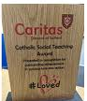
The Caritas Award is presented each week to a child in recognition of their outstanding achievement in putting love into action. This week the award goes to Rosie May in Year RS for cutting a child’s dinner up for them when she could see them struggling. How very thoughtful and kind!
Attendance
Overall whole school attendance this week has fallen to 93.8%. The best class for attendance this week, once again, is 6W with 100%, which is amazing! This is the third time on the run that they have won it!
We had 47 pupils late 61 times and 9 pupils late after the registers close 13 times. School doors open at 8.40am to give the children time to take off their coats and be ready at their desks for an 8.45am start. The doors close promptly at 8.45am.
Under the UN Convention on the Rights of the Child (UNCRC), Article 29, children have the right to an education. If you are experiencing any difficulties or require any additional support with attendance or punctuality, please contact our Attendance Officer, Mrs Burgess Hamlett.

Let’s Talk
Good oracy skills are really important. Oracy doesn't stop at the school gates! To support this journey, try our "Let’s Talk" discussion below.

Here is this week’s suggestion:

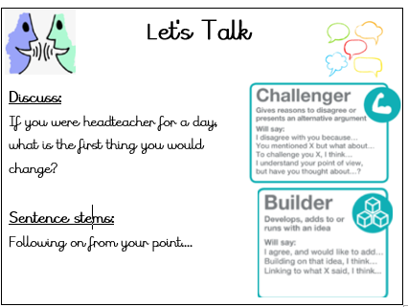

If you come up with any wonderful ideas, please let me know.

Statutory assessments

Year 1 phonics screening check takes place the week commencing Monday 8th June. The Year 4 multiplication times table checker also takes place this same week. Tests have to be completed during this window, so children have to be in school for the assessments.
Thank you for your support with this matter.

Year 6 dates
This half term is very busy for our Year 6 pupils as they come ever closer to moving on from St Clare’s. Please note the following dates:

Bikeability - 8-12 June (one day each in groups)
Mini Clares to Our Ladys' - 12th June
End of year retreat in school - 29 June and 3 July
Our Lady's transition day - 30 June
KS2 sports day - 26 June
Young Enterprise - 7 July
Leavers service in church - 8 July 5pm
Leavers play - 15 July 9.15am
Forest Fest - 15 July 5-7pm

Baby news
I am delighted to share the very happy news that we have welcomed a new baby to the St Clare’s family this week. Miss Conway gave birth to a healthy, beautiful baby boy. We send them our love and best wishes. May God bless baby Oscar.

Vacancy
We are hoping to recruit a SEND level 2 teaching assistant to work with some of our children with additional needs from September 2026. The post is to cover maternity leave and will end at the end of April 2027. Please see the advert on our website for further details.
https://st-clares.manchester.sch.uk/our-school/vacancies/ta-send-level-2-maternity-cover-vacancy

Online safety
'What I wish my parents or carers knew…': a guide for parents and carers on children's digital lives (Children's Commissioner) The Children's Commissioner, Dame Rachel de Souza, has published a guide to help parents and carers navigate the challenge of managing children's everyday online habits. Written with direct input from children and young people, including teenagers consulted in schools and the Commissioner's Youth Ambassadors. The guide is designed to make difficult conversations easier and more regular.

Please click on the link for more information https://www.childrenscommissioner.gov.uk/resource/what-i-wish-my-parents-or-carers-knew-a-guide-for-parents-and-carers-on-managing-childrens-digital-lives/

Support
As a school we are here for both your children and your family. If you are experiencing any difficulties or have any anxieties, please get in touch with Mrs Sylvester for a private conversation. Her email address is c.sylvester@st-clares.manchester.sch.uk or you can ring the school number or message via the school app. If we are unable to help you, we may be able to refer you to somebody who can.

Safeguarding
Safeguarding children is everyone’s responsibility. If you have any concerns regarding the safety of a child, please report it. You are able to refer concerns directly to children’s services or via school.

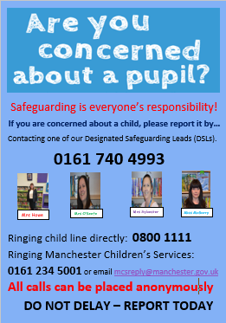

Enjoy the weekend,
Mrs Howe

Upcoming dates
Tuesday 9th June – Holy Communion party and photographs (for our Year 6 children too).
Tuesday 16th June – Nursery new intake meeting 5-6pm
Wednesday 17th June – Reception new intake meeting 5-6pm
Thursday18th and Friday 19th June – Year 5 to Debdale waterpark.
Friday 19th June – whole school Mass
Wednesday 24th June – EYFS / KS1 sports day (back up date 1st July)
Friday 26th June – KS2 sports day (back up date 2nd July)
Friday 26th June – choir at The Big Sing
Friday 10th July – 1G Sealife Centre
Monday 13th July -Whole school FUN DAY
Tuesday 14th July – Whole school end of year Mass
Friday 17th July – finish for summer at 1.15pm

The weekly newsletter is also available on our school website Newsletters

