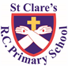

ST CLARE’S R.C.P NEWSLETTER

Our School Mission Statement: Guided by Jesus Christ, our teacher, we journey together learning to dream, believe and achieve. Friday 13th June 2025

Friday 24th November 2023

Children in Year 1 to Y5 have been busy completing assessments this week to demonstrate their learning.

On Wednesday, a travelling farm visited our Nursery setting. The children were able to see, stroke and feed the animals whilst learning some facts about them. They loved the experience. Meanwhile on Thursday, our Reception children visited Smithills Farm. They had a wonderful day riding on donkeys, riding in a tractor and meeting baby animals. It was a lovely day out. In RE, Year 1 have been learning who our neighbours are and how we can care for them. As part of their science topic, Year 2 are investigating habitats and went on a search around our school grounds. In geography, Year 3 have been looking at Madagascar and its compass points. Year 4 have started learning about what a mountain is and where they are located using the seven continents. Year 5 have had exciting visits to Debdale Outdoor Centre to take part in raft canoeing. They had a great time. In science, Year 6 have been using microscopes to investigate micro-organisms.

**Assembly**

We had two class assemblies this week. On Monday, 6W performed their last class assembly for us based on friendship. They led us in thinking what a good friend is and how, like Jesus, we should be friends with our brothers and sisters around the world.

On Tuesday, RS led our other assembly. Their assembly focused on gathering and what we do when we gather. It was based on the biblical quote from Matthew 19:14, ‘Let the children come to me.’ We are all invited to join Christ in the Mass each week.

The children were all amazing – spoke clearly and sang beautifully. Thank you to everyone who joined us for the Celebration of the Word.

**Sun**

This week, our school council also reminded our key stage 2 children about how to stay safe in the sun. Children were reminded to wear suncream; wear a hat; drink plenty of water; stay in the shade; and not to be out in the sun during the hottest times of the day. Please bear all of this in mind when sending your child into school. It is sports day next week too, so the advice remains the same.

**Chapel / prayer garden**

Our chapel / KS2 prayer garden is open each Tuesday morning before school for staff, pupils and parents to come and pray privately. Starting the day with God is a beautiful way to begin the day. You are very welcome to pop in from 8.15am each Tuesday.

**Pupil Certificates**

|  |  |  |
| --- | --- | --- |
|  | Pupil of the week | Achievement |
| N | Natna for always trying hard at everything | Bobby for being really brave around the animals and overcoming his fear. |
| RDM | Kieran for always trying hard in all that he does | Gerald for fantastic effort with his writing |
| RS | Lula for always being a kind and thoughtful friend. | Uhmiana for using finger spaces and a full stop independently in her writing. |
| Y1G | Luka for being a great partner to Uyi this week in PE. | Romeo for his amazing attitude during assessment week. He has been so focused and a role model for all. |
| Y1S | Abongwi for a great attitude to learning and being very focussed all week. | Irene for trying very hard in her assessments this week. |
| Y2C | Tomasz for always having an amazing attitude to learn` | Izzy for giving lots of amazing answers about the Great Fire of London when on our trip! |
| Y2D | Rosie for always being ready to learn and trying hard in every lesson. | Tymofiy for using interesting adjectives in our Literacy lessons. |
| Y3F | Carter H for having a really good week, you can see already how he is ready for Year 4! | Saffron for doing amazing work in geography when looking at Madagascar on a map. |
| Y3H | Igor for a super understanding of compass points and where countries are in relation to one another. | Grace for a very impressive score in her SPAG assessment. |
| Y4H | Kacper has behaved beautifully this week and tried really hard with his handwriting. | Freddy has worked so hard (as always!) and achieved some amazing scores on his assessments, I have been so proud! |
| Y4O | Kodie for a great week of working hard in class and showing a very sensible attitude to his work. | Evana for some brilliant results in her assessments this week. Well done! |
| Y5G | Ryan for having such beautiful manners and always following the rules of the school. | Archie for his fantastic team work and leadership during our trip to Debdale. |
| Y5K | Arwaa for always following the school rules of: “Be Ready, Be Respectful and Be Safe.” | Shae for her amazing progress in her assessments. |
| Y6S  CARITAS | Lilly for being so kind and thoughtful during her forest school session by making gifts using log slices! | Tianna for the fantastic effort she has been putting into her end of year performance practise. |
| Y6W  CARITAS | Hannah for her enthusiasm and rhythm in dance this week. | Jessica for the fantastic effort she has been putting into her end of year performance practise. |

**Headteacher Awards**

Samuel in Nursery for his growth in confidence.

Gabriel in RS for his loud, clear voice in the class assembly.

Ivy in 1S for working so hard to improve the quality of her writing.

Tommy in 2D for greater independence and better quality writing.

Pippa in 3H for her positive attitude to school life.

Felicity in 4H for good answers in science.

Cassius for amazing performances in play rehearsals.

**Caritas Award**

The Caritas Award is presented each week to a child in recognition of their outstanding achievement in putting love into action. This week the award goes to Poppy C and Valeria for choosing to maintain our school environment by painting the shed during their forest school session.

**Attendance**

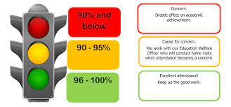

Overall whole school attendance this week is 94.9%. We had more children late this week than the previous week – 109 occasions in totaL

Please ensure that your child is at school for 8.40am.

**Under the** **UN Convention on the Rights of the Child (UNCRC), Article 29, children have the right to an education**. If you are experiencing any difficulties or require any additional support with attendance or punctuality, please contact our Attendance Officer, Mrs Burgess Hamlett.

The best class for attendance this week is 1G with 99%. They will receive a longer break next week as a reward.

**Parental cookery course**

Just a reminder that next week (26th June) is the last session. I know that the parents who joined the programme have enjoyed it and will receive a slow cooker for attending the course.

**Sports Day**

Sports days are planned for next week. Hopefully the weather will continue to be dry. The forecast is good!

Children should come into school in their relevant house / saint colour t-shirt.

Timings are as follows:

25/6 EYFS sports day 9.15am

25/6 KS1 sports day 10.45am

26/6 LKS2 sports day 9.15am

26/6 UKS2 sports day 10.45am

**Classes next year**

We are already making preparations for September. Part of this is assigning class teachers to each class and giving the children some time to spend with them. We will be hosting a move up afternoon on Wednesday 2nd July.

The staff / class structure in September will be:

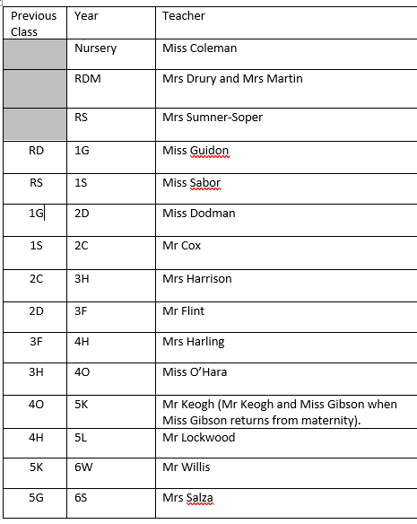

**Support**

As a school we are here for both your children and your family. If you are experiencing any difficulties or have any anxieties, please get in touch with Mrs Sylvester for a private conversation. Her email address is [c.sylvester@st-clares.manchester.sch.uk](mailto:c.sylvester@st-clares.manchester.sch.uk) or you can ring the school number or message via the school app. If we are unable to help you, we may be able to refer you to somebody who can.

If you are struggling to buy food at the moment, please contact school. We do not want any families to go without food. We do have contact with some food banks who may be able to offer support.

**Safeguarding**

**Under the United Nation Convention on the Rights of a Child, all children under the age of 18 have a right to be protected from violence, abuse and neglect (Article 19) and a right to be alive (Article 6).**

There are many forms of abuse – sexual, neglect, emotional, physical, online – and it is everyone’s responsibility to safeguard children from any harm.

If you have any concerns regarding the safety of a child, please report it. You are able to refer concerns directly or you can contact one of the Designated Safeguarding Leads in school. Contact details can be found below.

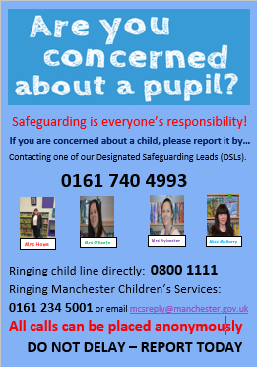

Enjoy the sunshine this weekend,

God bless you all,

Mrs Howe

**Upcoming dates:**

Wednesday 25th June – EYFS sports and KS1 sports day

Thursday 26th June – KS2 sports day

24th and 27th June – Year 6 retreat in school

Friday 27th June – Eco schools celebration.

Tuesday 1st July – Year 6 enterprise

Tuesday 8th July – KS2 music showcase

Thursday 10th July – Year 6 leavers service in church 5.30pm

Friday 11th July – school reports sent home

Tuesday 15th July – whole school end of year mass 9.00am

Tuesday 15th July – Year 6 Forest Fest

Wednesday 16th July – Year 6 leavers play 9.15am

Friday 18th July – finish at 1.15pm for summer.

***The weekly newsletter is also available on our school website***[*Newsletters*](https://st-clares.manchester.sch.uk/parents/newsletters/newsletters-2024-2025)

**A Prayer of Hope**

