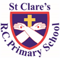

ST CLARE’S R.C.P NEWSLETTER

Our School Mission Statement: Guided by Jesus Christ, our teacher, we journey together learning to dream, believe and achieve. Friday 27th June 2025

Friday 24th November 2023

On Monday, our choir went along to the Bridgewater Hall in Manchester to take part in the Big Sing along with over 1800 other children. They joined lots of other Manchester schools in singing ‘one hit wonders.’ They really enjoyed the opportunity to take part and their behaviour, as always, was great.

On Tuesday and Friday, our Year 6 pupils took part in a religious retreat looking over their time at St Clare’s and helping to prepare them for moving on to high school.

On Friday, our Eco group went for a celebration event at Heaton Park in recognition of achieving the Eco Green Flag.

Our Early Years and KS1 sports day took place on Wednesday on the playground – due to a boggy field.

It was lovely to see all the children physically active and helping to earn point for their house saint. Thank you to everyone who came along to support the children.

The results are:

EYFS

St Clare (blue): 673

St Josephine (yellow): 611

St Francis (red): 596

St Patrick (green): 490

Year 1 and 2:

St Patrick (green): 944

St Clare (blue): 863

St Josephine (yellow): 709

St Francis (red): 707

Key Stage 1 and EYFS combined:

St Clare (blue): 1536

St Patrick (green): 1434

St Josephine (yellow): 1320

St Francis (red): 1303

**Assembly**

Our Mini Clares led the assemblies this week. They focused on the Jubilee Year and Pilgrims of Hope theme.

We are very lucky to have such dedicated, enthusiastic children in our Mini Clares group to help lead the religious side of our school. They have been active all year. Thank you to each and every one of them. Special thanks to Miss Sabor for giving up her time to lead the group and to Mrs Albuquerque for her assistance too.

**Chapel / prayer garden**

Our chapel / KS2 prayer garden is open each Tuesday morning before school for staff, pupils and parents to come and pray privately. Starting the day with God is a beautiful way to begin the day. You are very welcome to pop in from 8.15am each Tuesday.

**Pupil Certificates**

|  |  |  |
| --- | --- | --- |
|  | Pupil of the week | Achievement |
| N | Michael for always doing the right thing and being a joy to have around. | Kerry for being really well behaved and sensible during our Sports Day! |
| RDM | Jessen for always setting a good example | Layla-Mae for fantastic effort in all the events on Sports Day |
| RS | Chukwu for always being a kind, fair friend. | Zion for trying so hard with subtraction in maths this week! |
| Y1G | Frankie for being a kind and caring member of our class. | Blake for trying super hard on sports day - he really impressed his team leader. |
| Y1S | Savanna for a fantastic attitude to learning this week and doing amazing work in lessons. | Szymon for working really hard with his reading. |
| Y2C | Arly for always showing his wonderful behaviour in class | Cole for an amazing ‘I can do it’ attitude during sports day |
| Y2D | Yohannes for being resilient and having a can-do attitude during sports day. | Lennox for an amazing narrative. |
| Y3F | Olivia for always willing to help others, adults and children. | Fabian for really trying during his writing this week, he has been trying to include all the types of punctuation he needs to! |
| Y3H | Hope, for being able to locate Madagascar on a world map. | Ophelia for being able to articulate her mathematical thinking clearly. |
| Y4H | Rory for consistently good behaviour in class. | Avayah for answering some  brilliant questions in many different subjects this week. |
| Y4O | Layla for always being a real help and assistance around the class. | Rudi for a big improvement in the standard of his independent writing. |
| Y5G | Harry for always being such a helpful member of our classroom. | Phaedra for creating a beautiful independent letter based on going to the farm. |
| Y5K | Ire for always being “Ready, Safe and Respectful,” throughout the school day. | Annie for producing a fantastic “Graffiti Art Throwie!” Using contrasting colours and shadows. |
| Y6S | Alexa for being so helpful with the making of the backdrop for the year 6 end of | Laura for creating a lovely, thoughtful prayer during our Moving On Retreat workshop with the Marist Sisters. |
| Y6W | Ryan Mc for helping both staff and children during KS1 sports day. | Sam for a great piece of work on Mayan artefacts |

**Headteacher’s Award**

Victoria in RDM for working hard and being a wonderful role model to others.

Penelope in 1G for finding nouns, verbs and conjunctions in a text.

Ryan in 2C for amazing participation in sports day.

Tyler in 4O for being so helpful to others.

Phaedra in 5G for great art work.

Cole in 5K for a great recount letter based on Charlotte’s Web.

Aliyah in 6S for being so generous in bringing in resources for the end of year play.

**Caritas Award**

The Caritas Award is presented each week to a child in recognition of their outstanding achievement in putting love into action. This week the award goes to Dior in RDM for always being so kind and considerate to the children and adults in Reception!

**Attendance**



Overall whole school attendance this week is 94.7%. 66 children were late 83 times this week before 9am. 8 children were late after 9am.

Please ensure that your child is at school for 8.40am.

**Under the** **UN Convention on the Rights of the Child (UNCRC), Article 29, children have the right to an education**. If you are experiencing any difficulties or require any additional support with attendance or punctuality, please contact our Attendance Officer, Mrs Burgess Hamlett.

The best classes for attendance this week ar RS and 2D with 98%. Well done to them! They will receive a longer break next week as a reward.

**Parental cookery course**

The cookery course has now finished. Thank you to the parents who attended. I hope you enjoy using your new slow cooker.

**Classes next year**

We are already making preparations for September. Part of this is assigning class teachers to each class and giving the children some time to spend with them. We will be hosting a move up afternoon on Wednesday 2nd July.

The staff / class structure in September will be:

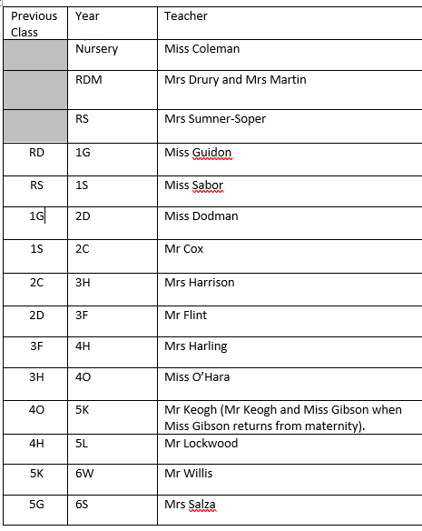

**Support**

As a school we are here for both your children and your family. If you are experiencing any difficulties or have any anxieties, please get in touch with Mrs Sylvester for a private conversation. Her email address is [c.sylvester@st-clares.manchester.sch.uk](mailto:c.sylvester@st-clares.manchester.sch.uk) or you can ring the school number or message via the school app. If we are unable to help you, we may be able to refer you to somebody who can.

If you are struggling to buy food at the moment, please contact school. We do not want any families to go without food. We do have contact with some food banks who may be able to offer support.

**Speech and Language**

On **Thursday 3rd July at 9.15 am** there will be a parent advice session in the infant hall from The Flying Start Team.  This in a session around speech and language and strategies/support for you to use at home.  The session will finish at approximately 10 am.  We hope you can join us.

**Safeguarding**

**Under the United Nation Convention on the Rights of a Child, all children under the age of 18 have a right to be protected from violence, abuse and neglect (Article 19) and a right to be alive (Article 6).**

There are many forms of abuse – sexual, neglect, emotional, physical, online – and it is everyone’s responsibility to safeguard children from any harm.

If you have any concerns regarding the safety of a child, please report it. You are able to refer concerns directly or you can contact one of the Designated Safeguarding Leads in school. Contact details can be found below.



Enjoy the sunshine this weekend,

God bless you all,

Mrs Howe

**Upcoming dates:**

Monday 30th June – Year 6 enterprise – change of date.

Thursday 3rd July – Back up KS2 sports day

Tuesday 8th July – KS2 music showcase

Thursday 10th July – Year 6 leavers service in church 5.30pm

Friday 11th July – school reports sent home

Tuesday 15th July – whole school end of year mass 9.00am

Tuesday 15th July – Year 6 Forest Fest

Wednesday 16th July – Year 6 leavers play 9.15am

Friday 18th July – finish at 1.15pm for summer.

***The weekly newsletter is also available on our school website***[*Newsletters*](https://st-clares.manchester.sch.uk/parents/newsletters/newsletters-2024-2025)

**A Prayer of Hope**

