ST CLARE’S R.C.P NEWSLETTER
Our School Mission Statement: Guided by Jesus Christ, our teacher, we journey together learning to dream, believe and achieve. Friday 3rd July 2026
Friday 24th November 2023

What a turn around in the weather! This week has been far more manageable and we have been able to host all our sports days. Thank you to the children for their wonderful participation; to parents and friends for coming to support them; and to the staff for organising / running the events.
The results are:
EYFS winner – St Francis (red) team
KS1 winner – St Therese (yellow) team
Lower KS2 - St Therese (yellow) team
Upper KS2 – St Francis (red) team
Overall winner: St Francis – by 8 points!

Our Year 6 children took part in a religious retreat in school this week relating to moving on. Children who are going to attend Our Lady’s also had their transition day. Children here also spent an afternoon with their new teachers for September. A group of children from Y3 and Y4 took part in a football competition last night. They had a fantastic time.
In Nursery, they have been creative in the funky fingers area using junk modelling to make different creations. In maths, our Reception children have been consolidating number bonds to 5 through different songs and rhymes. Year 1 have been learning about money in maths and looking at different coins, notes and their quantity. Year 2 have been learning about Jewish Traditions as part of our world faiths work. In maths, Year 3 have been learning all about 2D and 3D shapes and describing their properties. In English, Y4 have been writing poems using similes and metaphors incorporating some lovely vocabulary. Year 5 enjoyed a fantastic transition morning at Our Lady’s High School, taking part in a Home Economics session where they cooked their own pasta bolognaise as part of Design and Technology. It was a fun, hands-on experience that gave pupils a great taste of secondary school life. As well as preparing for their leavers service and leavers play, Year 6 have studied the artwork of Jacob Lawrence and recreated one of his dynamic cubism pieces.

Assembly
He said to them, “But who do you say that I am?” Simon Peter replied, “You are the Christ, the Son of the living God”. Matthew 16:15-16

This week our assembly focused on St Peter and St Paul. The children considered how they can be like them. They can be like Peter by being strong like a rock, admitting
when they make mistakes and following Jesus. They can be like St Paul by sharing their faith, telling everyone about Jesus and encouraging others.

Come and pray
Our chapel / KS2 prayer garden is open each Tuesday morning before school for staff, pupils and parents to come and pray privately. Starting the day with God is a
beautiful way to begin the morning. You are very welcome to pop in from 8.15am each Tuesday – our Mini Clares would love to greet you.

Pupil certificates
 | Pupil of the week | Achievement
N | Victoria for always being a fantastic role model to all | Shai for being so sensible during our sports day!
RDM | Sam - Fantastic attitude and effort during sports day! | Storm - wonderful creative work!
RS | Ronnie for fantastic teamwork during sports day! | Bobby for amazing progress in handwriting!
Y1G | Tare for representing the school at an awards show. | Bereket for having a great can do attitude during sports day.
Y1S | Joelvy for a fantastic attitude all week and being a superstar on our trip. | Lula for putting 100% effort into all of the sports day activities.
Y2C | Zion for always having an amazing attitude to learning | Mia for her determination during sports day
Y2D | Isaac for being ready to learn and setting a good example. | Matilda for your lovely work in our English lessons.
Y3F | Chloe for being an amazing helper and always being ready to learn. | Ellis for doing amazing shape work in maths.
Y3H | Isabello O for outstanding effort in everything she does. | Anuli for an in depth comparison between the climates Madagascar and thee U.K
Y4H | Saara for being a kind and considerate shoulder partner! | Pablo for being a fantastic rounders player!
Y4O | Ophelia for being focused and ready to learn all week. | Peter for fantastic participation during sports day.
Y5KG | Josephine for being a shining light in our classroom by bringing lots of positive energy every single day. | Rudi for being a fantastic independent learner this week especially in maths and reading.
Y5L | Felicity for showing outstanding dedication in supporting others during music, consistently offering help with patience, clarity and enthusiasm. | Kacper, Lottie, Jake and Rayarna for delivering a supportive and inclusive dance performance, creating a welcoming environment where every participant felt valued and encouraged.
Y6S | Alexis for helping the year 3 and 4 children so well during their sports day | Skylar for a fantastic dynamic cubism painting in the style of Jacob Lawrence
Y6W | Lily for always doing what is asked of her being a role model in behaviour and attitude | Malik for his creativity and interesting ideas in P.E

Headteacher Awards
Michelle in 1S for being a kind and helpful friend to everyone and always thinking about others and looking out if they’re in need.
Blake in 2D for being a super star all the time.
Aria in 3H for her beautiful art work on the visit to Our Lady’s.
Emiley in 4O for fantastic ideas and sentences in her poetry.
Caritas Award 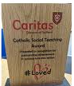
The Caritas Award is presented each week to a child in recognition of their outstanding achievement in putting love into action. This week the award goes to Rhiley in Nursery for always being such a caring girl towards her friends and teachers.
Laudato Si Award Winner
This week one of our pupils, Tare in Year 1, went to the Laudato Si Centre with some friends as he had been nominated for an award relating to caring for our common home. We are thrilled to announce that he won the award! Tare had the pleasure of being presented with his award by Bishop John. We are very proud of him and thank Mr Dale for accompanying Tare on the day.
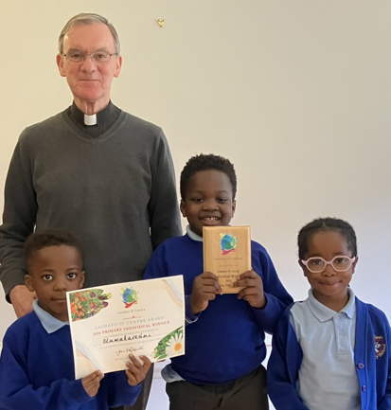
NHS online gallery competition
Children took part into the Step into the NHS art competition. We are delighted that Marnie in Year 5s art work has been highly commended and shared on the website. What a great achievement! https://www.stepintothenhs.nhs.uk/primary-schools/online-gallery
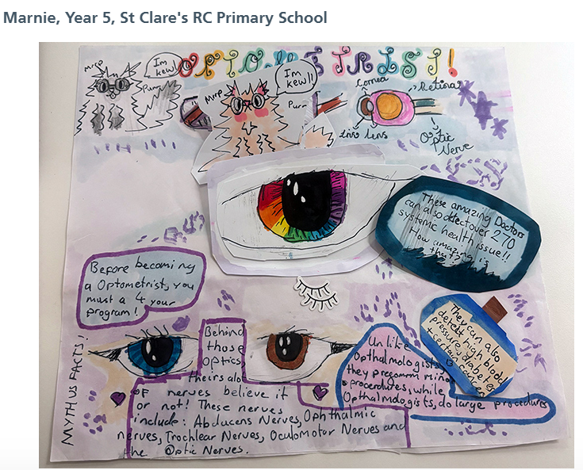
Attendance
Overall whole school attendance this week is 96.2% which is the best it has been recently. The best classes for attendance this week is 5L with 99% Well done – they will get a longer break.
School doors open at 8.40am to give the children time to take off their coats and be ready at their desks for an 8.45am start. The doors close promptly at 8.45am.
Under the UN Convention on the Rights of the Child (UNCRC), Article 29, children have the right to an education. If you are experiencing any difficulties or require any additional support with attendance or punctuality, please contact our Attendance Officer, Mrs Burgess Hamlett.

Uniform Swap
Our school council are organising a uniform swap on Thursday 16th July. You can bring in clean uniform in good condition and exchange it. There is also the option of you taking some uniform ready for September. The aim is to stop parents having to buy new uniforms and re-cycling clothing to help save the planet!

Help Restore Saint Clare’s Roman Catholic Church for Our Centenary in 2029
In 2029, Saint Clare’s Roman Catholic Church in Blackley, Manchester, will celebrate a truly remarkable milestone—100 years of faith, worship, and service to our community.
For almost a century, Saint Clare’s has been far more than just a building. It has been a place where generations have gathered to pray, celebrate baptisms and weddings, First Holy Communions, Confirmations, mourn loved ones, and support one another through life’s joys and challenges. As we approach our centenary, we want to ensure that our church remains a welcoming and inspiring place of worship for future generations.
To help achieve this, we are launching a fundraising appeal to support essential renovation and restoration works at Saint Clare’s Church:
200 Club (information available on the form at the School office)
As we prepare to celebrate 100 years of Saint Clare’s Roman Catholic Church, we invite you to be part of this important chapter in our history.
Your generosity will help preserve our church, honour the faith and dedication of previous generations, and ensure that Saint Clare’s continues to serve the people of Blackley for many years to come.
Thank you for your support, prayers, and kindness.
Fr Jeremiah

Let’s Talk
Good oracy skills are really important. Oracy doesn't stop at the school gates! To support this journey, try our "Let’s Talk" discussion below.

Here is this week’s suggestion:
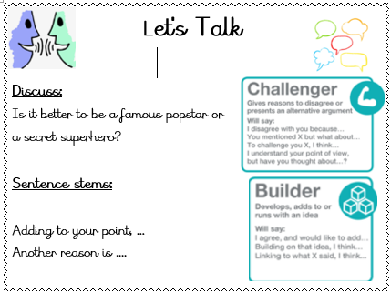

Year 6 dates
This half term is very busy for our Year 6 pupils as they come ever closer to moving on from St Clare’s. Please note the following dates:

Young Enterprise - 7 July
Leavers service in church - 8 July 5pm
Leavers play - 15 July 9.15am
Forest Fest - 15 July 5-7pm

Support
As a school we are here for both your children and your family. If you are experiencing any difficulties or have any anxieties, please get in touch with Mrs Sylvester for a private conversation. Her email address is c.sylvester@st-clares.manchester.sch.uk or you can ring the school number or message via the school app. If we are unable to help you, we may be able to refer you to somebody who can.

Safeguarding
Safeguarding children is everyone’s responsibility. If you have any concerns regarding the safety of a child, please report it. You are able to refer concerns directly to children’s services or via school.

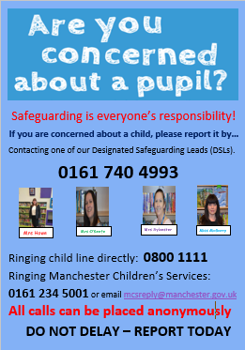

Enjoy the weekend,
Mrs Howe

Upcoming dates
Friday 10th July – 1G Sealife Centre
Monday 13th July -Whole school FUN DAY
Tuesday 14th July – Whole school end of year Mass
Friday 17th July – finish for summer at 1.15pm

The weekly newsletter is also available on our school website Newsletters

