ST CLARE’S R.C.P NEWSLETTER
Our School Mission Statement: Guided by Jesus Christ, our teacher, we journey together learning to dream, believe and achieve. Friday 25th September 2026


Thank you once again for your overwhelming support and generosity with our Macmillan Coffee Morning. It is lovely for the school community to come together to support this charity and for us to welcome you into school. Thank you for providing the cakes to sell and then buying them back. You are very kind. Thank you to our Year 6 staff and pupils, Leo’s Leaders, for hosting the morning. With your tremendous support, we have raised a staggering £723.36 and truly lived out our mission of loving and helping others.

In Nursery this week, they have been looking in the mirror and painting self-portraits. In Reception, the children have been exploring prepositional language in maths through storytelling. Year 1 had lots of fun tasting different foods in science. They tried sweet, bitter, sour, spicy and salty foods. Year 2 have been learning about the seas that surround the United Kingdom in Geography. Year 3 have been learning about the features of a volcano in science and geography this week. Year 4 have been enjoying their final week of swimming, and writing Fantasy Narratives in English. This week, Year 5 investigated thermal properties by measuring the insulation effectiveness of three different materials, allowing them to compare and evaluate their findings in Science. In PSHE, Year 6 have been creating campaign posters and presentations for an article of their choice from the UN Rights of the child.

Assembly
Our Year 6S pupils led the assembly this week. They focused on the International Day of Peace linked to St Francis. The children gave us lots of ways that we can be more peaceful in our daily lives. They also linked peace to the United Nations Convention on the Rights of the Child. Our children were confident and clear when speaking and led the assembly well. Thank you to them and those of you who were able to join us. We are very proud of them all.

3H will be leading our KS2 assembly on Monday at 2.40pm in the hall. You are most welcome to join us.

Come and pray
Spending some quiet time with God is a great way to start each day. You are invited into our chapel each
Tuesday morning from 8.15am to start your day with individual prayer.
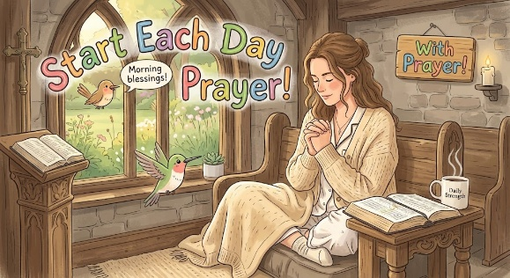

Pupil certificates
 | Pupil of the week | Achievement
N | Zara for being such an amazing role model to all | Ariella for having such beautiful manners all of the time
RDM | Danica for being helpful and super tidying at tidy up time! | Arthur for working really hard in our phonics lessons
RS | Alyssa for always bringing a positive sparkle to our classroom! | Lucy for creating a fantastic piece of homework of her dream house!
Y1G | Nia-Remi for being a role model to others in the classroom. | D’Jamela for amazing independent writing about the Gruffalo.
Y1M | Timi for always being ready to learn and answering lots of questions on the carpet. | Ronnie for writing a brilliant character description of the Gruffalo.
Y2C | Joelvy for being a kind and helpful member of our class | Heidi-May for beautiful letter formation and starting her letters on the line
Y2D | Gerald for having a super week, being ready to learn and trying his best! | Michelle for working hard in our English lessons all week!
Y3F | Oscar B for really trying hard to complete his work this week | Paige for doing some fantastic sentence work in English this week
Y3H - caritas | Amelia for always being kind, helpful, hardworking and an excellent role-model to her friends | Gilly for working really hard in gymnastics in this week’s lesson on symmetry.
Y4H | Chloe for always having lovely manners and being polite to adults. | Frankie for making great contributions to our Guided Reading session.
Y4O’H | Isabelle O for being such a supportive, helpful member of her table. | Anuli for writing a fantastic fantasy narrative.
Y5W | Deborah for demonstrating a fantastic attitude towards her maths learning. | Pablo for his fantastic effort and improvement in his maths understanding this week.
Y5L | Daylia for giving 100% in every lesson, her enthusiasm is infectious. | Joy for producing some amazing homework on Ancient Greece.
Y6S | Esosa for always being ready to learn, and putting 110% effort into all that she does. | Felicity for her brilliant homework this week - she has made a periscope to build upon her learning in Science.
Y6GK | Kian for giving 100% in every lesson: always enthusiastic about his learning and sharing insightful ideas. | Layla for a fantastic score on her arithmetic test this week, all of her hard work is paying off!

Attendance
Overall whole school attendance this week 95.58% The best classes for attendance this week 3H and 6GK with 98.2 %. Well done – they will get a longer break.
School doors open at 8.40am to give the children time to take off their coats and be ready at their desks for an 8.45am start. The doors close promptly at 8.45am.
Under the UN Convention on the Rights of the Child (UNCRC), Article 29, children have the right to an education. If you are experiencing any difficulties or require any additional support with attendance or punctuality, please contact our Attendance Officer, Mrs Burgess Hamlett.
There are strict procedures in place issued by the government for schools to follow in the event of poor absence which may not be due to genuine illness. Parents can be fined or face legal action. We do not want this to happen, so please work with us if you are struggling getting your child to school or you personally need any support. Contact Mrs Burgess Hamlett.

St Francis Mass
This year marks 800 years since the death of St Francis and has been declared a special jubilee year by Pope Leo. Bishop John is coming to our parish to celebrate this special occasion on Sunday 4th October at 10.30am. You are all welcome to attend. We will be asking the choir and Mini Clares to come along and join the parish acting as a choir.
Own clothes Day
On Friday 16th October, children are able to wear their own clothes in return for a food item for the parish foodbank. We are living out our Catholic Mission of loving one another and serving others.
Any food donations are gratefully received, but we suggest
Nursery and Reception children – cereal
Y1 – tinned vegetables
Y2 – pasta
Y3 – rice
Y4 – tinned meat
Y5 – tinned meat
Y6 – pasta or rice.
Benedict’s Law
The campaign was established by the family of Benedict Blythe, a five-year-old boy who tragically passed away from an allergic reaction at school in 2021. His family fought for clear national rules so that no family has to go through a similar experience, ensuring every child with allergies is safely supported at school.

What Schools Are Required to Do
Under the guidance, all schools must follow strict safeguards to manage allergy risks and emergency responses:
- Mandatory Staff Training: teachers, lunch staff, and support personnel must undergo regular training to recognise early signs of allergic reactions and respond immediately.
- Spare Adrenaline Auto-Injectors (AAIs): Schools must hold accessible, non-prescribed spare emergency injectors on site.
- Individual Healthcare Plans (IHPs): Clear, structured action plans must be created in partnership with parents for any child with a diagnosed allergy.
- Near-Miss & Incident Logging: Schools must formally record and review any allergy-related incidents or near-misses to continuously improve safety procedures.

How You Can Help Us Keep All Children Safe
While our staff are fully trained on emergency protocols, parent partnership is essential to keeping our school environment safe:
- Keep Us Updated: If your child develops a new allergy or their prescription details change, notify the main office immediately so we can update their Individual Healthcare Plan.
- Check Expiry Dates: Ensure any medication, inhalers, or auto-injectors kept at school are up to date.
- Be Mindful of Packed Lunches: Avoid sending nuts, sesame, or common high-risk allergens in packed lunches or for class celebrations.

High School applications
Parents of children in Year 6 MUST apply for a high school place by 31st October. The web link is manchester.gov.uk/admissions
Statutory assessments
As you are aware, children are not authorised to take term-time holidays. During the summer term, there are statutory assessments which we have to administer at set dates / weeks. It is imperative that your child is in for these tests.
Year 1 phonics check – 14th -18th June.
Year 2 phonics check for those who did not pass it in Year 1 – 14th-18th June
Year 4 multiplication tables check -7th – 18th June
Year 6 SATs – 10th-13th May
Thank you for your understanding and support with these very important dates.
Support
As a school we are here for both your children and your family. If you are experiencing any difficulties or have any anxieties, please get in touch with Mrs Sylvester for a private conversation. Her email address is c.sylvester@st-clares.manchester.sch.uk or you can ring the school number or message via the school app. If we are unable to help you, we may be able to refer you to somebody who can.

Safeguarding
Safeguarding children is everyone’s responsibility. If you have any concerns regarding the safety of a child, please report it. You are able to refer concerns directly to children’s services or via school.

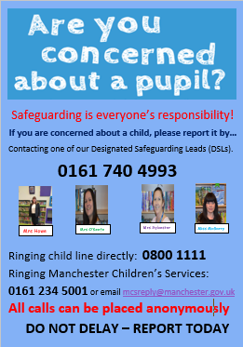

Mrs Howe

Upcoming dates
Sunday 4th October – St Francis Mass 10.30am
Tuesday 6th October – whole school St Francis Mass 9.00am
Sunday 11th October – Family Mass (Sacramental Programme) 10.30am
Friday 16th October – own clothes day in return for food items for the parish food bank.
Tuesday 20th October – Harvest Service in church 9.00am
Wednesday 21st October – parents evening

The weekly newsletter is also available on our school website Newsletters

