ST CLARE’S R.C.P NEWSLETTER
Our School Mission Statement: Guided by Jesus Christ, our teacher, we journey together learning to dream, believe and achieve. Friday 2nd October 2026

This weekend we welcome Bishop John to our Sunday 10.30am Mass as part of the Jubilee Year dedicated to St Francis. We are looking forward to seeing and hearing our children sing at the Mass.

On the same theme, 3H led our assembly this week focusing on the life of St Francis and why he is so special. The children reflected on how we can live like St Francis today. Thank you to 3H for their confident presentation and thank you to all those who were able to join us.

On Monday, our Mini Clares will be leading the children through some prayer stations linked to St Francis and we will be celebrating a whole school Mass on Tuesday at 9am in church. You are most welcome to join us.

Thank you to the parents who were able to join our maths workshop for our Key Stage 1 children on Thursday and thanks to Mr Cox for leading it.

This week, Reception have been learning about the different parts of our body and labelling them. In English, Year 1 have been looking at comic book strips and learning how to write a speech bubble. Year 2 have been investigating which ball will bounce the highest in their science lessons. They also had Biffa workshops promoting recycling. Year 3 have been looking at how water can affect rocks and carried out an investigation in Science on this matter. In history, Year 4 have been learning about the Anglo-Saxon invasion of England, and are writing one-sided arguments in English about school dinners. In their history topic, Year 5 have been discovering who Ancient Greek philosophers were and why they were important to Greek society. Year 6 have been learning about long division in Maths and using their multiplication and partitioning skills to help them.

Come and pray
Spending some quiet time with God is a great way to start each day. You are invited into our chapel each
Tuesday morning from 8.15am to start your day with individual prayer.
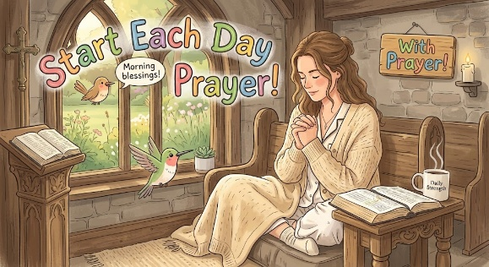

Pupil certificates
N | Luca for being so settled in Nursery and following all of our routines. | Pip for coming into school so happy every day!!
RDM | Arlo for coming into school with a big smile on his face and settling quickly! | Zuriel for super handwriting and drawing beautiful pictures!
RS | Matthew for being a fantastic, encouraging talk partner! | Yaroslava for beautiful handwriting in all her work!
Y1G | Daniel for working hard to sound out his words. | Isabella for her enthusiasm for completing her homework.
Y1M | Bobby for always being ready to learn. | Ayoyimika for writing lovely sentences using an exclamation mark
Y2C | Aiden for having a fantastic attitude to learning and always trying hard | Mila for her super letter formation
Y2D | Dior for always being ready to learn and trying her best. | Ariana for writing a fantastic character description on Traction Man.
Y3F | Alba Downie for always being ready to learn! | Oskar D for doing some great RE work all about Saint Francis’ Canticle of Creation.
Y3H - | Joel for always making sensible choices and setting an excellent example to his friends. | Amy for writing a beautiful canticle to praise God for his creations.
Y4H | Finley, for amazing behaviour in Forest School and having a great attitude to learning this week. | Teti for making a fantastic powerpoint presentation for her homework, all about the importance of a balanced diet.
Y4O’H | Esther for showing great knowledge and understanding in maths this week focusing on addition. | Ryan for giving a fantastic soap box speech in our English based on why children should receive free school meals!
Y5W- Caritas | Saffron for always helping around the classroom. | Shay for his fantastic graph in science.
Y5L -  Caritas | Keriane for always being ready, respectful and safe in her learning. | Vanna for producing a brilliant fact-file on Ancient Greek Philosophers in History.
Y6S | Kacper for always trying his best in all that he does. | Avayah for a fantastic non-chronological report in English
Y6GK | Kodie for a fantastic start to year 6! I have been so impressed with his behaviour, maturity and attitude to learning. | Marta for making excellent progress in all of her lessons due to her focus, work ethic and attitude towards booster groups.

Headteacher’s Awards
Isabelle in RDM for always smiling, always being ready to learn and always so helpful to teachers and pupils!
Freya in 1M for making her own comic strip, including speech bubbles.
Sofia in 4H for always behaving beautifully and setting a wonderful example to others. She is a joy to teach.
Poppy T for making great progress in writing and maths because she is ready to learn at all times and a fantastic student!

Caritas Award 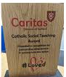
The Caritas Award is presented each week to a child in recognition of their outstanding achievement in putting love into action. This week the award goes to Nova in Year 5 for demonstrating exceptional helpfulness, kindness, and continuous commitment to supporting her classmates in their academic growth. How delightful!

Attendance
Overall whole school attendance this week 95.2% The best classes for attendance this week are 5W, 1M and 5L with 98%. Well done – they will get a longer break.
School doors open at 8.40am to give the children time to take off their coats and be ready at their desks for an 8.45am start. The doors close promptly at 8.45am.
Under the UN Convention on the Rights of the Child (UNCRC), Article 29, children have the right to an education. If you are experiencing any difficulties or require any additional support with attendance or punctuality, please contact our Attendance Officer, Mrs Burgess Hamlett.
There are strict procedures in place issued by the government for schools to follow in the event of poor absence which may not be due to genuine illness. Parents can be fined or face legal action. We do not want this to happen, so please work with us if you are struggling getting your child to school or you personally need any support. Contact Mrs Burgess Hamlett.

Own clothes Day
On Friday 16th October, children are able to wear their own clothes in return for a food item for the parish foodbank. We are living out our Catholic Mission of loving one another and serving others.
Any food donations are gratefully received, but we suggest:
Nursery and Reception children – cereal
Y1 – tinned vegetables
Y2 – pasta
Y3 – rice
Y4 – tinned meat
Y5 – tinned meat
Y6 – pasta or rice.

High School applications
Parents of children in Year 6 MUST apply for a high school place by 31st October. The web link is manchester.gov.uk/admissions
Support
As a school we are here for both your children and your family. If you are experiencing any difficulties or have any anxieties, please get in touch with Mrs Sylvester for a private conversation. Her email address is c.sylvester@st-clares.manchester.sch.uk or you can ring the school number or message via the school app. If we are unable to help you, we may be able to refer you to somebody who can.

Safeguarding
Safeguarding children is everyone’s responsibility. If you have any concerns regarding the safety of a child, please report it. You are able to refer concerns directly to children’s services or via school.

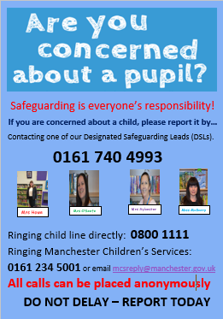

Mrs Howe

Upcoming dates
Tuesday 6th October – whole school St Francis Mass 9.00am
Sunday 11th October – Family Mass (Sacramental Programme) 10.30am
Friday 16th October – own clothes day in return for food items for the parish food bank.
Tuesday 20th October – Harvest Service in church 9.00am
Wednesday 21st October – parents evening

The weekly newsletter is also available on our school website Newsletters

