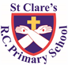

ST CLARE’S R.C.P NEWSLETTER

Our School Mission Statement: Guided by Jesus Christ, our teacher, we journey together learning to dream, believe and achieve. Friday 27th September 2024

Friday 24th November 2023

First of all, a big thank you for your generosity today in supporting our Macmillan coffee morning. You donated so many cakes and then sent money in to buy them back! You are so incredibly kind. We are so grateful for your support. The Year 6 children loved hosting the event and did an amazing job. They made us all very proud. I will let you know the total amount raised as soon as the money has all been counted, but we have raised at least £600 so far which is brilliant.

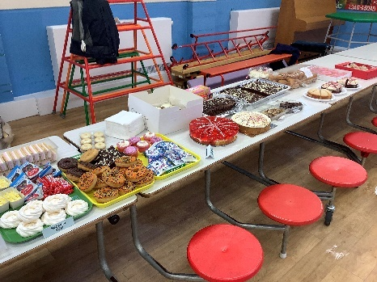

Meanwhile in nursery our pupils have been reading ‘The Colour Monster.’ They have been learning about different colours and matching different objects to each colour. Reception pupils have been learning about our senses. They have been on a sound hunt and been tasting different fruits. After having read ‘The Gruffalo’ by their class author, Julia Donaldson, Year 1 have been writing character descriptions about him. Year 2 have been writing a character description too about Scissor Shark, the evil villain in their class book. In Spanish, Year 3 have been learning to count to 10. In science, Year 4 have been making clay models of our teeth. As part of RE, Year 5 have learning that it takes courage to use our God given qualities, but our skills and qualities help to make us unique. Year 6 have been learning all about unconditional love through the example set by St Therese.

**Assembly**

**If anyone wants to be first, he must make himself last of all and servant of all. Mark 9:35**

Our assembly this week focused on the scripture reading where the disciples argued about who is the greatest. The children discovered that the most important things in life are not winning, being the best or most beautiful. Instead, Jesus taught His disciples that to be the greatest in God’s sight, we must put others first.

**Chapel / prayer garden**

Our chapel / KS2 prayer garden is open each Tuesday morning before school for staff, pupils and parents to come and pray privately. Starting the day with God is beautiful. You are very welcome to pop in from 8.15am each Tuesday.

**Sacramental Programme**

Thank to everyone who attended the registration meeting with Father Jeremiah. If you were unable to make the meeting, you would need to make contact with the parish urgently. All the meeting and celebration dates have been sent out to you and a copy is available on our school website. <https://st-clares.manchester.sch.uk/religious-life-at-st-clare-s/sacramental-programme-dates-2024-25>

**Caritas Award**

The Caritas is awarded each week in recognition of someone in school who has shown kindness to others by putting love into action. The award this week goes to Jagger in 6W for donating books to school for our library. He wants to share his love of reading with others.

**Attendance**



Whole school attendance this week is 96.6%. We are aiming for 97% so are very close to our target. Best attendance this week is class 3F for the second week running with 99%. They will receive a longer play as a reward.

We have an Attendance Officer in school who is available to offer support and advice on any issues pertaining to attendance and punctuality. Contact Mrs Burgess Hamlett via the app or call into school to see her.

**Half-term**

I just want to point out that our half term holiday in October begins **Monday 28th October**. This is different to some of the Manchester schools’ half-term, but falls in line with Our Lady’s second week of the holiday.

**Blessing of the animals**

To coincide with the feast of St Francis, there will be a blessing of the animals at St Clare’s parish hall on Friday 4th October at 6pm. Father Jeremiah invites you to bring your pets along to this special event.

**Girls football**

A group of our Year 5 and Year 6 girls took part in a football competition this week and were undefeated. They won one and drew two matches, but the British weather put stop to their final match. They represented the school well and enjoyed the opportunity to play. Special thanks to Mr Keogh and Mrs Gill for taking the girls to the event.

**Support**

As a school we are here for both your children and your family. If you are experiencing any difficulties or have any anxieties, please get in touch with Mrs Sylvester for a private conversation. Her email address is [c.sylvester@st-clares.manchester.sch.uk](mailto:c.sylvester@st-clares.manchester.sch.uk) or you can ring the school number or message via the school app. If we are unable to help you, we may be able to refer you to somebody who can.

**Safeguarding**

Safeguarding children is everyone’s responsibility. If you have any concerns regarding the safety of a child, please report it. You are able to refer concerns directly or you can contact one of the Designated Safeguarding Leads in school. Contact details can be found below.

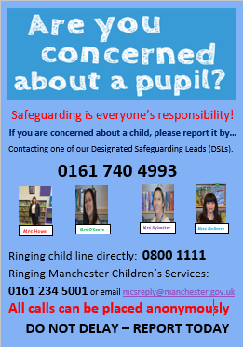

Enjoy the weekend!

Mrs Howe

**Upcoming dates:**

4th October – St Francis Day Mass 9.00am in church