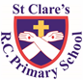

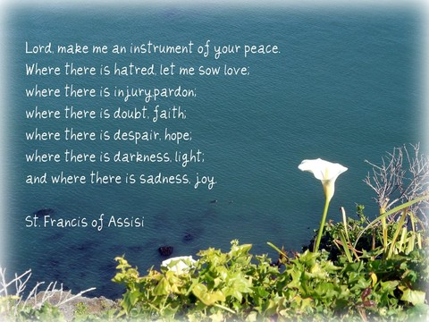

ST CLARE’S R.C.P NEWSLETTER

Our School Mission Statement: Guided by Jesus Christ, our teacher, we journey together learning to dream, believe and achieve. Friday 3rd October 2025

Friday 24th November 2023

This weekend is the feast day of St Francis of Assisi: a saint recognised for his love and compassion for all of creation – all people and animals. After the terrible incident that happened yesterday at the Jewish synagogue, let us keep the victims and all those affected by this tragic event in our prayers. Let us pray that where there is hatred, love grows.

Events such as these are horrific and frightening. I just want to assure you that we have been informed that school was not believed to be in any danger yesterday. Had we been, the police and the local authority would have contacted us. We do have lockdown procedures in place which we do practise with the children in case of an unlikely emergency situation. School is a calm, safe place for your children and they are best kept to their normal routines.

There is some information available if you want to speak to your children about conflict:

**UNICEF - How to talk to your children about conflict and war | UNICEF Parenting**

**Talking to children about war and conflict (beaconhouse.org.uk)**

**Place2be -** [**https://www.place2be.org.uk/about-us/news-and-blogs/2022/march/talking-to-children-and-young-people-about-war-and-conflict/**](https://www.place2be.org.uk/about-us/news-and-blogs/2022/march/talking-to-children-and-young-people-about-war-and-conflict/)

**BBC Bitesize guidance from Consultant Clinical Psychologist, Sheila Redfern (Anna Freud Centre) 7 tips on how to help your child discuss and understand upsetting news - BBC Bitesize**

*Bishop John Arnold, Bishop of Salford, has shared a statement following the devastating stabbing attack at the Heaton Park Hebrew Congregation Synagogue earlier today:*

*“The local Catholic community stand united in our prayers for the Jewish community following the tragic attack on a synagogue in Manchester, especially on this sacred day of Yom Kippur.*

*“We condemn such acts and pray for those who have died, the injured, emergency responders, and all affected.*

*“Let us work together in hope to strengthen our community solidarity. We must remain united in our common beliefs against those who sow hatred and division.*

*“We also pray for peace and tolerance around the UK and the world.”*

***Right Reverend John Arnold****Bishop of Salford*

In Nursery this week, the children have been making their own Super Tatos heroes. In PE, Reception have been learning different ways to jump (star, tuck, straight) and how to land on two feet safely. Year 1 made their smoothies and enjoyed drinking them in DT. As part of their computing work, Year 2 have been coding – inputting directions for characters to follow. In geography, Year 3 have been using the Ring of Fire to locate volcanoes in Europe. Year 4 have been busy writing persuasive letters to the government about why all children should receive free school meals. Year 5 have a visit from some physicists this week who led workshops for them on ‘tiny matter.’ As part of Black History month, Year 6 have been learning about Lewis Latimer, a scientist who improved filaments in electric light bulbs.

Today, all of our Key Stage 2 children were treated to drumming workshops delivered by Amasing. This experience was donated to us by a family who bid for it at a charity auction. Thank you to the family concerned for their kindness and generosity.

**Assembly**

**… remember that you in your lifetime received your good things Luke 16:25**

Our assembly this week helped children understand the secret of true wealth: their faith in God and the gifts He gives us. Through the parable of the rich man and the poor man, children explored how God wants them to live life to the full now and for eternity! The children were encouraged to see that living life to the full means putting God first and sharing what we have with others. They also identified in themselves and others, good gifts to be treasured and shared.

**Come and pray**

Our chapel / KS2 prayer garden is open each Tuesday morning before school for staff, pupils and parents to come and pray privately. Starting the day with God is a beautiful way to begin the morning. You are very welcome to pop in from 8.15am each Tuesday.

**Prayer Trail**

As part of the Jubilee Year of Hope, our Mini Clares led a prayer trail for our key stage 2 pupils. The pupils were led to reflect upon how they can use their voices to make positive changes; how they can care and look after the environment and celebrate creation; and how that can love themselves and use their talents to help others. Well done to our young prayer leaders!

**Macmillan coffee morning**

I would like to express our sincere gratitude for your generosity in supporting our Macmillan coffee morning. It was wonderful to see so many family members and friends in school to share the event with us. This is part of our Catholic life and mission – reaching out to support those in need. We raised an amazing £948.81 for the charity. Last year we raised £786.48. Thank you all!

**Pupil certificates**

Daniel in RS for good pencil control when labelling his house.

Mayah in RDM for looking after God’s world.

Chidumebi in 2D for being a good friend to everyone like Jesus.

Zane in 4H for showing kindness to another child.

Ludiana in 6s for being a supportive friend.

|  |  |  |
| --- | --- | --- |
|  | Pupil of the week | Achievement |
| N | Lucy for listening beautifully to our story ‘Supertato’ and remembering the key events in the story. | Kory for being an enthusiastic learner during our literacy carpet sessions. |
| RDM | Emilia for always trying hard and being ready to learn. | Jomi for a fantastic model of a house for homework this week! |
| RS | Roseanne for having an amazing attitude to learning! | Timi for always offering fantastic ideas in all carpet sessions! |
| Y1G | Daisy for putting 100% into all her work! | Aria-Rose for using her Fred talk when writing speech bubbles. |
| Y1S | Layla for having a positive attitude towards all her work and trying very hard in everything she has done. | David for working very hard on his letter formation. |
| Y2C | Szymon for being amazing all week | Zion for his amazing answers in our maths challenges |
| Y2D | Ella for working hard and being on task in every lesson. | Fauziyah for your amazing drumming skills. |
| Y3F | Tymofiy for always being ready to learn and setting a good example. | Maggie for having an excellent work, completing her work to a high standard. |
| Y3H | Yaroslav for working hard to challenge himself in English writing lessons. | Joseph for brilliant pair work in our dance lesson. |
| Y4H | Carter S for fantastic addition of four digit numbers with exchanges. | Kody for being super focussed and hard working! |
| Y4O | Peter for his fantastic persuasive speech in English on why all children should receive a free school meal! | Joel for having a wonderful first week at St Clare’s |
| Y5K | Tyler for always being ready to learn and for great enthusiasm about our History topic of Ancient Greece | Rudi for a great recent improvement in the quality of his handwriting and presentation. |
| Y5L | Tyler for his continued hard work and development of his handwriting. | Esosa for her excellent oracy discussion   and contributions during Science. |
| Y6S | Steven for settling into 6S so well, he is a fantastic addition to our class. | Molly for writing a great, factual non-chronological report about light and how it travels. |
| Y6W | Oleksandr for having a great start to St Clare’s. | Jasmin for her fantastic non-chronological report on light. |

**Headteacher Awards**

**Caritas Award** 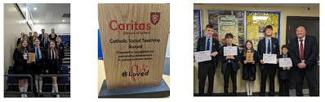

The Caritas Award is presented each week to a child in recognition of their outstanding achievement in putting love into action. This week the award goes to Liza in 6W for making a new friend feel so welcome and supported at St Clare’s and acting as a translator to aid his understanding.

**Attendance**

Overall whole school attendance this week is 94.7%. Lates are much improved this week with 20 pupils being late after 9am 23 times.

School doors open at 8.40am to give the children time to take off their coats and be ready at their desks for an 8.45am start. The doors close promptly at **8.45am.** Thank you for your support in ensuring a smooth start to the day.

Under the **UN Convention on the Rights of the Child (UNCRC),** Article 29, children have the right to an education. If you are experiencing any difficulties or require any additional support with attendance or punctuality, please contact our Attendance Officer, Mrs Burgess Hamlett.

The best classes this week for attendance is 6W with 98%. They will have a longer playtime as a reward.

**Blessing of your pets**

On Saturday the 4th October at 2pm there will be a special blessing of pets on the Feast day of St Francis. Everyone is welcome to bring their pets to this special event at church.

**Reception stay and play**

On **Thursday 9th October,** parents are invited into school when they drop their children off for a Read Write Inc information session, followed by a stay and play with your children in the classroom.

**Year 6 high school places**

You are now able to apply for your child’s high school place for next September 2026. **Applications must be made prior to October 31st 2025 for a September 2026 start.**

If you live in Manchester, you can apply online via <https://www.manchester.gov.uk/info/500322/secondary_school_admissions/7516/apply_for_a_year_7_secondary_place_for_september_2020>

If your address comes under Rochdale, the link is <https://www.rochdale.gov.uk/school-admissions-appeals/apply-secondary-school-place>

If you need any support with filling in the application, please ask.

As a Catholic school, we hope that you will continue to choose to educate your child in a Catholic high school.

Our Lady’s have an open evening to which you are all invited. You have already been sent out the flyer for this event.

**Support**

As a school we are here for both your children and your family. If you are experiencing any difficulties or have any anxieties, please get in touch with Mrs Sylvester for a private conversation. Her email address is [c.sylvester@st-clares.manchester.sch.uk](mailto:c.sylvester@st-clares.manchester.sch.uk) or you can ring the school number or message via the school app. If we are unable to help you, we may be able to refer you to somebody who can.

**Safeguarding**

Safeguarding children is everyone’s responsibility. If you have any concerns regarding the safety of a child, please report it. You are able to refer concerns directly to children’s services. The contact details for them is particularly important during the summer holidays when some children may be susceptible to more harm and neglect.

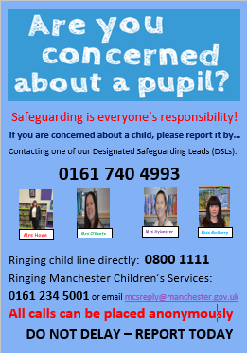

I hope that you all have a peaceful weekend,

Mrs Howe

**Upcoming dates**

6th October – St Francis day mass 9am

7th October – Black history ‘Hidden Figures’ assembly

9th October – Black history ‘Handa’s Surprise’ workshops.

0.Reception RWI stay and play

12th October – Family mass 10.30am

21st October – Harvest Service in church 9am

22nd October – parents evening

***The weekly newsletter is also available on our school website***[*Newsletters*](https://st-clares.manchester.sch.uk/parents/newsletters/newsletters-2024-2025)

**A Prayer for Peace**

