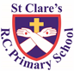
ST CLARE’S R.C.P NEWSLETTER
Guided by Jesus Christ, our teacher, we journey together learning to dream, believe and achieve.
Friday 6th October 2023

We started off this week by celebrating diversity within our school. This month is Black History Month and two dancers led our Key Stage 1 children in African Dancing. Key Stage 2 will have their dance sessions next week. We want our children to know that God loves us all equally regardless of what we look like. We are unique and made in God’s image. We are all different for a reason, as God has a different plan for each of us, but we are all one body in Christ. No one is more or less important than anyone else.
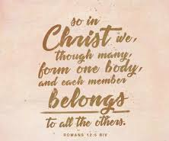
We also welcomed the Curiosity Cube into school on Thursday and classes from Years 4,5 and 6 were invited into the ‘lab’ to take part in scientific activities.
Our Nursery children have made Super Tato superheroes this week. Reception have compared weights using the terminology heavy and light. In English, Year 1 have been writing speech bubbles about Bog Baby. Year 2 have written instructions on how to make a shield. In Spanish, Year 3 have been learning about colours. As part of their family topic, Year 4 have been looking at the role of Joseph in Jesus’s life. Year 5 have made decades of the Rosary using wool. Year 6 have planned and written a narrative based on The Light Jar.
Mass
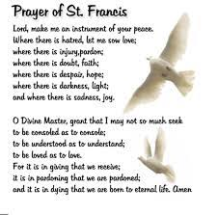
On Wednesday we celebrated a whole school Mass to celebrate the feast of St Francis. Or prayer garden is named after St Francis and our school is named after one of his followers, St Clare. Our Mini Clare’s led us through the Mass and our prayers. Our choir led our singing beautifully. It was a special Mass for our Mini Clares as Father Jeremiah commissioned them in their role of helping to lead the Catholic life and mission of our school. Congratulations to all our Mini Clares who are expressing their faith in this very important role.
In the evening, families were invited to have their pets blessed by Father in the church hall.
Morning Prayers
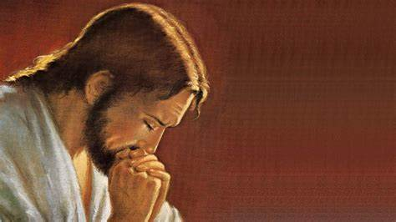
Our school chapel will be open every Tuesday morning from 8.30 -9.00am for parents (and children) to come into school for some private prayer, some time alone with God or quiet reflection. Thank you to everyone who came along last week.
Caritas Award
This week’s award goes to Yoel in 4S for showing kindness to a classmate at swimming.

Hope in the Future
On Tuesday, some of our Mini Clares joined with other schools in the diocese to celebrate our faith. It as a day of reflection and prayer where we reminded of the call to be Ambassadors of Christ. We are Christ’s body on earth and as such should promote Jesus’s teaching by our words and actions. Bishop John led a liturgy reminding us of the need to care for our common home as requested by Pope Francis in his encyclical Laudato Si.
Our pupils were extremely well behaved and enjoyed the day. They are a credit to you and the school.

MacMillan Coffee Morning
Once again for your support and generosity in making our coffee morning such a success. It is lovely for the whole school community to come together to help support others. We raised an amazing £741.30 which is even more than we raised last year. I’m sure the charity will be pleased with our donation.
Pupil certificates
Class | Pupil of the week |  | Achievement award
N | Theo |  | Heidi May
RDM | Matilda |  | Chloe
RS | Jayson |  | Miles
1D | Farhan |  | Prince
1G | Eliana |  | Joshua
2C | Zane |  | Emily
2O | Igor |  | Rehoboth
3F | Joleen |  | Osamagbe
3H | Freddy |  | Denver
4H | Jasmin |  | Shae
4S | Jacob |  | Alexis
5G | Liam |  | Halle
5W | Hannah |  | Tope
6K | Charlotte |  | Daniel
6S | Alex |  | Maddison
Headteacher’s Awards |  | Amelia in RDM  Elijah A in 1D  Ellion in 2O  Olivia K in 3H  Hepzibah in 4S  Oliver in 6S

Special mention goes to Oliver in 5G this week who has prepared and shared a prayer and liturgy session which we made at home with his class. What a great example he is to others!
Attendance
This week our whole school attendance is 95.8%. 3H and 4H both have 99% attendance this week which is excellent. They will have a longer playtime next week as a reward.
Please ensure that your child is in school for 8.50am, ready to start at 9.00am prompt. This week there has been 17 hours of missed learning due to the number of lates we have had. I am sure that you will agree that this is unacceptable and mostly unnecessary.
Month of the Holy Rosary
A member of the parish is going to come into school every Thursday during October to lead children in a decade of the Rosary to mark this special month dedicated to Our Lady and the Holy Rosary. If any parents wish to join us to pray, please come into school for 12.15pm each Thursday. You are most welcome!
Our Mini-Clares will also be leading decades of the Rosary with each class in school.
The Mark 10 Mission have set a Rosary challenge asking families to pray a decade of the Rosary every day during October. Please see https://www.themark10mission.co.uk/rosary-challenge for further details.
Harvest Festival
We have our Harvest Festival Service in church on Tuesday 17th October at 9.15am. You are most welcome to join us.
If you are able, would you please send in a tin of food on that day which we will donate to the parish food bank to help struggling families. Thank you in advance for your kindness and care.
Support
We know that families may experience difficult times and difficult situations throughout a year, especially with the cost of living increase. We are here to support you in any way we can - should you need it. If you are experiencing any financial or other worries, please get in touch. If we are unable to help you, we may know of a group who can help. Please contact Mrs Sylvester at school for a discrete conversation if you require some support.
Upcoming dates:
9th October – African dancing
11th October – Reception RWI stay and play
12th October – Year 2 Parent Reading Meeting 3.20pm
17th October – Harvest Festival service in church 9.15am
18th October – parents evening

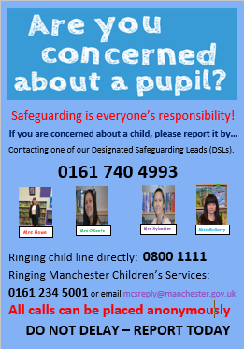
As always, thank you for your support. St Clare’s is a great place to be!
God bless,
Mrs Howe

